
Next test was performed before the ROT-54/2.6 deconservation

The next test was organized on December 3, 2020. The radio sources were chosen from the Radio sources catalog, we appointed sources would be able to watch by the ROT-54/2.6 antnna in its current state.

The HUSC team received professional support in this regard from John Sargsyan, a leading expert at Parks Observatory in Australia.

Based on the calculation of their coordinates and local siderial time in the sky, the time points for the tracking of our radio telescope antenna through the meridium were determined for that day.

Using special geodetic devices, the position of the pendulum bearing the secondary mirror of the ROT-54/ 2.6 radio telescope antenna was measured with a certain allowable accuracy for two axes in relation to the zenith direction from the angle of the azimuth and declination.

Tigran Brutyan and Narek Hambardzumyan from HUSC team, climbed to the ring shape rigel beam structure mounted on the tripod of the antenna, together with a specially invited climbing trainer, and provided mechanically the rotation of the pendulum at an angle of about 1 deg of arc to the West due to the movement of the North-South axis.

Thus it became possible to coincide the central meridian of the antenna (the line North-Antenna center - South) with the meridian of Tegher (North-Tegher Monastery dome -South line).

Using the credit: Technical University of Eindhoven NL for utilizing Grasp, AG expert Kees Van’t Klooster provided us with some calculations.
1.

Fig.1 Microstrip patch antenna, calculated with MOM, based on model provided by Ticra, radiation pattern decomposed in spherical waves, with respect to assumed origin (as needed to refer to in subsequent calculations). Spherical wave expansion transferred to secondary focus of a spherical main reflector with a correcting sub-reflector. The correcting sub-reflector is similar as to the one used in calculations presented in 18-September virtual Armenian Radio telescope and Interferometer Conference ➔see for details in that hand-out concerning correction spherical reflector and correcting sub-reflector, analyzed with a dedicated corrugated horn (18 sept).

2. Predicted radiation pattern for a spherical wave expansion representing a microstrip patch mounted in the focal point in the large radio telescope. One assumption has been made and checked: the part beyond ~32 meter is ignored in the physical optics calculations, as its contribution goes to a low level.

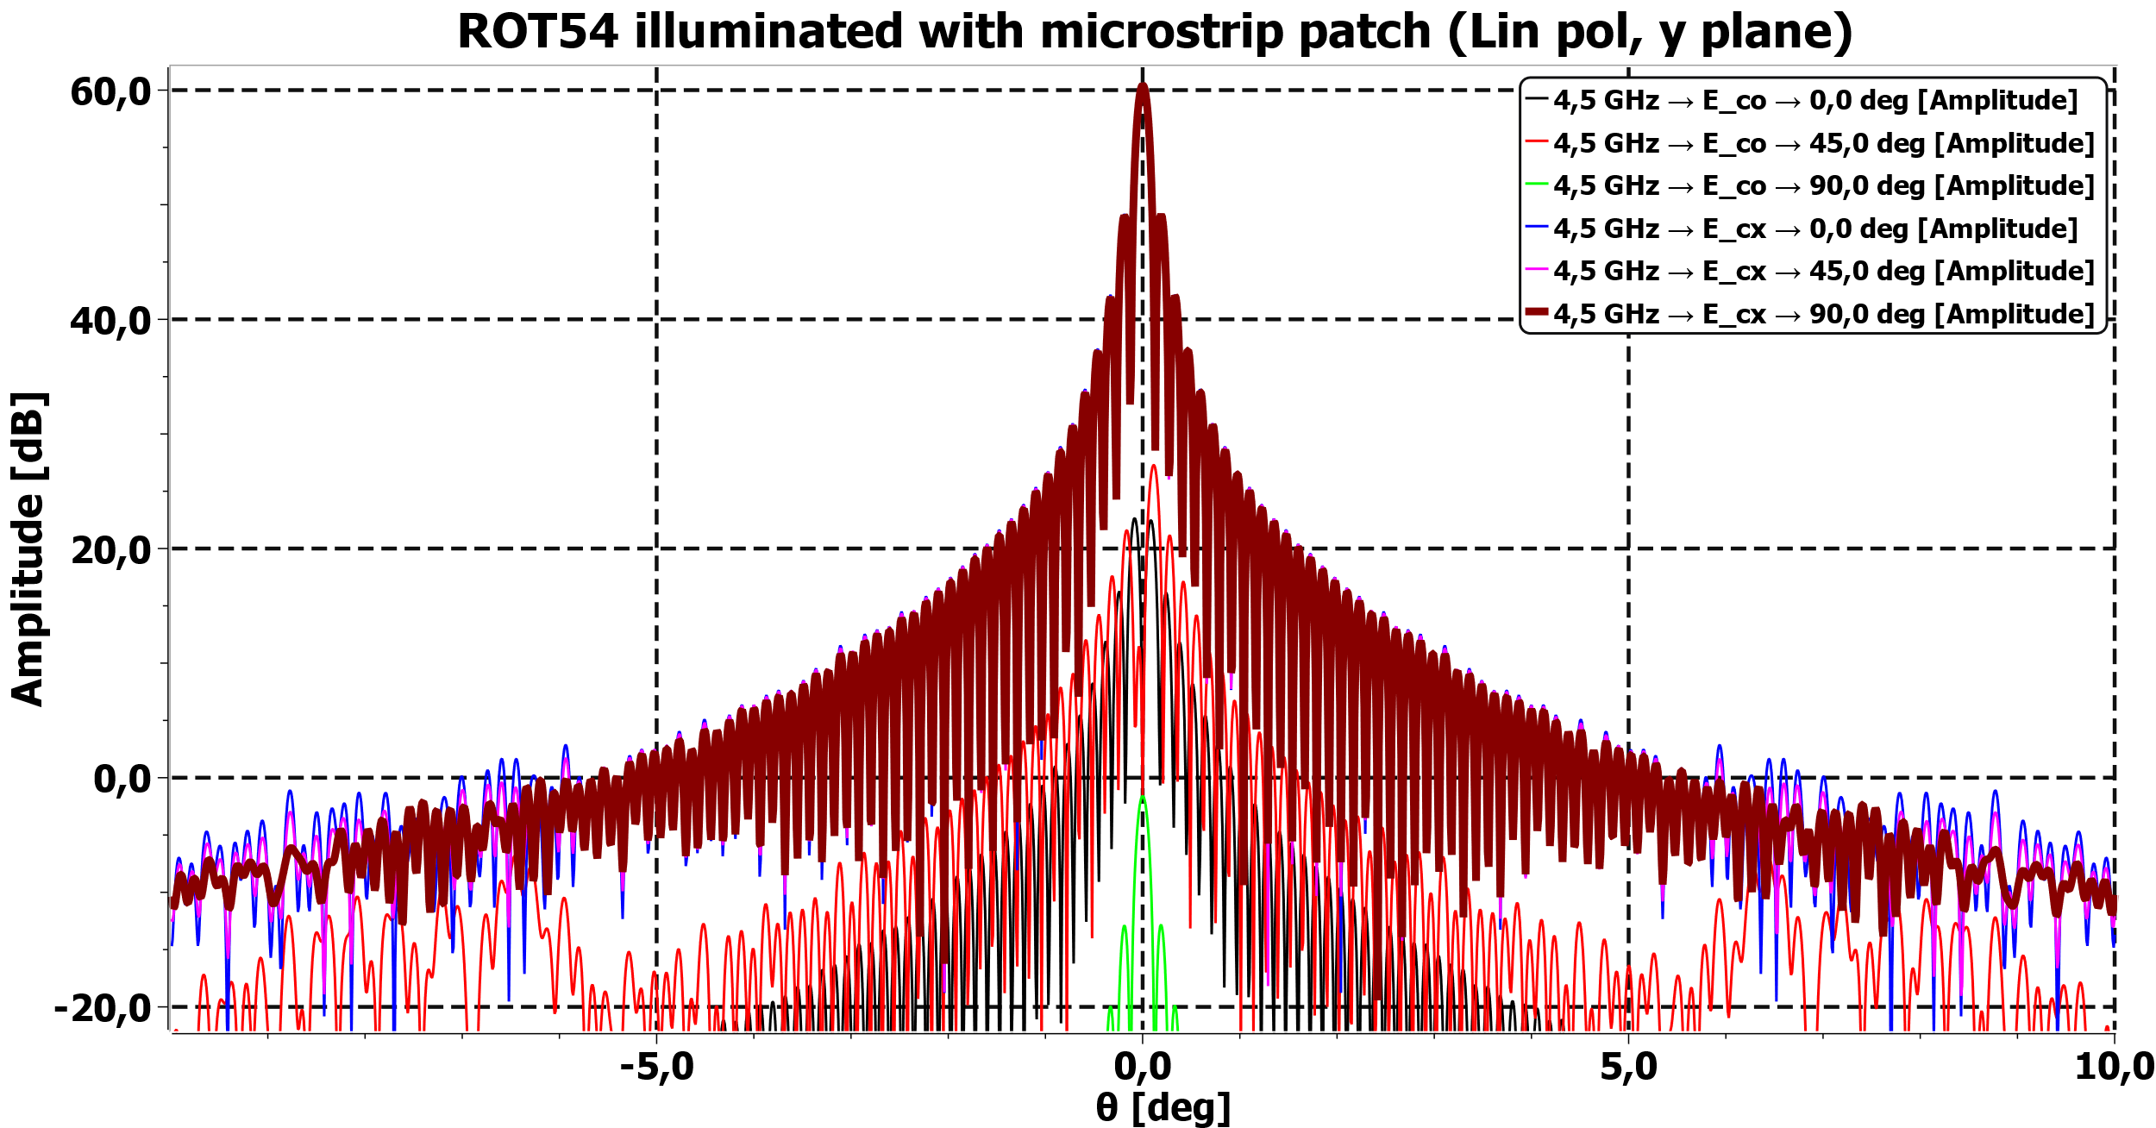

Fig.2 ROT54 illuminated with microstrip patch (Lin pol, y plane). The microstrip patch is linearly polarized, asymmetric feeding point. Spherical wave expansion patch co-aligned with ROT54 focal position.
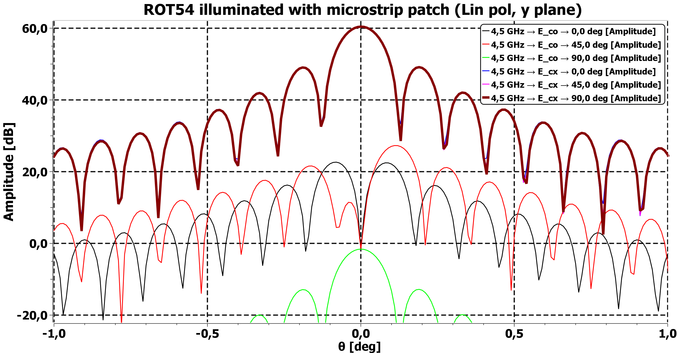

Fig. 3. ROT54 illuminated with microstrip patch (Lin pol, y plane).
The microstrip patch is linearly polarized, asymmetric feeding point, resulting asymmetry in cross-polar pattern. Spherical wave expansion patch co-aligned with ROT54 focal position.

3. Two-dimensional representation of total telescope pattern. It is noted that the microstrip –patch antenna with its asymmetrical feeding point causes an increase of the asymmetry in the cross pol-level.
A previous calculation was for the feed location laterally offset by 0.03m or about λ/2 lateral offset in C-band. This calculation presents the result for the feed representation in the focus: no beam-shift. (see pattern at the end of document: pointing effect)
Scales are in (kx, ky) or (u,v) or just take the arcsine of the values to find angle in degrees. Two lines at about +0.01 and -0.01 relates to ±0.57°(manually drawn pendulum).
It is to stress the pointing accuracy needed, in order to catch a point source, with a somewhat arbitrary boundary limit of ±0.01 = ±0.57°.

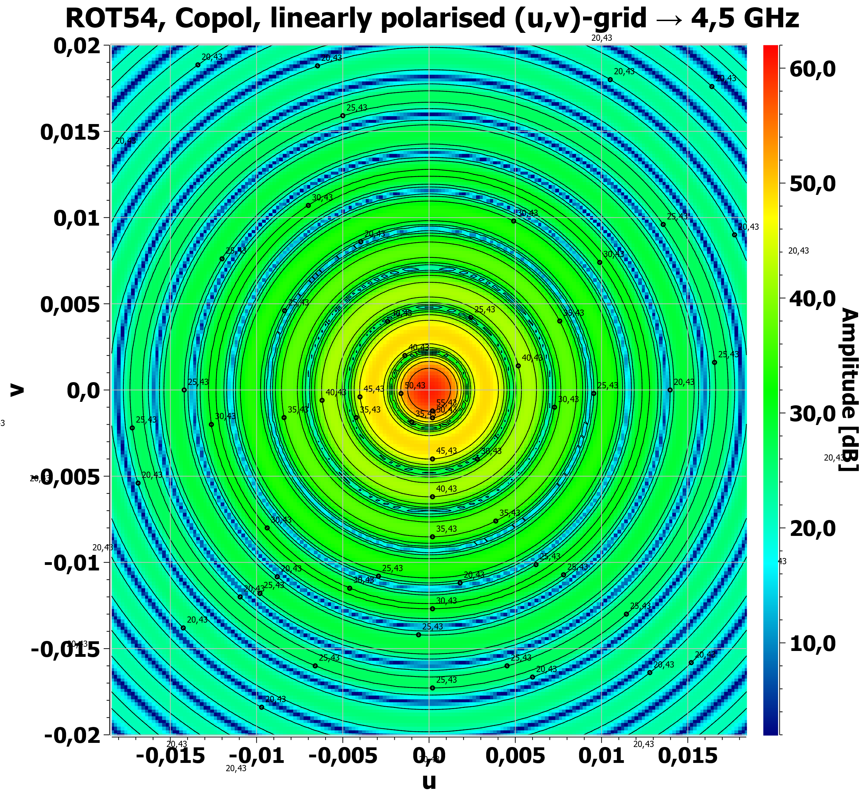

Fig. 4. ROT54, Copol, linearly polarised (u,v)-grid → 4,5 GH, 1.15 deg is distance between -0.01 and +0.01 (arcsin(0.02) ~1.15).

Since it is impossible to scan an antenna pattern at declination angle today due to the forced immobility of the East-West axis, it was intended to observe at the multiple sources of SygX in the Sygnus constellation that make up the so-called Loop of Sygnus.

On December 9 the online meeting of HUSC's Advisory Group took place, during which Dr. Arevik Sargsyan and Dr. Suren Eyramjyan presented what they had done on December 3 and the signal processesing of the observation results.
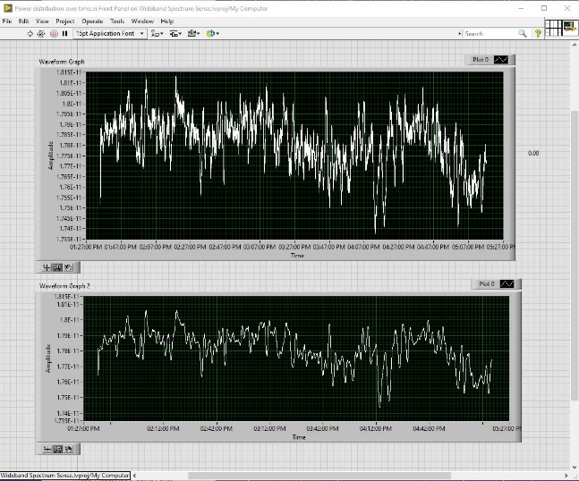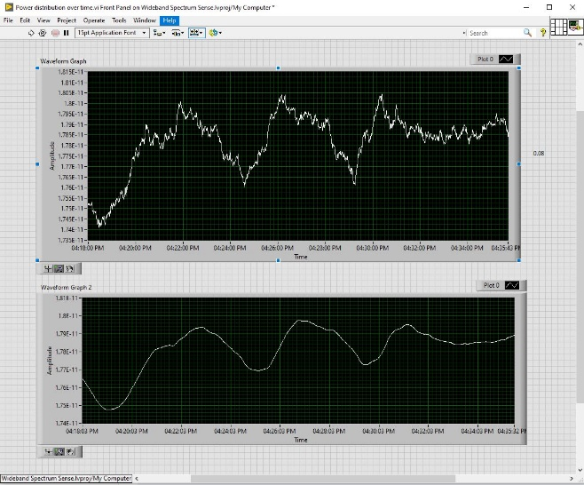
Fig.5 Observation results in general (left) and averaged (right) pictures.
Our European experts answered all the questions in detail, we tried to find the answers to our doubts together.

It was decided to repeat the observation of the same part of the sky at the same time֊ of the observation in the Syg Loop and, comparing the first & second recordings to conclude that the radio telescope is "breathable" based on the ratio of clearly measurable time deviation of the obtained images.
So, December 16th the second observation for repeating the previous one was done on the time calculated for “presence” of the same piece of Sky around the Zenith sector for the ROT54.
The comparative result of the signal processing is shown on the Fig. 6.
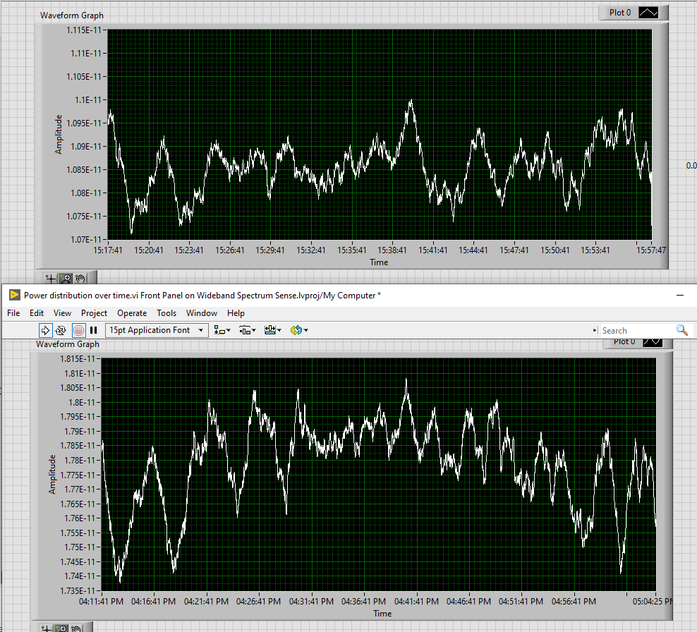
Fig. 6. Measurements by date: 16 Dec 2020 (top) and 3 Dec 2020 (bottom) accordingly

The curves matched by those visual similarities and expected time of appearance. There is an approximate difference around 54 minutes between Dec 3 and Dec 16 measurements. Since there is an issue with synchronization and time stamping, the time mismatch might exist and the error can be an accumulative. In Dec 16, the measurements should have been more precise in terms of timing, but unfortunately the SW crashed in the end of the measurement process and all necessary components for time correction were lost. So, we used the same time approximation method that we’ve used for Dec 3th measurements.
However, on Fig. 7 it is possible to see the visual similarities that let us assume, that the measurements and received results correlating to each other (red highlight).
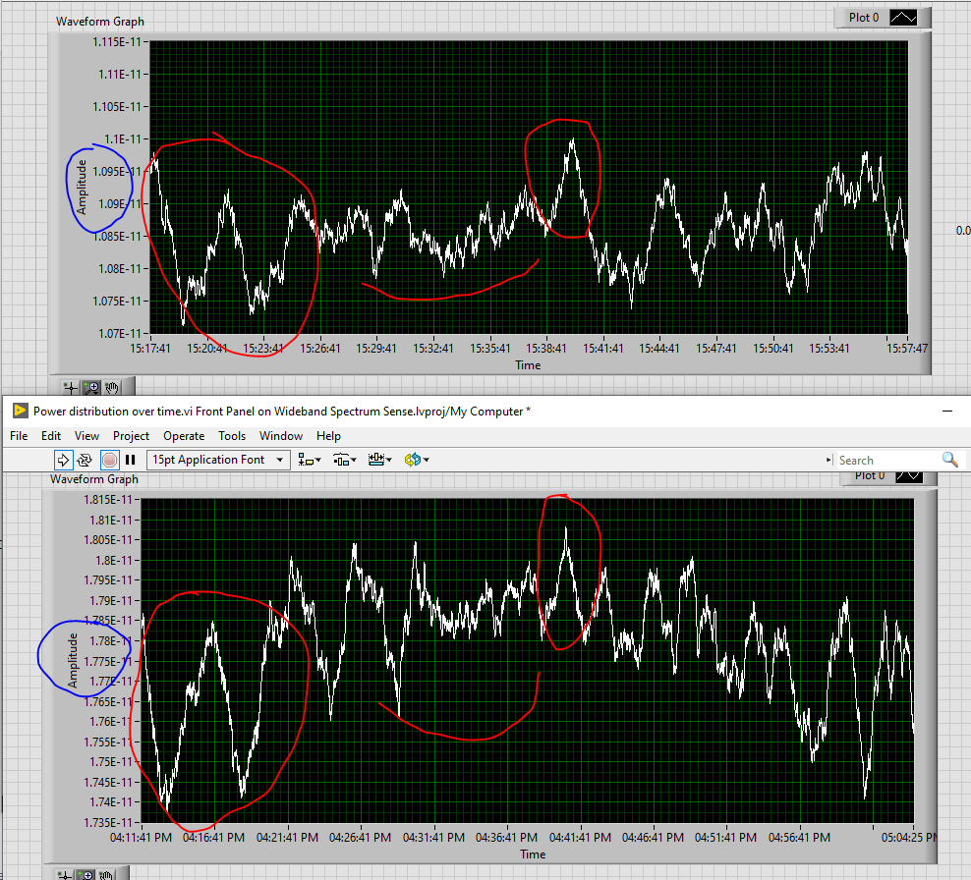
Fig. 7. Highlights of similarities between two days’ measurements

In addition, as it is seen, around 7pW difference of average received power levels (blue highlight) between two days data. Our assumption is that it might be a result of existing snow at the bottom of large mirror (Fig 8.). According the curves (Fig. 9) the 4.5GHz frequency penetration is around 8cm, which means that a significant part of our dish might even did not work, and as a result – we received less integral power.

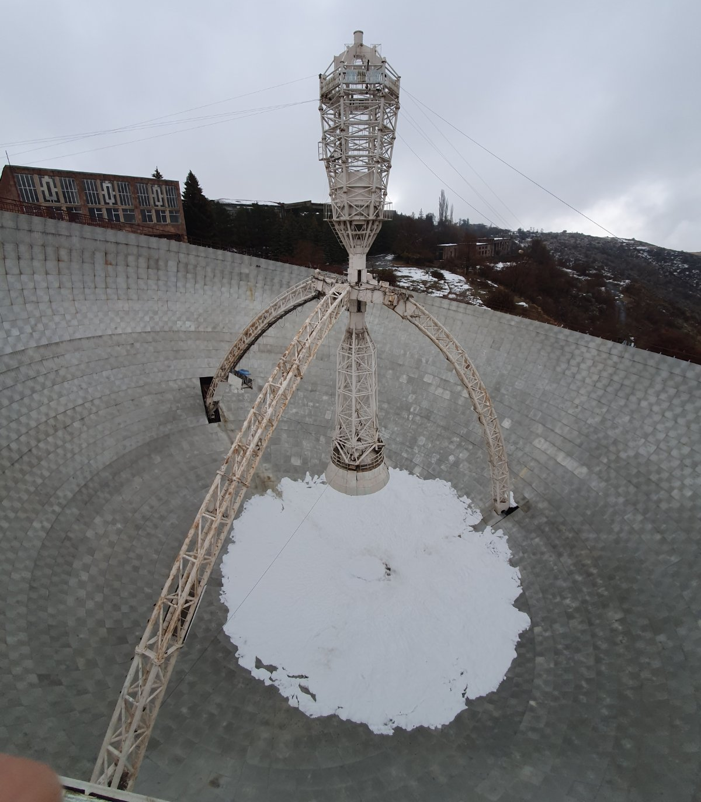
Fig. 8. ROT54/32 on December 16
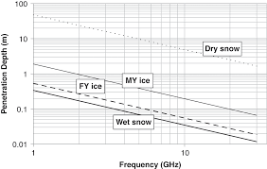
Fig.9. Sea Ice Observations [1]
References
[1] https://www.cambridge.org/core/books/sea-ice-analysis-and-forecasting/sea-ice-observations/EBD20C2373741005E79A2A14701EF67B

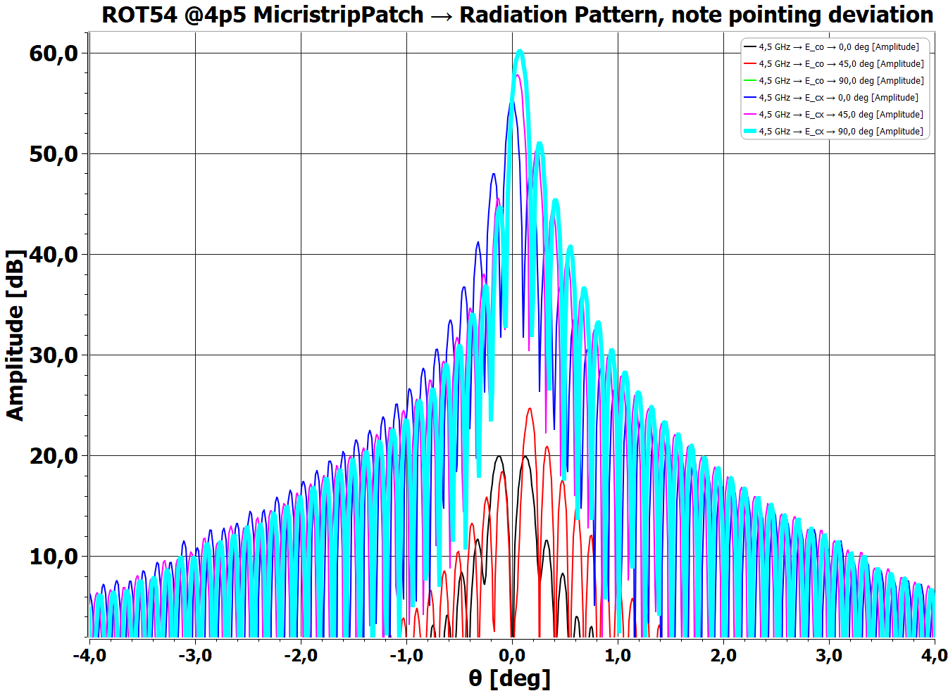
Last figure is for displacement of 0.03m. Note impact on pointing
Micristrip=Microstrip….

