
Express Production Real-time e-VLBI Service
EXPReS is funded by the European Commission (DG-INFSO), Sixth Framework Programme, Contract #026642

Monthly Report- February 2009
Date: | 2009 April 2
Filename: | 2009-feb-rev07.odt
Author: | T. Charles Yun, Project Manager, JIVE
Co-Authors: | EXPReS Management Team
Summary: | Monthly report

Document Log
Version | Date | Summary of Changes | Author(s)
1.0 | 2008 April 2 | final | tcyun
0.9 | 2008 Mar 15 | Draft | tcyun
0.1 | 2008 Mar 9 | Initial Draft | T. Charles Yun

Project Information
Project Acronym | EXPReS
Project Full Title | Express Production Real-Time e-VLBI Service
Proposal/Contract number | DG-INFSO #026642

Table of Contents
1. Introduction
2. Network Activity Updates
* NA1- Management
* NA2- EVN-NREN
* NA3- e-VLBI Science Forum
* NA4- Public Outreach, Dissemination and Communications
3. Specific Service Activity Updates
* SA1- Production e-VLBI Service
* SA2- Telescope Network Connections
4. Joint Research Activity Updates
* JRA1- FABRIC

Section 1- Introduction
A great deal of project energy was focused on preparations for the board meeting and its wrap up. Happily, the meeting went smoothly and is now wrapped up. As we move to the final stages of the project, it is nice to see that the planning activities have less to report and the other groups are showing more activity. The production groups are now operational, so reports are closer to updates on schedules. The Research activity is also now focusing on optimizations and documentation. These, we feel, are all good signs.
The call for period 3 updates has also been initiated. As the text is received, these reports will begin to integrate not only the text, but the graphics that will eventually make it into the final project report. So the size of these reports is likely to increase.

Section 2.1 – NA1 Management
The project office completed the last items from the Board Meeting, both publishing the minutes from the meeting to the wiki (as noted in an announced to the Board via email) as well as finalizing the budget discussions. The budget discussions establish the expectations for the budgets as the project extends into the 6 month extension.
Also this month, the Project Manager was asked to sit on the External Advisory Board for DORII (Deployment of Remote Instrumentation Infrastructure). The invitation comes (we believe) because of EXPReS's experience as both an application and infrastructure activity. The Project Manager accepted the invitation and the first meeting is schedule for March 2009.
Discussions for a short term visit to JIVE from PSNC of one engineer have begun. The plan is to have a short duration, intensive face-to-face period where some odds and ends items can be wrapped up quickly. The majority of the work will be for FABRIC. JIVE and PSNC are currently in discussing what arrangements are necessary and what we can expect to achieve from this type of a visit. We believe the visit will occur in late spring or early summer.
Section 2.2 – NA2 EVN-NREN
No update at this time.

Section 2.3 – NA3 eVSAG
The second announcement for the End of Science meeting has been distributed. The website <http://www.oan.es/expres09/> is being updated dynamically in response to minor adjustments and corrections. In all, planing is moving forward smoothly.
Based solely on private emails and mailing list chatter, we believe that there will be a decent amount of interest for the meeting and should expect to fill the target of 80 people per day (the size of the meeting room). This will make the meeting one of the largest e-VLBI gatherings of the year.
Section 2.4 – Public Outreach
Preparations for both the JIVE and EXPReS annual reports has begun. With that, some of the early graphics are being distributed to be used in presentations and reports. The most recent include the following "fishbone" diagrams that highlight activities over time.
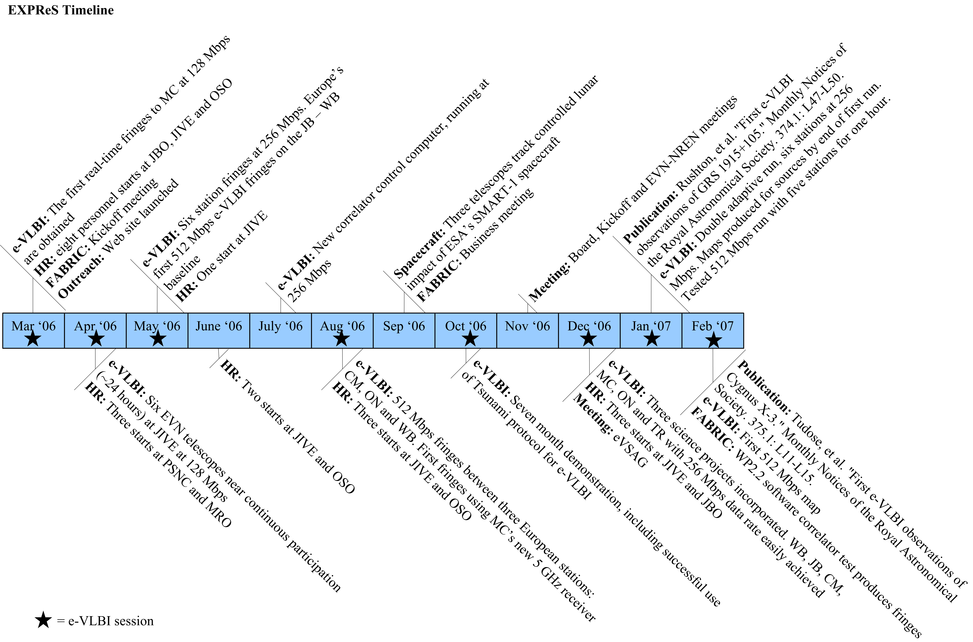
Period 1 Highlights

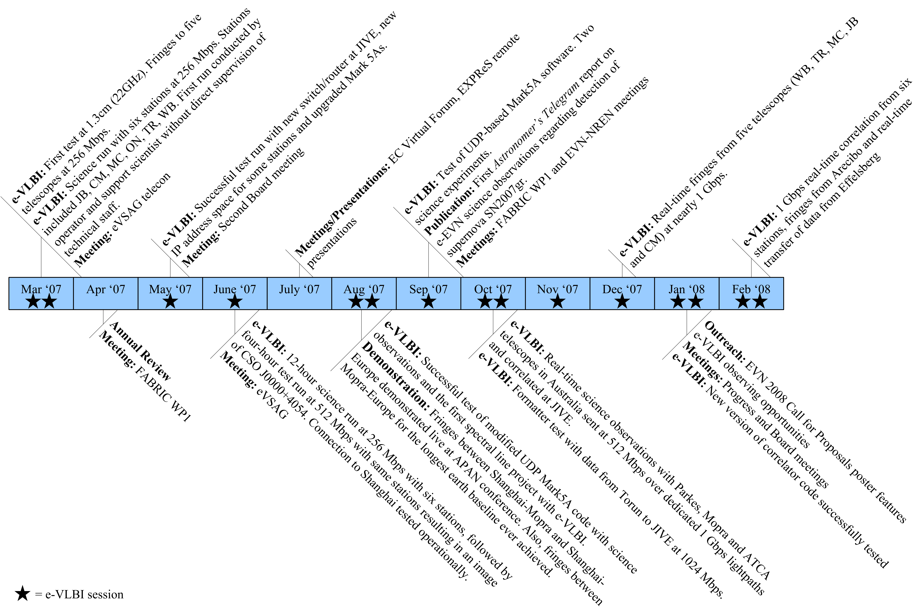
Period 2 Highlights

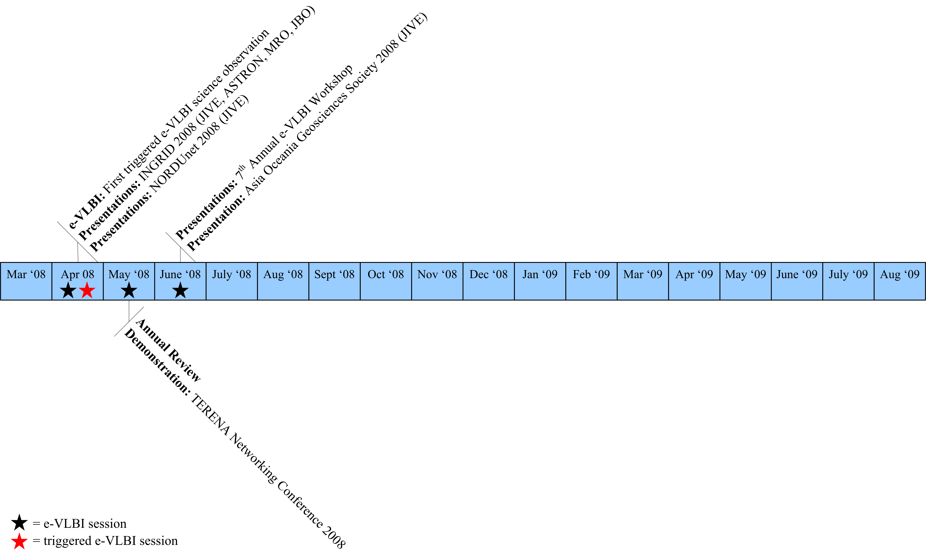
Period 3 Highlights

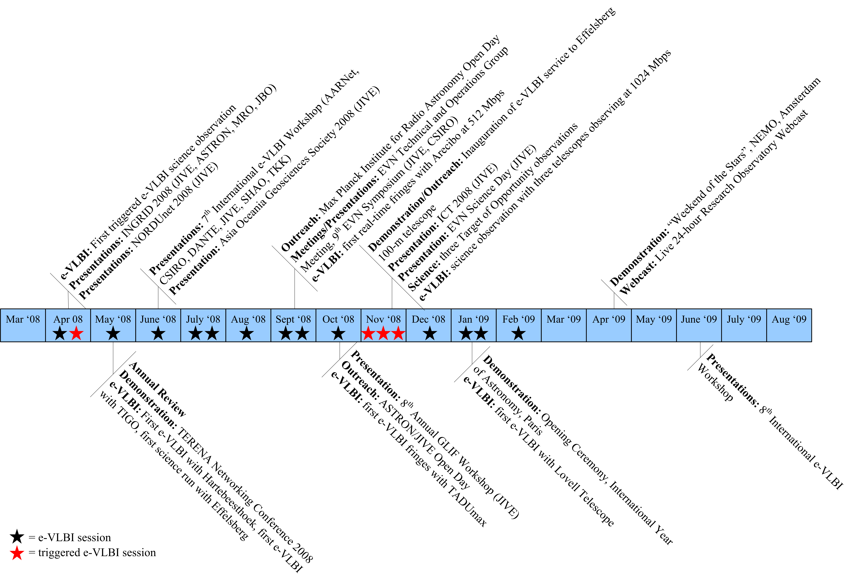
Final Period, modified Diagram

Section 3.1 – Production e-VLBI
e-VLBI observations have been running smoothly from an operational point of view. However, there are some external factors that have intruded on our operational smoothness. In addition to the situation in South Africa, we have learned of two additional problems. Both are track problems. Effelsberg and Lovell have cracks in their tracks (the rail on which the telescope rotates). The cause seems to be the unusual changes in temperature at the site over the past weeks/month. (Note, a similar crack occurred several years ago at Effelsberg during similar weather.) The repair, while complicated, is considered routine for both pieces of equipment. This means that they will not be able to participate in the next upcoming e-VLBI observation. More details will be shared as they are announced.
That said, dates for the next round of e-VLBI observations have been sent out by JIVE. The expected next dates are:
20-21 August [Thu-Fri]
27-28 Aug [Thu-Fri]
10-11 Sep [Tue-Wed]
29-30 Sep [Tue-Wed]
15-16 Oct [Thu-Fri]
17-18 Nov [Tue-Wed]
1- 2 Dec [Tue-Wed]

Hi,

There were two projects observed in the 10-11 February e-EVN run,
both in the L-band, at 512 Mbps.

In RP015A we had Arecibo (@256 Mbps) besides the western EVN telescopes.
Unfortunately Effelsberg could not take part the observations
because of the azimuth rail crack. In Jodrell Bank the Lovell Telescope
was used; besides Cambridge, Knockin data were streamed to JIVE
as well, through the same Mark5A. After the first hour of the
experiment the Lovell Telescope was stopped because there, too,
a crack was discovered in the azimuth rail. As usual for L-band, some
RFI caused minor problems but otherwise the observations went well.

During the night, Shanghai and the MarkII telescope in Jodrell joined
RF005. There were no major problems till the very last 30 minutes when
we had to restart the Cm Mark5A. This went well but we could not get back
Kn and On started to behave badly. A correlation job restart was necessary
which failed in the last 20 minutes. Overall, RF005 was a great success.

Would you please send the logs and antabfs files to vlbeer. Thanks!

With regards,
Zsolt

===========================================================================
Zsolt Paragi | Tel. : +31 521 596 536
Senior Support Scientist | Fax : +31 521 596 539
Data Processor Research and Development |
|
Joint Institute for VLBI in Europe | E-mail : zparagi@jive.nl
Postbus 2, 7990 AA Dwingeloo, NL | Web : www.jive.nl/~zparagi
===========================================================================
Email from Zsolt Paragi indicating problems with Effelsberg and Lovell, as well as general update on the e-VLBI observation.

Section 3.2 – Telescope Network Connections
No update at this time.

Section 4.1 – FABRIC
PSNC (Poznan) has been active the past month. They recently sent out a note indicating that a new member of their staff will be working on EXPReS. Mateusz Pabis will work on the correlation job and VLBI Broker functionality. He was introduced to the team via email. Additionally, they have submitted another code drop for their FABRIC activity (available via the wiki). They provided the following text and graphic to describe the state of their work.
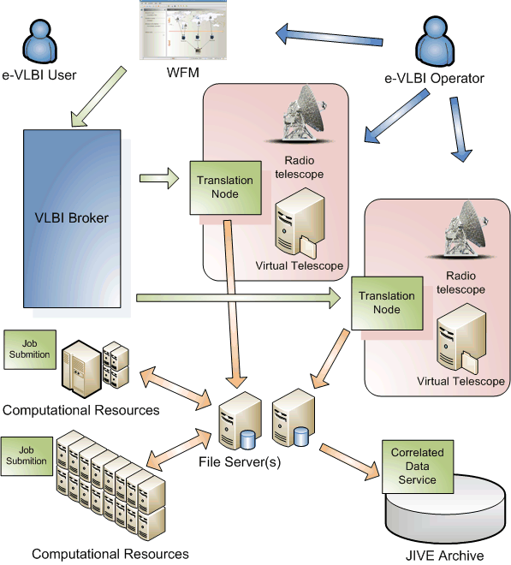
Diagram of Grid – e-VLBI architecture

PSNC has been developing a prototype for high data rate, distributed correlator. In the distributed approach, single central data processor at JIVE has been replaced with a software-based distributed correlation embedded in Grid Computing environment. The Grid approach to e-VLBI required a creation of some form of a user interface as a typical approach based on creating a text-based single control file for the experiment was not sufficient. In this case, a user should specify a set of Grid-specific parameters and define required resource types together with their specific connections creating an e-VLBI workflow. An interface to network monitoring modules should also allow to modify all required parameters and convert experiment parameters into software-correlator compatible data automatically. (A full description of each of the steps is included in the document posted to the wiki.)
JIVE posted related code and documentation to the wiki to PSNC's work. The software correlator code is posted and visible via the wiki. The main work over the past month has been on various levels of optimization. Some of the vector operations have been optimized on modern PCs and the code is adjusted to take advantage of this fact. Additionally, some internal communication optimization was completed. Specifically how data is moved between input and correlator nodes. (Note, the group has not yet run formal benchmarks, so the absolute improvement in performance is not clear at the moment, but it is considered "significant and noticeable.") Several additional features were also added to the code and are outlined in the release notes.

