EXPReS SA2 REPORT

Author: Francisco Colomer (f.colomer@oan.es)
Date: May 31st 2007

Reports on the status of the following deliverables:

Code | Description | Status
D13 SA2 SA2.01 | Feasibility study of the last-mile connection to the nearest NREN node for participant CNIG-IGN | finished
D14 SA2 SA2.02 | Feasibility study of the last-mile connection to the nearest NREN node for participant MPIfR | finished
D15 SA2 SA2.03 | Equipment of the last-mile infrastructure for participant INAF (telescope in Medicina) | finished
D16 SA2 SA2.04 | Feasibility study of the last-mile connections to the nearest GEANT NREN node for participant CAS (Shanghai, Urumqi, Miyun, Yunnan) | finished
D17 SA2 SA2.05 | Feasibility study of the last-mile connection to the nearest NREN node for participant VIRAC | finished
D18 SA2 SA2.06 | Feasibility study of the last-mile connection to the nearest NREN node for participant HRAO | ongoing
D19 SA2 SA2.07 | Feasibility study of the last-mile connection to the nearest NREN node for participant NAIC (Arecibo) | finished
D20 SA2 SA2.08 | Feasibility study of the last-mile connection to the nearest NREN node for participant TIGO | finished
D21 SA2 SA2.09 | Feasibility study of the last-mile connection to AARNET for participant CSIRO | finished
D29 SA2 SA2.10 | e-VLBI test observations, Medicina | finished
D37 SA2 SA2.011 | Equipment of the last-mile infrastructure for participant MRO | finished
D38 SA2 SA2.12 | Construction and equipment of the last-mile infrastructure for participant CNIG-IGN | ongoing
D39 SA2 SA2.13 | Construction and equipment of the last-mile infrastructure for participant MPIfR | ongoing

- Feasibility study of the last-mile connection to the nearest NREN node for participant CNIG-IGN

The CNIG-IGN 40-meter radiotelescope is located in the town of Yebes, 75 km NE of Madrid (Spain). The data is to be delivered to the GÉANT national node at RedIRIS, in Alcobendas (94 km to Yebes).

Out of the study of feasibility it has been concluded that the best options are the serviced commercial lines. At least two companies offer solutions (fiber optics placed in high voltage electricity transport infrastructures by REE/Albura, now Deutsche Telecom; and by Telefónica de España, the largest telecommunications company in Spain). We expect to close negotiations before the summer to construct the needed infrastructure in the fall of 2007 and start 1 Gbps operations in January 2008.

- Feasibility study of the last-mile connection to the nearest NREN node for participant MPIfR

The fiber infrastructure to connect the MPIfR 100-m radiotelescope in Effelsberg is being constructed, and best estimate for start of its operation is October 19, 2007.

A LOFAR station at Effelsberg, recently installed, which will need a 10 Gbps line to Groningen with a 10 Gbit line (traffic at ~3 Gbit). EXPReS eVLBI traffic will be sent through the same line, as one fiber can be used to get from Groningen to JIVE/Dwingeloo.

- Equipment of the last-mile infrastructure for participant INAF (telescope in Medicina)

Starting from 2006 the Medicina radioastronomical station is connected to Garr/Geant network via a optical path 140 Km long where is present a repeater that support a maximum speed of 1 Gbit /sec and NO jumbo frames.

In these months the discussion between LEPIDA (the network of Regional Council of Emilia-Romagna) and the "regional railroad" was continued to find an agreement about the path of the optical fibers for a direct connection (40 Km) between Medicina and Bologna. LEPIDA say that in next months the new project will be realized and we will have the final dark fiber for the e-VLBI experiments.

In the first day of May 2007 we install and test a new equipment to manage our network connection. With the Express funds we buy a "Extreme Summit X-450" switch-router that will mount optical converter (GBIC) for a speed up to 10 Gbit/sec.

In our test the new equipment shows that we have a sustained speed of 810 Mbit/sec with Jive (with peaks of 950 Mbit/sec) in memory to memory tests. With our upgrades, and with the changes in the Jive front-end Mark-V equipment now Medicina can works, in the e-VLBI network, at 512 Mbit/sec.

In the last tests (May 7th 2007) we have some episodes of congestions on the GEANT network. We think to overcame these problems when will be operative the "network light-path" from Milano to Amsterdam that Garr and European NREN are setting up.

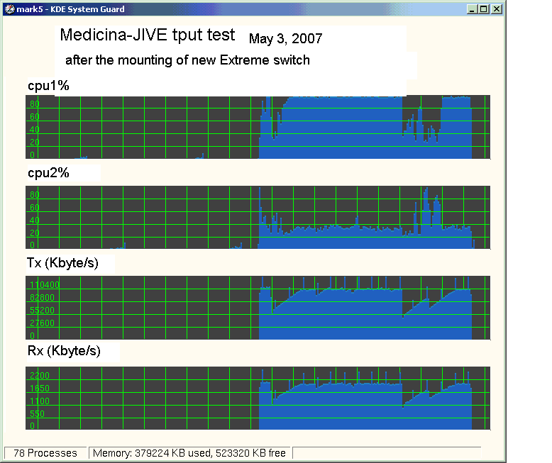
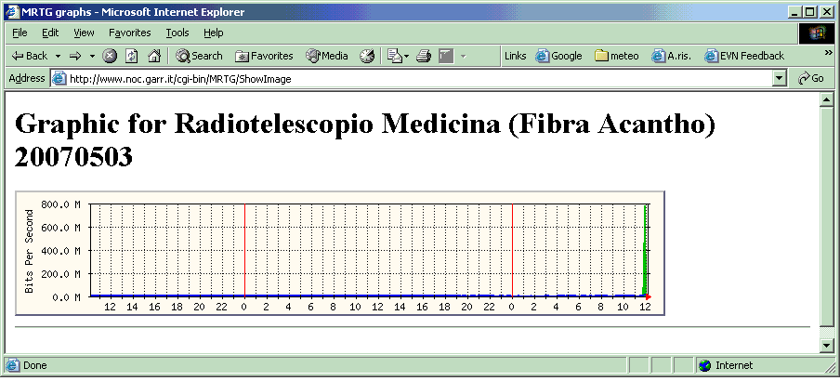

- Feasibility study of the last-mile connections to the nearest GEANT NREN node for participant CAS (Shanghai, Urumqi, Miyun, Yunnan)

All the network equipment of the Sheshan Station is ready, and a fiber from Sheshan Station to SHAO is rented so the data can be transmitted to CSTNET-Hong Kong-JIVE. Engineers of CAS, CSTNET and JIVE are testing the network from SHAO to JIVE.

The data transfer rate from Hong Kong to JIVE can now reach 340 Mbits/s, with packet loss of 0%. The next experiments will be done in early June 2007.

- Feasibility study of the last-mile connection to the nearest NREN node for participant VIRAC

The construction of the last mile dark optical fiber from Irbene to Ventspils International Radioastronomy Center (about 30km) is finished. Equipment to light the fiber to 1 Gbps is being purchased.

Participation of VIRAC in e-VLBI observations depends on other issues, such as radiotelescope calibration and receiver availability. Tests are in progress.

- Feasibility study of the last-mile connection to the nearest NREN node for participant HRAO

The situation with regards to e-VLBI in South Africa is a lot more positive than in previous reporting periods. Parliamentary funding has been set aside in the current financial year to setup a new research network communications infrastructure (SANReN) with e-VLBI as a stated goal. To this end, external funding has been provided towards the last mile connection at Hartbeesthoek, and the new fiber trench is already in sight of the main telescope control building, with completion of the project expected within six weeks.

The intention is to temporarily route via the current 190MBps connectivity of the current TENET research network in Cape Town, with a more permanent 1Gbps connection to follow. To this end, we hope to directly test the Cape Town connectivity to confirm the viability of the temporary routing. Although this bandwidth shows significant competing traffic, we have been assured that portions of this is mirror traffic that can be suspended during e-VLBI sessions. Most spectral line observing modes should be possible with a continuum capability hopefully up to 128 Mbps before year end.

Also HartRAO has ordered a Mark5B upgrade kit, including a new dual Xeon motherboard with additional memory which should be capable of handling higher date rate flows when that becomes possible.

- Feasibility study of the last-mile connection to the nearest NREN node for participant NAIC (Arecibo)

The local internet provider submitted a quote for the upgraded service, expected in March, only last month. Therefore there has been little progress, because (1) this important piece of the connection, viz the transition to gigabit ethernet at the Miami Exchange Point, managed by Florida International University (FIU), remained to be priced; and (2) we are still negotiating with our high-speed networking partners at the University of Puerto Rico for the sharing of the link.

A gigabit ethernet fiber interface has been acquired for the Arecibo Observatory router. An upgraded link for testing purposes is expected before the end of June 2007 (assuming negotiations with UPR can conclude in early June). Meanwhile a peering with NLR via the Atlantic Wave optical network has been opened by FIU, which has significantly shortened the path length between AO and JIVE.

- Feasibility study of the last-mile connection to the nearest NREN node for participant TIGO

There have been no substantial changes since last month's report.

Three different parts of the connection are to be considered:

- TIGO-UdeC/DTI, already connected at 1 Gbps.

- UdeC/DTI-REUNA, 155Mbps, limited by switch and rented service.

- REUNA-world/GEANT, 90Mbps, limited by rented service.

The University of Concepción (UdeC) is connected by the national academic network (REd Universitaria Nacional = REUNA). This connection offers 155Mbps capacity of which around 100Mbps are used during business hours (6:00-23:00). In the moment this line does allow for data transmissions above 50Mbps only at weekends or during a few morning hours. This problem is subject to change presumably during the second half of this year 2006 to allow for the proposal to EXPReS: 24 times 24h with 64Mbps for e-VLBI. Please note, that UdeC rents only a fraction of the total bandwidth of 155Mbps and that for the test purposes of EXPReS the limit will be adapted to the needs.
REUNA is connected with 90Mbps to GEANT. Currently about 25Mpbs are used; indicating that about 64Mbps will be available for EXPReS upon special request. If necessary the bandwidth can be increased.

- Feasibility study of the last-mile connection to AARNET for participant CSIRO

The LBA achieved the first e-VLBI observations in March 2007. The data were correlated at a small 30-node computer cluster running the Swinburn software correlator. Sustained rates for 256 Mbps were achieved between the ATNF antennas (Parkes, Mopra, ATCA) and 128 Mbps to Hobart (although this is restricted by 155 Mbps links from the mainland to Tasmania). First scientific results have been submitted and accepted for publication in MNRAS letters. Although these developments are not directly in the EXPReS plans, they will have a positive impact on our eVLBI readiness.

The full EXPReS test is planned for September-October. So far much progress has been made:

- software tests between ATNF and JIVE to establish compatibility of LBA data with JIVE. These are ongoing.

- the traffic to Europe from CSIRO has been switched by AARNet to use the S/X transport links which have 10 Gbps capabilities from Australia to US.

- there have been at least 3 technical planning meetings between CSIRO and AARNet to sort out the technical details. This is also progressing well.

- more extensive tests of the international links are planned for the period 18-25 June when access to the telescopes is easier during a scheduled LBA observing week. Test time has already been allocated.

- Equipment of the last-mile infrastructure for participant MRO

There have been no substantial changes since last month's report. The 14-m radiotelescope at Metsähovi is connected at 1 Gbps, and planning of tests for data transfer between MRO – JBO (U.K.) - OSO (Sweden) at 4 Gbps are underway.

