
Express Production Real-time e-VLBI Service
EXPReS is funded by the European Commission (DG-INFSO),
Sixth Framework Programme, Contract #026642

Workflow Manager Application – WFM

Title: | Workflow Manager Application – WFM
Date: | 2007 September 10
Version: | 0.5 DRAFT
Filename:
Author: | Name, Title, Institution
Co-Authors | Name, Title, Institution
Summary: | Description and status of the WFM application.

Document Log
Version | Date | Summary of Changes | Authors
0.5 | 2007 Sep 12 | Added cover sheet | D. Stoklosa
0.1 | 2007 Sep 10 | Initial draft | D. Stoklosa

Project Information
Project Acronym | EXPReS
Project Full Title | Express Production Real-Time e-VLBI Service
Proposal/Contract number | DG-INFSO #026642

Workflow Manager Application – WFM
The main interface between user and system has been constructed using Java technology. The graphical user interface has been designed with Swing library and great help of JGoodies libraries. We have deployed the prototype of the WFM with Java Web Start technology. Using Java Web Start technology, standalone Java software applications can be deployed with a single click over the network. Java Web Start ensures the most current version of the application will be deployed, as well as the correct version of the Java Runtime Environment will be used.

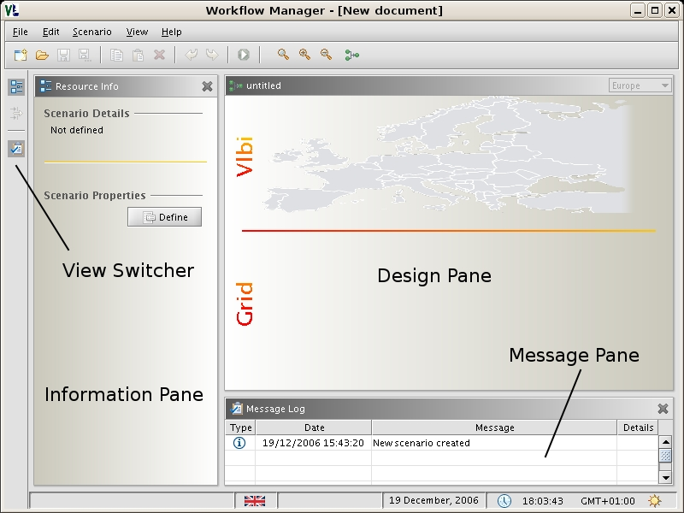
- WFM – main view

The current status of the WFM

GUI
The Graphical User Interface has been designed (see Figure 1). The Workflow Manager Application is divided into several working panes: Information Pane, Design Pane and Log Message Pane. Each view has its own place in the application window. Information Pane presents different information based on the application state. Design pane it is used mainly by the VLBI operator for the VLBI scenario design and management. The message pane is used as an information board between user and system. There are several types of messages: information, error and notification.

Resource types
The WFM allows designing and managing an experiment workflow. It is possible to add new resources: file servers, which are responsible for handling data streams from the radio telescopes and correlation nodes, which in fact conduct the correlation process. Several dialogs have been created to allow customization of the resource’s parameters.
Data flows
When all the resources are placed on the design pane it is possible to design data flows between components by connecting nodes together. The connections established by the operator are analyzed by the system during the execution phase.

Communication interfaces
We have designed and implemented several communication interfaces which allow system components to interact witch each other.

VLBI Broker
The first, initial release with the limited functionality of the VLBI Broker has been deployed.

