PUB-06-151v3

Report Describing Research Network Support for eVLBI Tracking of the SMART-1 Spacecraft

6th November 2006

Executive Summary
This report is written to describe the support given by the research network community to a user group with a challenging network application. This proved to be an important test case for the GÉANT2 Performance Enhancement Response Team (PERT) and for inter-working practices generally, between network domains.

Following a request from the VLBI centre, JIVE, DANTE instigated a series of measures to resolve data-transfer rate issues between TIGO (Chile) and JIVE (Netherlands). The effort was coordinated by DANTE and the GÉANT2 PERT and involved input from GÉANT2, RedCLARA, REUNA, SURFnet, TIGO and JIVE engineers. Despite very significant effort from all parties, the issue was not resolved by the date of the VLBI tracking of the SMART-1 spacecraft. This report outlines the direction of the investigation and the practical steps taken to diagnose and resolve performance issues.

Principal outcomes are that:
- The PERT procedures were proven to work well in addressing complex problems over multiple domains
- No faults were detected in the international backbones
- Respectable data transfer rates of 20-30 Mbps were shown to be possible end-to-end, but this was not reflected in the actual transfers
- Problems seem likely to be at the application level and in local packet loss
- The timescale available did not allow full investigation and testing of the application
- The PERT case has now been closed as significant improvements were made in the transfer rate and the upgrading of the REUNA network is imminent

Introduction
The European Space Agency’s SMART-1 moon-orbiting spacecraft was scheduled to descend to the moon’s surface around the 2nd/3rd September 2006. To track this descent, telescopes used radio signals to pinpoint the craft. Since Latin America was best positioned to view the event, a telescope in Chile (TIGO) sent data relating to the descent to JIVE in the Netherlands for analysis. It should be pointed out that this was not a real-time transfer of data and network transfer was intended purely to improve analysis time.

To facilitate this data transfer JIVE conducted tests on the network bandwidth available between the two radio observatories. Due to a less-than-optimum bandwidth being obtained, JIVE contacted DANTE to help facilitate performance improvements on the networks between the sites.

Despite considerable efforts (listed below) by TIGO, JIVE, DANTE, the GÉANT2 PERT, RedCLARA, REUNA and SURFnet, the necessary level of data throughput was not obtained by the radio astronomers. The reasons for this have been investigated by experienced network engineers and experts in both Latin America and Europe. Many possibilities have been eliminated, and it seems likely that no one precise cause will be identified. In the absence of an identifiable problem in the international backbones, it seemed likely that congestion of the REUNA network (now being upgraded) and/or application level issues may have been at the root of the problem. Since the period from the networks’ awareness of the requirement to the SMART-1 descent was too short for a full investigation, work continued until the end of October to attempt to identify and resolve the issue for future transfers and to improve the likelihood of success of similar transfers in the future. 32 Mbps is seen as the minimum requirement for the real-time eVLBI transfers anticipated between TIGO and JIVE in the EXPReS project and provided a useful target for the optimisation work. Before work was concluded, transfers in excess of 30 Mbps were achieved, suggested that when REUNA backbone capacity is doubled in the near future, eVLBI will be a practical proposition between TIGO and Europe.

Summary of Actions Taken
The work conducted to address the networking issues between TIGO and JIVE was necessarily a collaboration between many organisations, because several network domains were involved and because it was necessary to ensure that specialist engineering knowledge was applied to the problem. A total of 15 different organisations were involved in testing and the analysis of network data. A full list can be found in Annex 3.

An extensive series of network diagnostic tests were carried out between Europe and Latin America, which resulted in several important findings:
- The timescale was immediately realised to be insufficient to fully troubleshoot such a complex network path
- Initial tests confirm no packet loss in SURFnet, GÉANT2 or REDCLARA networks
- TIGO access to the REUNA backbone was rate-limited to 5Mbps. This was lifted to facilitate the transfers
- Traffic shaping applied and shown to improve transfer rates over REUNA
- A 90Mbps rate-limit on the REUNA-RedCLARA access circuit was raised to the 155Mbps maximum.
- The burst-limit on the access router was found to be set unusually low. This was reset to an appropriate level.
- 28Mbps was achieved between Europe and TIGO using iPerf testing
- Only 2Mbps was achieved on the real transfers of the SMART-1 data

The PERT trouble ticket was held open beyond the date of the SMART-1 descent to investigate the causes of the poor transfer rate and to facilitate future transfers TIGO-JIVE:
- Tests centred on application optimisation reveal that significant data throughput improvements could be made (to 15Mbps) from TIGO to JIVE if SACK (Selective Acknowledgement) was implemented on the JIVE PC.
- Similarly, improvements could be made if the TIGO kernel was updated.
- Minor local packet loss appears to be a consistent feature of transfers, the most likely cause being congestion, and it is expected that the imminent REUNA upgrade will significantly improve matters.
- More significant packet loss has also been noted sporadically and may not be improved by the upgrade. The cause of this is as yet unknown, but may be due to a router/firewall or frequent traffic rerouting.

A diagram of the network elements making up the path from TIGO to JIVE is given in Annex 1. The full chronology of work associated with the SMART-1 tracking is listed in Annex 2.

Conclusions
- As a test case for GÉANT2 procedures, SMART-1 has proved very useful and has demonstrated the soundness of PERT procedures and the value of an expert team to address performance issues.
- Addressing this case has also reinforced collaboration between radio astronomers and network engineers and has helped establish a virtual community of contacts.
- As the SMART-1 data was buffered, no scientific information was lost and the exercise has proven an important starting point to achieve a stated objective of the EXPReS project: to connect TIGO to Europe for real-time eVLBI sessions.
- Appointment of a dedicated case manager is an important step in coordinating test effort and results in complex multi-domain cases.
- Any long distance, multi-domain, high bandwidth data transfer will be challenging. Optimisation of all network elements is time consuming and application-level issues cannot be ruled out.
- No packet loss was found to occur on the RedCLARA, GÉANT2 or SURFnet backbones.
- The packet loss which did occur within the REUNA network is low and is likely to be solved by an imminent backbone upgrade
- Backbone rate-limiters (correctly limiting traffic to subscribed bandwidth levels) have had influence on achievable performance as have conservatively-set burst limits on routers.
- Data transfers using the Mk5 processors favoured for eVLBI work have consistently been significantly slower than proven optimum (memory-memory) transfer speeds. It seems likely that the issues behind this performance loss might have an even greater impact over the distances involved in an intercontinental transfer.
- Implementation of SACK at JIVE and updating the kernel of the Mk5 processor at TIGO has been shown to improve transfer rates to 12-18Mbps.
- The high latency associated with the RedCLARA-GÉANT2 interconnection circuit is an unhelpful reality in this case. Any high-bandwidth, high-latency network connection will suffer similar issues. Consideration should be given to the use of parallel data streams to reduce the bandwidth-delay product.
- Requirements to connect sites over long network paths must be investigated as a complete solution. Few engineers have knowledge of both network and application optimisation.

Recommendations for future cases

Specific recommendations for this case:
- The Universidad de Conception campus network should be investigated and rate-limiting policy reviewed.
- TIGO should consider increasing their access capacity (subscribed bandwidth) to REUNA. 5Mbps will not be sufficient for effective transfers in future.
- PERT engineers recommend adding a BWCTL server in REUNA to facilitate improved network diagnostics.
- Greater PERT access to REUNA statistics would be helpful for future cases
- JIVE and TIGO should implement SACK on their respective Mk5 processors
- TIGO should update the Kernel on the Mk5 processor
- Parallel data streams should be considered for very long distance eVLBI transfers
- EXPReS should inform GÉANT2/RedCLARA of intended transfers at the planning stage
- An investigation should be made of tools and technologies to improve long network path transfers. This could include Logistical Session Layer (LSL) servers to reduce the strain on the application and reduce the impact of minor packet loss.
- Continued optimisation of the transfers between TIGO and JIVE is recommended after the REUNA backbone upgrade. This will allow investigation of application-level issues with equipment at TIGO and JIVE.

General recommendations
- An accessible record of network configurations such as rate limits, burst limits etc and a more effective information exchange between NOCs would save effort
- Whilst access to international experts is essential to the PERT function, dedicated full-time PERT staff would add greater consistency to the handling of cases and ease the co-ordination process.
- The number of individuals within the PERT having experience of application trouble-shooting is limited. Increasing this capability would significantly improve the value of this function.
- Future replacements or upgrades to the Latin America – Europe circuit(s) should consider carefully the optimum relationship between bandwidth, latency and cost. Although a more direct circuit would be more expensive, a lower bandwidth might actually allow higher data transfer rates if the route was more direct.
Annex 1: Network Diagram of the Path TIGO-JIVE

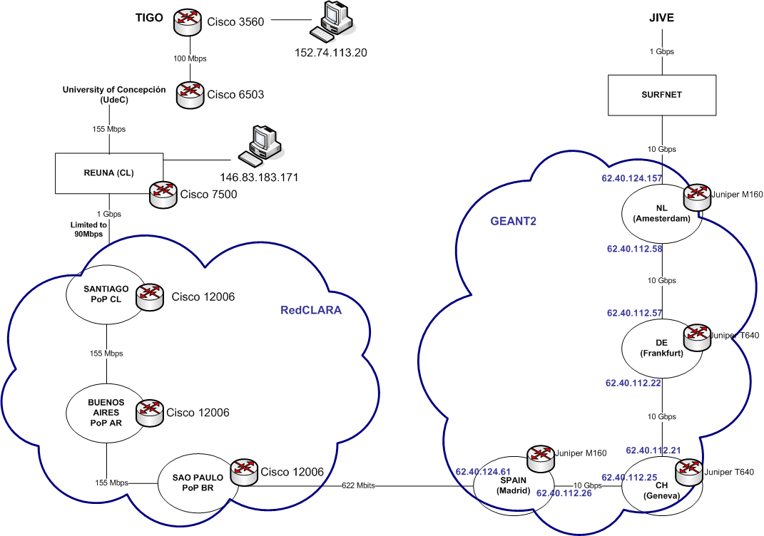

Annex 2: Chronology of Events

Work conducted prior to SMART-1 moon descent
- 07/08/06 JIVE contact DANTE to inform of requirement to connect non-European telescopes to JIVE. Telescopes mentioned: TIGO (Chile), Fortaleza (Brazil) and Shanghai (China). TIGO requires MK V connectivity. Requirement stated as 100Mbps from TIGO. 7 Mbps had by that stage been achieved. It is stated that a local bottleneck is the presumed cause.
- 08/08/06 GÉANT2 user support responded to JIVE and referred performance issues to the GÉANT2 PERT and REUNA’s operations team.
- 08/08/06 SURFnet conduct MTR test and identify packet loss only in REUNA and TIGO sections (i.e. no packet loss in SURFnet, GÉANT2, RedCLARA).
- 08/08/06 PERT case opened
- 10/08/06 Timescale of project revealed by JIVE. Target date =02/09/06. This allows 3 weeks to resolve issues TIGO-JIVE. GÉANT2 user support explain to JIVE that this is insufficient for resolving multi-domain, intercontinental network issues.
- 10/08/06 REUNA confirm that work has commenced on TIGO diagnostics
- 22/08/06 TIGO 5Mbps rate limitation identified and removed.
- 22/08/06 REUNA iPerf tests show: 20Mbps achieved TIGO-SWITCH (CH) [–at 70% utilisation level of the REUNA backbone], TIGO-REUNA = 49Mbps, REUNA-SWITCH = 31Mbps, RedCLARA-SWITCH = 90 Mbps
- 23/08/06 Rate limit of 90Mbps (on RedCLARA-REUNA access circuit) discussed.
- 25/08/06 (approx) PERT suggests Selective Acknowledgements are activated at TIGO, resulting in an increase in throughput.
- 27/08/06 Tests over REUNA backbone at a period of low utilisation achieve ‘close to iPerf limit’ using traffic shaping
- 28/08/06 Traffic shaping suggested as a solution to throughput issues
- 29/08/06 GÉANT2 user support arranges access to RedCLARA stats, to investigate supposed packet loss on the REUNA-RedCLARA access circuit identified by JIVE.
- 29/08/06 REUNA confirm only 30% utilisation for RedCLARA access circuit. iPerf test REUNA-RedCLARA = 80Mbps on a 90Mbps circuit.
- 30/08/06 RedCLARA rate limit stated to be lifted to 155Mbps for REUNA access. This was NOT actually the case.
- 30/08/06 Summary of tests so far and rate limit status etc sent out to all parties by GÉANT2 user support.
- 30/08/06 JIVE request MPLS path to TIGO. [It is too late to implement this and, in any case, is technically difficult in Latin America]
- 30/08/06 TIGO-JIVE tests show sawtooth behaviour indicative of packet loss.
- 30/08/06 PERT diagnostics reveal two issues: RedCLARA rate limit still in place and the burst limit level on the access router (REUNA-RedCLARA) is set unusually low, apparently accounting for a small amount of packet loss.
- 31/08/06 GÉANT2 PERT check Linux system at TIGO and tune TCP parameters. It is felt to be capable of supporting the transfers. SWITCH-TIGO iPerf only 4Mbps.
- 31/08/06 Rate limit lifted at RedCLARA-REUNA access to line rate (now 155Mbps). Burst size now set to 16MB. iPerf test SWITCH-REUNA between 60 Mbps achieved (average) peaks over 90Mbps. iPerf SWITCH-TIGO achieves 28 Mbps. Reverse tests Chile-Geneva show similar results.
- 01/09/06 Initial traffic shaping does not improve throughput to TIGO. Up to 27 Mbps achieved. Attempt to find a ‘sweet spot’ for shaping between 20-30 Mbps. No significant improvement in throughput.
- 03/09/06 Real data transfer of the SMART-1 descent at only 2Mbps throughput. It is unclear why this is so much lower than the 22Mpbs shown to be possible through iPerf testing. Previous transfers using the Mk5 processors at JIVE have shown less than optimum transfer rates compared with available network capacity.

Post-event
- 04/9/06 PERT ticket held open to facilitate future transfers from TIGO and to improve knowledge of network and application-level optimisation over significant network path lengths. Simon Leinen / SWITCH have taken responsibility for the case, having the most appropriate application-level experience of all the PERT managers.
- 12/09/06 Analysis of REUNA traffic does not indicate congestion over the links utilised for the transfer. 14 hours of Ping testing reveal 0% packet loss in REUNA
- 26/09/06 Tests and discussions continue to date. BWCTL tests arranged.
- 27/09/06 Testing from REUNA to Europe using UDP shows that 30Mbps can be maintained without packet loss. Higher data rates were not attempted to avoid impacting other network traffic.
- 29/09/06 Multiple acknowledgements are identified as a problem with TIGO data.
- 02/10/06 Enabling SACK at JIVE improves performance to 12-18Mbps.
- 02/10/06 Recognition that the kernel version running at TIGO should be updated and would improve TCP performance
- 03/09/06 New test from TIGO to JIVE (post-kernel upgrade) shows only 3Mbps performance. Suspicion is of local transitory congestion
- 09/10/06 Rate limit at REUNA/RedCLARA access circuit is found to be asymmetric –it is possible that TCP acknowledgements are rate-limited
- 10/10/06 Both UDP and TCP tests show packet loss to be high above 4 Mbps from TIGO.
- 10/10/06 Packet loss is found not to affect flows into TIGO. It is deduced that a rate limiter in or close to Universidad de Conception (host site of TIGO) is the cause
- 13/10/06 PERT make a general recommendation that groups conducting high-bandwidth TCP transfers, set the packet reordering parameter to >3
- 16/10/06 Tests indicate that 6Mbps is the maximum possible rate from the TIGO at low-traffic periods. A rate-limiter within U de C of around 7Mbps is diagnosed.
- 19/10/06 REUNA confirm that the rate limit lifted at U de C has again been applied. Rate limit lifted again for tests to continue
- 20/10/06 0.5-2% packet loss observed in both directions from TIGO-SWITCH. No packet loss observed from GÉANT2 PoP in NL to RedCLARA
- 23/10/06 Bidirectional UDP tests SWITCH-TIGO found to be lossless. TCP shows 25Mbps disk-to-disk. Delays due to traffic bursts, congestion, firewalls or rate limiters suspected cause of unusual TCP behaviour
- 23/10/06 90 Mbps lossless UDP tests carried out successfully from SWITCH-RedCLARA. Appoximately 3Mbytes per second (24Mbps) reliably achieved to TIGO.
- 23/10/06 Smaller window size used to reduce bursts. Resulting behaviour more stable.
- 24/10/06 BWCTL server installed at TIGO. PERT recommends similar server in REUNA.
- 26/10/06 New tests show only a proportional increase in loss for high data rates-indicating a congestion rather than rate limitation issue.
- 30/10/06 BWCTL tests conducted between TIGO and the GÉANT2 NL PoP. Unstable, but up to 50Mbps achieved.
- 30/10/06 Disk-to-disk TIGO-SWITCH achieves 20-30Mbps sustained. UDP tests show occasional significant packet loss.
- 01/11/06 REUNA need to commit resources to a network upgrade (to 310 Mbps), which it is hoped will positively impact TIGO-JIVE transfers. PERT case closed pending these changes.

Annex 3: List of the participating organisations
JIVE (NL)
TIGO (CL)
DANTE (EU)
CLARA (LA)
REUNA (CL)
SURFnet (NL)
SWITCH (CH)
FUNET CSC (FI)
PSNC (PL)
BME (HU)
FCCN (PT)
OETIKER (CH)
NOAA (US)
CUNI (CZ)
CISCO (US)

