
Express Production Real-time e-VLBI Service
EXPReS is funded by the European Commission (DG-INFSO),
Sixth Framework Programme, Contract #026642

Software for workflow management

Title: | Software for workflow management
Sub-title:
Date: | I.2009
Version: | 1.0
Filename:
Author: | D. Stokłosa

Project Information
Project Acronym | EXPReS
Project Full Title | Express Production Real-Time e-VLBI Service
Proposal/Contract number | DG-INFSO #026642

Software modules description – distributed correlation
PSNC has been involved in the FABRIC activity, which main objective is to develop a prototype for high data rate e-VLBI using a distributed correlation. In the distributed approach, single central data processor at JIVE has been replaced with a software-based distributed correlation embedded in Grid Computing environment. The Grid approach to e-VLBI required a creation of some form of a user interface as a typical approach based on creating a text-based single control file for the experiment was not sufficient. In this case, a user should specify a set of Grid-specific parameters and define required resource types together with their specific connections creating an e-VLBI workflow. An interface to network monitoring modules should also allow to modify all required parameters and convert experiment parameters into software-correlator compatible data automatically. The Grid – e-VLBI architecture is presented in the figure below followed by a short description of each module.

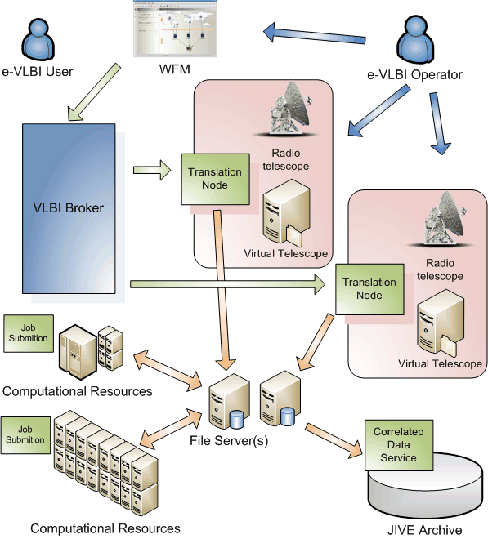
- WFM – main view

The provided software modules are divided into two groups: external helper libraries, which have been created by PSNC to be used by other modules in order to increase code reuse and finally modules itself.

EXPReS remote library
File: 02-01.2009-FABRIC-PSNC-expresRemote.zip
EXPReS remote library contains a set of utility classes which are used by all e-VLBI modules. Among other things it contains communication interfaces and implementation classes for internal data exchange between modules. Moreover it also contains an e-VLBI model classes, which are used to store an VLBI experiment and other resources which are required for proper management during execution.

Graph common library
File:04-01.2009-FABRIC-PSNC-graphCommon.zip
Graph common library is used by Workflow Management Module. The library contains a set of classes responsible for creating a graphical representation of a VLBI experiment as a graph. It allows adding and removing new resources, as well as defining a connection between them.

VLab common library
File: 05-01.2009-FABRIC-PSNC-vlabCommon.zip
Set of general purpose utility classes which are used by different modules. The library contains classes for session management, dates and time conversions, threads management, internationalization helper classes, set of helper classes for swing components an many others.

Correlation Node module
File: 01-01.2009-FABRIC-PSNC-correlationNode.zip
CorrelationNode module is a web application module working under control of Tomcat and Axis-2. It's duty is to start and monitor each correlation job on the computing cluster. This module communicates with VLBI Broker via Web Service interface and it's located on site (cluster). It keeps an eye on data transfers, data locations, jobs execution etc. It is possible to set up a new experiment and to run new computing task when proper service is invoked. Currently it is not possible to monitor the status of the task.

Network Monitor module
File: 03-01.2009-FABRIC-PSNC-ExpressNetworkMonitor.zip
The Network Monitor module is responsible for ordering best suit pairs from the list of transition nodes and storage elements. The ordering is based on network measurement (RTT, bandwidth utilization). The module has the following functionality: possibility to request network measurement related to the list of end points. Application provides pairs with the best measured parameters.

VLBI Broker module
File: 06-01.2009-FABRIC-PSNC-vlbiBroker.zip
VLBI Broker is the central element of eVLBI system providing the centralized control of the entire experiment. The Broker module processes experiment definition submitted from the WFM application and forwards tasks’ description to telescope sites (Translation Nodes). This module is also responsible for coordination and submission of computational tasks with distributed correlation. Currently only one threaded version of VLBI Broker is available.

Workflow Manager module
File: 07-01.2009-FABRIC-PSNC-workflow_manager.zip
The main interface between user and system has been constructed using Java technology. The graphical user interface has been designed with Swing library and great help of JGoodies libraries. The Workflow Manager Application is divided into several working panes: Information Pane, Design Pane and Log Message Pane. Each view has its own place in the application window. Information Pane presents different information based on the application state. Design pane it is used mainly by the VLBI operator for the VLBI scenario design and management. The message pane is used as an information board between user and system. Currently the Workflow Management Module has been implemented with the following functionality: possibility to load a vex file, possibility of converting a vex file to CCF file, CCF editor, possibility to create an observation workflow, possibility to submit a workflow for execution

