
Express Production Real-time e-VLBI Service
EXPReS is funded by the European Commission (DG-INFSO),
Sixth Framework Programme, Contract #026642

What is the FABRIC of the future?
- Fabric Overall Design Implications

Date: | 2008 Feb 20
Version: | 0.9 DRAFT
Filename:
Author: | Huib Jan van Langevelde
Co-Authors | T. Charles Yun
Summary: | FABRIC Overall Design Document

Document Log
Version | Date | Summary of Changes | Authors
1.0 | 2008 Feb 20 | Added diagram | TCY
0.9 | 2008 Feb 20 | Rework text | TCY
0.5 | 2008 Jan 14 | Internal review | HJvL
0.1 | ? | Initial draft | HJvL

Project Information
Project Acronym | EXPReS
Project Full Title | Express Production Real-Time e-VLBI Service
Proposal/Contract number | DG-INFSO #026642

Objective
In this document we discuss the implications of the design decisions made in the various FABRIC work-packages. After evaluating what we have learned from the work in FABRIC so far, we re-calibrate the total impact of the FABRIC activity on designing the e-VLBI system of the future. In this exercise we take into account the developments in the field achieved elsewhere, and we identify ideas for R+D activities, some of which may be done within the scope of FABRIC, some are clearly aimed at future projects.
Introduction
FABRIC (Future Arrays of Broad-band Radio-telescopes on Internet Computing) basically has two major components. The first is to develop the data acquisition and transport mechanisms to make effective use of the increasing bandwidth available on the network. The second is to develop the concept of distributed correlation. Besides these two major goals, there are various other deliverables on the study of protocols and the interface between public and private network transport. There are 7 partners in FABRIC: JIVE, PSNC, ASTRON, MPIfR, TKK, OSO, UNIMAN.
These activities are set-up to arrive at very specific prototype demonstrations. Below we first describe these original goals and the specific design choices that have been made to reach these. We continue with a discussion on whether these prototypes have direct use for scientific operations and how they fit in with the options the EVN has for future implementation.
Demonstrating high bandwidth e-VLBI
Choices made
The goal of this activity was to demonstrate that VLBI can make use of bandwidth beyond 1 Gbps, specifically to demonstrate VLBI at a data rate of 4 Gbps, possibly over the newly available 10 Gbps fiber optic network connections. This requires a few components to come together simultaneously: increased connectivity, a new data acquisition system and the matching correlator capacity. For this demo the Onsala telescope was targeted. After discussion of the various options, it was decided that correlation at the new e-MERLIN correlator was the most attractive solution for showing actual results. Not only does that path have synergy with work in SA1 to route MERLIN data out to the EVN, but it also has some interesting possibilities for science applications.
Considerable progress has been made with the increased connection to Onsala with NORDUNET. It seems that the Onsala telescope will have a high-speed connection, and not only to MERLIN, but also to the Dutch POP in Amsterdam and to Finland and the Metsahovi station. This allows various options for future testing. Some of the work has been carried out in synergy with the requirements for the Onsala LOFAR station. If we have learned one thing, it is that the NRENs find it hard to distinguish between different radio-astronomy projects; common solutions must be found for these specific situations.
Following the work on the e-MERLIN interface in SA1, the choice has been made to implement the path into e-MERLIN on iBOBs. There exist considerable differences between observing with the e-MERLIN correlator and normal VLBI practices. First, the observing bandwidth for e-MERLIN is not divided up at the telescope into a number of sub-bands, as is the normal practice in VLBI for mostly historic reasons. But in e-MERLIN most of the division into sub-bands is done in the correlator system, which allows flexible assignment of a number of bands, with independent bandwidth, over the full incoming band. The clocks are distributed to the telescopes from a central source and the telescope based phase and delay corrections are inserted in the data by station boards in front of the correlator.
The same iBOBs will be used at the Onsala antenna for data acquisition. This includes outfitting them with high speed samplers and conditioning the signal for UDP based transport. Pragmatic solutions have been made to reach the FABRIC goals, and therefore the implementation at the telescope is aiming at digitizing a large piece of bandwidth (500 MHz) without channelization. This is a mode incompatible with the normal Mk5 (A,B or C) modes, although a similar data identification scheme is proposed as the Mk5C standard. The result is compatible to the 16 Gbps e-MERLIN mode, which has the same bandwidth, albeit sampled with 8 bits. The telescope-based corrections are done at the interface of the correlator, while the whole correlation will also rely on the stability of the Onsala maser clock.
Expectation for the end of the project
Besides all of the iBOB work, which is under pressure because of the slow delivery of the FPGAs, the delivery of the e-MERLIN correlator system is also on the critical path for this activity. This has been the motivation for implementing the simplest possible system. Demonstrating fringes between Onsala and one or more e-MERLIN telescopes at a data rate of 4 Gbps is expected that by the end of EXPReS. This will show that the EVN can make use of the enhanced network capacity and will demonstrate the usefulness of the iBOB for implementing a versatile data acquisition system. Most of all it will execute VLBI in a mode that is different than currently implemented.
Applicability for science observations
The system in which the Onsala telescope delivers 2 x 512 MHz bandwidth at 2 bit samples to the e-MERLIN system may have some direct science application, as it adds longer baselines to the MERLIN telescope with compatible sensitivity. Before it is an operational system it will require additional work, in order to control the phase stability, integrate the telescope into MERLIN operations, and allow flexibility in frequency and bandwidth settings.
The prototype system will also be distinguishably different from a typical VLBI system. In particular, it may not have the typical break-up in discrete sub-bands that is used in the Mk4 data acquisition. However, current work on the iBOB platform at Metsahovi may show that this functionality can be easily adopted in the iBOB based system, similar to the Haystack DBE system. The correlation of the e-MERLIN system is also different from common VLBI practice as the mode is largely defined in the correlator. In this way it is more like a connected interferometer system.
Other developments
In parallel with the effort we describe here, the VLBI group in Haystack has initiated its Mk5C development. This system is based on a digitization scheme, which produces data in sub-bands and records raw data-streams directly on PC Disk or conditions them for 10 Gbps data networks. Also worth mentioning is the ongoing effort in EXPReS SA1 to have a few telescopes connected on higher bandwidth connection standards (10Gbps), although these can only be used for 1 Gbps data streams, or multiples if there is parallel equipment at the telescope sites.
Further work
Clearly, the objectives of work-package 1 in FABRIC can be met, namely demonstrating the options for making use of larger bandwidth connectivity. Without question, e-VLBI principles and direct connectivity will be the foundation for next generation systems. However, it is unclear if data should be divided in small sub-bands and transported as multiple parallel streams to the correlator or moved in a single large stream. The origin for this is obviously historic and based on the limited capacity to record bits sequentially on spinning tape. It may still have its use in geodesy where the bandwidth span is important. The optimal decision depends obviously also on the options available for the correlator system.
Demonstrating distributed correlation
Choices made
For demonstrating of the concept of distributed correlation a start was made to port the home-grown JIVE software correlator to a grid environment. The algorithm employed has the potential of doing ultra-high resolution spectroscopy, as it was originally developed for spacecraft monitoring with VLBI. The deployment on grid computing follows the concepts of the virtual lab, in which a central operator can decide how to connect the resources in an e-VLBI network.
In designing the software correlator, a number of conceptual difficulties have been encountered related to VLBI experiment workflow.
- the current implementation of VLBI is actually hard to map onto the process of distributed correlation. A process in which astronomers schedule experiments and participation on a best effort basis
- the nature of the current data-sources pose considerable problems due to the Mk5 units’ specific constraints on playing back the data
A relatively more straightforward problem has been the decision on the topology of the network. It was realized that dividing up the problem in small time slices and distributing time slices of data from all antennas to one point is the optimal topology for scaling and minimizing transport and calculations. This topology may be complemented by antenna based processing to condition the signal before correlation.

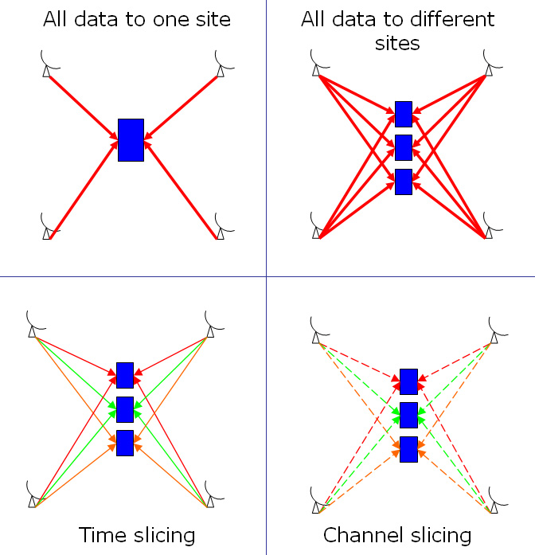
Figure: Options for transferring data from telescopes to correlators
Expectation for the end of the project
The goal of work-package 2 is to demonstrate distributed correlation, implying that more than 2 data sources (telescopes) will deliver data to more than 2 compute nodes. This will be possible for data created with Mk5 data systems and will be run in a grid environment.
The software correlator itself (called SFXC for Super-FX Correlator) will be able to run on computer clusters and deliver output that is ready for astronomical processing. SFXC is highly parallel and MPI enabled, taking advantage of multiple compute nodes in clusters.
Besides the FABRIC effort, there is also a Dutch funded SCARIe project in which the same algorithm may be tested on a network topology that can be changed on demand. This research project is more focused on optimal data routing than real-time analysis. Working with bandwidth-on-demand mechanisms, may be important for the distributed correlation application.
Applicability for science observations
The SFXC code is operationally used at JIVE for the ftp tests, in which the telescope data is verified in real-time before normal (recorded) sessions are about to start. By the end of the FABRIC project the software correlator may be optimized to run efficiently on large clusters. However, to become a competitive scientific instrument it needs to invoke at least a few thousand CPU’s, implying the need for part-time, but guaranteed resources at a few computer centres.
While FABRIC presents an application that requires the grid, it seems that the grid infrastructure required to run time-critical applications are still largely missing. The FABRIC distributed correlator requires a mechanism to allocate compute resources in real-time and to reserve the bandwidth for the data paths. At the moment there is limited progress in the Grid to introduce such real-time reservations.
There is considerable pressure to deploy software correlators in the next year or two. The existing correlators will fall short when data-rates go over 1 Gbps and miss some of the flexibility to deal with real-time observations, for example, providing mixed bandwidth data which was historically supplied by multiple pass correlation). Moreover, there is a demand for special processing that can be much easier and more precisely implemented in software, such as pulsar gating and spacecraft detection. For a number of these applications the demands on processing power are modest, such as monitoring spectral line sources with a limited number of antennas.
Other developments
The DifX correlator project is another software correlator effort that started earlier and has produced astronomical results already. Compared to it the FABRIC effort adds functionality for distributed processing and ultra-high (spacecraft) modes. There is an ongoing debate, whether such software based correlators are the cost effective solution for the future. Software correlators offer a lot of flexibility and scalability. In that respect only very large correlator problems may be implemented more economically on dedicated hardware. But additional considerations come from the much higher operation costs in power-supply and cooling. FPGA based correlator may win in that respect and may become more and more attractive as development tools improve in ease-of-use.
Further work
There will still be work to do on the SFXC code at the end of the FABRIC project. At the moment several features are not planned, for instance multiple bit data and pulsar gating.
Beyond FABRIC there remains work on the fundamental problem of allocating resources in real-time on the Grid. It may require more work when an operational code is available, but it seems unclear at the moment that the computing power for large scale VLBI applications will be available on request from Grid centres. Even running batch applications at super computer sites will usually require some proposal review process. And we see few developments towards real-time support. It seems more unlikely that there will be free rides for computing, now that power consumption issues have gained much more attention in the computing world.
This does not mean that distributed correlation is a useless concept at all. It may be attractive for the VLBI network of the future to implement distributed correlation as a way to share the computational load between the VLBI partners. It may be feasible to have not only the telescope based signal conditioning, but also a share of the correlation at the telescope sites.
However this will be done, it is clear that for future processing, much tighter network operations must be implemented. This is needed for setting up the large scale networks in real time, but also for being much more flexible in organizing science experiments. If we have created a real-time network for VLBI, it must also be controlled in real-time. This implies more central control for some of the telescope parameters.
Conclusions
The FABRIC work-packages are still on course to deliver the prototypes that were envisaged in the proposal writing stage, although some of them are affected by (mostly) external delays. Both programs are exercising new methods that invoke a discussion how the VLBI of the future should be done.
The have in common that the signal conditioning for transport and correlation must be much more closely integrated in the correlator set-up. This is a logical consequence of doing real-time VLBI. It will be a challenge to realize this and at the same time realize a world-wide compatibility which is necessary to incorporate more and more global telescopes in the VLBI pool.
The FABRIC project has surfaced a number of these fundamental questions, and as such is already a success.

