-

Express Production Real-time e-VLBI Service
EXPReS is funded by the European Commission (DG-INFSO),
Sixth Framework Programme, Contract #026642

e-VLBI tests using Jodrell Bank e-MERLIN telescopes

SA1 Deliverables D45, D52 and D85

Title: | e-VLBI tests using Jodrell Bank e-MERLIN telescopes
Sub-title: | SA1 Deliverables D45, D52 and D85
Date: | 2009 08 25
Version: | 1.0
Filename:
Author: | Anthony Rushton, The University of Manchester (UniMan)
Co-Authors | Paul Burgess (UniMan), Alastair Gunn (UniMan), Ralph Spencer (UniMan),, Jonathan Hargreaves (UniMan), Richard Hughes-Jones (Uniman and DANTE)
Summary: | This report outlines the service activities needed for connection of e-MERLIN telescopes to the internet and then to JIVE for e-VLBI, using both the existing analogue MERLIN systems and the high bandwidth digital system still under development.
Delivery Slip
 | Name | Partner | Date | Signature
From
Approved by

Document Log
Version | Date | Summary of Changes | Authors
0.1 |  | Initial draft | Anthony Rushton
0.2 |  | Comments from RES/PB
1.0 |  | Submitted document

Project Information
Project Acronym | EXPReS
Project Full Title | Express Production Real-Time e-VLBI Service
Proposal/Contract number | DG-INFSO #026642

Table of Contents
Executive summary 2
1. Introduction 4
1.1. The European VLBI Network 4
1.2. The Network 4
2. Tests using Jodrell Bank e-MERLIN telescopes 5
2.1. Initial JBO e-VLBI 5
2.2. Trans-Atlantic data flows 5
2.3. Hardware limitations of the e-VLBI DTS 6
2.4. e-MERLIN experiments using UKLight 6
2.5. Achieving up to 1 Gbps data rates from multiple telescopes 6
3. Current status and tests using the e-MERLIN correlator 7
4. References 8

Executive summary

This report details the progress of e-VLBI tests at Jodrell Bank Observatory (JBO). The upgrade of the existing JBO VLBI capabilities has led to the successful completion of the EXPReS deliverables SA1: D45, D52 and D85. This requires multiple e-MERLIN telescopes to be connected to the European VLBI Network (EVN) and tested. Three deliverables, D45, D52 and D85, required tests using the local home e-MERLIN telescope, a remote e-MERLIN telescope and multiple e-MERLIN telescopes respectively. As the deliverables are critically interconnected this report will describe all three deliverables.

Since January 2005 dedicated high-speed networks have been installed between JBO and other institutes. Two 1 Gbps links have been used to transfer e-VLBI data from JBO to JIVE. A further 1 Gbps link has also been installed between JBO and Chicago, allowing trans-Atlantic e-VLBI. The Mark 5 data-transmission systems (DTS), based at JBO, has also been upgraded to enable the transmission of up to 1 Gbps (previous systems were limited to a maximum of ~500 Mbps).

The home e-MERLIN telescope (Mark II) has been successfully tested at up to 1 Gbps, whilst using using multiple remote telescopes (i.e. with Cambridge 32 metre and Darnhall 25 metre). However, each remote station was limited to a maximum bandwidth of 128 Mbps due to restrictions imposed by analogue links to the telescopes. This restriction was due to an external delay in the delivery of the e-MERLIN correlator. This has prevented full testing of the new fibre links to be used by remote e-MERLIN telescopes. Despite this delay the first science results have successfully been made with the existing e-MERLIN system. JBO now regularly participates (~ every six weeks) in e-VLBI science experiments with up to 1 Gbps from multiple e-MERLIN telescopes.

Introduction
The aims of the EXPReS project are to demonstrate the connection of the e-MERLIN home station telescope and remote e-MERLIN stations to the Joint Institute for VLBI in Europe (JIVE) for European VLBI Network (EVN) operations. High-bandwidth internet connections and dark fibres between Jodrell Bank Observatory (JBO) and the JIVE have been used to transfer telescope data via e-VLBI. This document details the progress made through the EXPReS project that has successful enable data rates of up to 1 Gbps from multiple e-MERLIN telescopes. This has resulted in regular e-VLBI sessions and numerous successful science experiments.

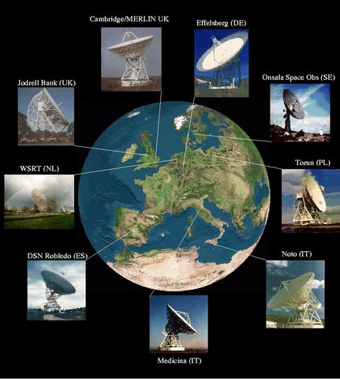
The European VLBI Network
The European VLBI Network (EVN) (figure 1) is an array of telescopes throughout Europe and the wider world. It is one of the most sensitive long baseline arrays, due to the extremely large telescopes that contribute to observations. The EVN was originally formed in the 1980’s by five major European radio institutes, MPIfR, IRA, ASTRON, OSO and Jodrell Bank Observatory, but since then has rapidly grown to include many other institutes. In 1993 the Joint Institutes for VLBI in Europe (JIVE) was formed to provide support for users and array operations.
Figure 1 The EVN Network
The formation of the e-EVN began in 2004 by linking the major European telescopes together using international fibre optics, through a technique known as e-VLBI. This allows for possible ‘real-time’ VLBI, that can rapid produce high resolution images of transient source.

The Network

The transfer of radio data over academic networks has been possible since the 1990s, when a transfer rate of ∼few Mbps was achievable. A short observation of a bright calibrator source was transferred from the antennas to the correlator, via FTP, to verify an array was working correctly.

It was not until April 2004 that bandwidths became large enough to develop ‘real-time’ VLBI. The first e-VLBI observations within the (e-)EVN were made using three antennas at a sustained data rate of 32 Mbps, comprising telescopes located in Sweden (Onsala), UK (JBO, Mark II) and the Netherlands (Westerbork Synthesis Radio Telescope). Data were transfered using the standard TCP/IP protocol over the academic production networks; however, these ‘routed’ network links proved unreliable as they heavily depended on the network traffic generated by other users (Spencer et al. 2007). To overcome this problem, the ESLEA (Exploitation of Switched Lightpaths for e-Science Applications) project demonstrated that circuit-switched optical networks (known as lightpaths) could be used to provide point-to-point fixed bandwidth links between institutes as shown in figure 2.
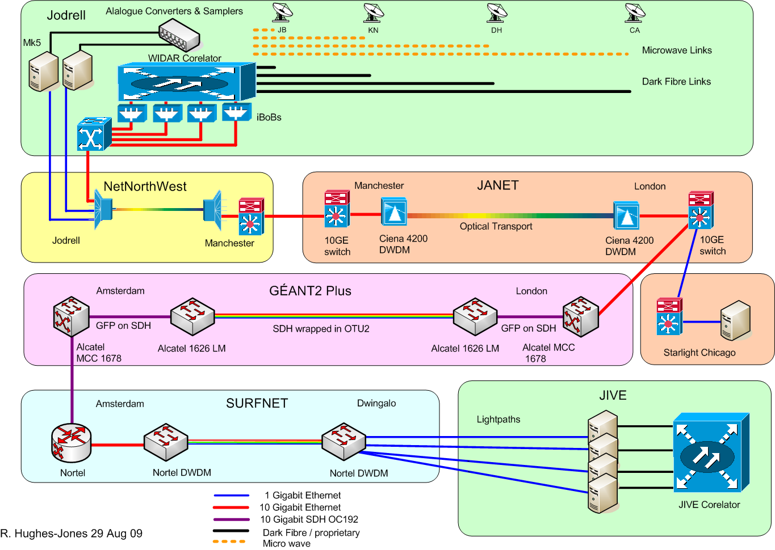
Figure 2 The Data Network

The EXPReS project aimed to link telescopes across the globe to the correlator located in JIVE and test the feasibility of sustaining high bandwidths over larger distances. The aim of the work reported here was to connect multiple e-MERLIN stations by up to 1 Gbps between JBO and JIVE. An increase in the data transport rate would allow observations of a larger bandwidth (ν) and thus increase the sensitivity of the telescope by √ν.

Tests using Jodrell Bank e-MERLIN telescopes

Date | Achievement
December 2004 | Two e-MERLIN stations at up to 500MHz of observable bandwidth at 5GHz
June 2005 | First UKLight path installed between Manchester and SURFnet
October 2005 | IGRID05 successfully demonstrate the use of 'lightpaths' for e-VLBI; UKLight provided a 1 Gbps link between Manchester and Chicago
January 2006 | Upgrade of the Mark 5A allowed data rates of > 512 Mbps
March 2006 | Tests showed first e-VLBI fringes of e-MERLIN telescope at 512 Mbps
March 2006 | Second UKLight path installed between Manchester and SURFnet
April 2006 | First e-VLBI science experiment at 128 Mbps from two e-MERLIN telescopes
March 2007 | First JBO e-VLBI tests at 22 GHz with a data rate of 256 Mbps
September 2007 | Casey (2008) demonstrated 1 Gbps data rates using 'packet-dropping'
July 2008 | First successful multi-outstation e-MERLIN out stations using both Cambridge and Darnhall telescopes
April 2009 | Delivery of e-MERLIN station and baseline boards
April 2009 | First e-MERLIN fringes
May 2009 | Test data sent from Onsala to the e-MERLIN correlator
May 2009 | Network 'bonding' allows first 1024 Gbps tests with e-MERLIN home station (i.e. > 1 Gbps !)
Table 1: A table showing the time-line of achievements

Initial JBO e-VLBI

Tests in the 1990s over academic production networks showed that transmission rates of a few Mbps were possible, where short sections of data from telescopes were transferred by FTP in order to check operations. The initial tests were at relatively low data rates, up-to 32 Mbps, using the production academic network packet switched connections from telescopes to JIVE, but nevertheless interesting results were obtained.

In December 2004 JBO participated in a series of EVN network tests. These were co-ordinated by Arpad Szomoru at JIVE and involved Torun, Onsala and Westerbork stations as well as JBO. JBO used the Mark II telescope to provide up to 500 MHz observable bandwidth at 5GHz of the fringe-finder source 3C145. Initial tests successful transmitted data at 128 and 256 Mbps allowing the first real-time fringes between JBO and JIVE. Further tests at a high bitrate of 512 Mbps showed intermittent data transmission, but no fringes were possible. However, development of a real-time VLBI system: e-VLBI, later became a possibility, as techniques improved making wide use of the internet. Table 1 shows a summary of achievements in e-VLBI at JBO.

Trans-Atlantic data flows

During conferences at iGRID 2005 and Super Computing 2005, JBO had the first opportunity to test the performance of dedicated lightpaths over long links. Telescopes in the USA regularly join in with the EVN in global VLBI experiments, where the extra resolution given by trans-Atlantic baselines is needed. e-VLBI tests were therefore organised where data from European telescopes (Onsala and Westerbork) were sent across GÉANT to London, UKLight lightpaths to Chicago and then via the HOPI and DRAGON networks to Haystack Observatory in Massachusetts. Data from JBO, Onsala and Westerbork were successfully transferred at line rates and an e-VLBI experiment was successfully conducted between Onsala and a telescope at Haystack at a rate of 512 Mbps from each telescope.

The link to Haystack was dismantled after Super Computing 2005; however, a 1 Gbps lightpath from Manchester to Chicago was established over UKLight early in 2007. Tests between server class machines at JBO and at the Chicago Starlight PoP using UDPmon and Iperf showed intermittent packet loss. Further tests after maintenance work on the links by Janet showed outstanding performance, with only 4 packets lost in 20 Billion transmitted continuously over 2.5 days at 940 Mbps. This test demonstrated the need for connectivity testing before applications are run.

Hardware limitations of the e-VLBI DTS

In 2005 the e-EVN used the Mark 5A data transmission system (DTS) to transfer data from the e-VLBI stations to JIVE. It was found that the Mark 5A's hardware was limiting the data transmission rate to ~500 Mbps. e-VLBI data transfers of 500 Mbps could be achieved on both the production link and the 1 Gbps dedicated UKLight link provided by the ESLEA project, but this point proved to be a bottleneck with the existing hardware. This bottleneck was thought to be caused by the JBO Mark 5A system and Strong et al. (2007) investigated its performance.

The JBO Mark 5A was upgraded in January 2006 with an Asus NCCH-DL motherboard, Intel Xeon 2.8 GHz processor and 1 GB of server specification SDRAM. e-VLBI tests between JBO and JIVE were repeated and obtained a reliable 512 Mbps data transmission to JIVE.

e-MERLIN experiments using UKLight

In June 2005 a fixed bandwidth point-to-point connection was made between JBO and JIVE as part of the ESLEA (Exploitation of Switched Lightpaths for E-science Applications) project. Janet (the UK's NREN), allocated a 1 Gbps connection between Manchester and SURFnet over 'UKLight'. This provided a guaranteed connection rate of 1 Gbps from JBO to JIVE. Initial e-VLBI tests allowed a 512 Mbps connection between both the home e-MERLIN station (Mark II) and a remote e-MERLIN station (Cambridge).

JBO e-VLBI links were now mature enough to conduct the first e-VLBI science experiment. Observations of an X-ray binary were made by Rushton et al. (2007b) and Tudose et al. (2007) with both the local e-MERLIN home stations (Mark II) and an e-MERLIN remote station (Cambridge). A data rate of 128 Mbps were sustained.

Achieving up to 1 Gbps data rates from multiple telescopes

Whilst data rates of 512 Mbps were quickly achieved from the home e-MERLIN station, 1 Gbps was a much more challenging goal. The fundamental problem was that data rates scale by 2^{n} due to correlator restraints. Therefore, 1024 Mbps of antenna bandwidth, plus overheads, need to fit into a 1 Gbps link. Two methods have been adopted to overcome this problem:

Packet dropping – Experiments by Casey et al. (2007) showed that it was possible to drop ~5% of the packets without the correlator failing. However, this method has the disadvantage of losing random parts of the bandwidth, hence reducing sensitivity.

Network bonding – It was possible to link the two 1 Gbps network to form an apparent 2 Gbps network allowing the full 1024 Mbps plus 128 Mbps from three outstations to be transmitted simultaneously. This required a further motherboard upgrade to provide dual network interfaces.

Current status and tests using the e-MERLIN correlator

Once e-MERLIN operations have been fully commissioned, it will be possible transfer data from remote e-MERLIN telescopes using a digital fibre network. Current e-VLBI tests use the existing analogue link, but this has the disadvantage of limiting remote telescopes to a maximum bandwidth of 128 Mbps per telescope.

Due to the late delivery of the e-MERLIN correlator by the Dominion Radio Astrophysicsal Observatory (DRAO) it has not been possible to fully test e-VLBI over the new digital links; however, as of April 2009 part of the e-MERLIN prototype correlator has been delivered and assembled at JBO. Four stations boards and one baseline board are currently being tested and new digital samples have been installed on two e-MERLIN telescopes. On 24th April 2009 the first e-MERLIN fringe was found between the Mark II and Pickmere telescopes.

During the commissioning of the prototype correlator, some e-VLBI tests were performed, despite the limitations of the early hardware. The internet break out board (iBOB) has been developed to interface between the correlator station boards and the high-bandwidth e-VLBI network (See D27 'VSI interface design' for a summary). Tests have successfully transferred data from the Onsala Space Observatory (OSO) in Sweden into the e-MERLIN correlator. These tests have demonstrated the capability of lightpaths to transfer up-to 4 Gbps between the e-MERLIN correlator and e-VLBI telescopes outside of the UK.

e-MERLIN stations are currently connected to the JIVE correlator via the dark fibre network and high-bandwidth network links. A dark fibre connects between JBO and Manchester, where connections to JANET are made with a point of presence (POS). JANET provides two 1 Gbps 'lightpaths' between and the Netherlands. The connection then links into the Dutch National Research and Education Network (NREN) known as SURFnet; international connections between the UK and Dutch NRENs, are managed by GÉANT. SURFnet then provide the connection into the JIVE dark fibre network and hence to the correlator.

The connection between e-MERLIN and JIVE can theoretically support up to 2 Gbps, but this is limited by the local JBO hardware and VLBI software requirements. However, a maximum data rate from the home e-MERLIN station has been achieved by linking the two lightpaths.

JBO has achieved high-bandwidth e-VLBI connections from both the home and remote e-MERLIN telescopes. Connections of up to 1 Gbps have successfully produced science results that have been published in international referred journals. This allowed rapid e-VLBI images from e-MERLIN stations of up to 256 MHz with dual polarisation at very high angular resolutions.

Future work will continue the development of even higher data rates from JBO once the e-MERLIN correlator has been completely assembled.

References

Casey, S., et. al, 2007, Lighting the Blue Touchpaper for UK e-Science – Closing Conference of Eslea Project

Rushton, A., et al., 2007, MNRAS, 374, L47

Spencer, R. E., et al., 2007, Lighting the Blue Touchpaper for UK e-Science - Closing Conference of ESLEA Project,

Strong, M., et al., 2007, Lighting the Blue Touchpaper for UK e-Science – Closing Conference of Eslea Project

Tudose, T., et al., 2007, MNRAS, 375, L11

