
Express Production Real-time e-VLBI Service
EXPReS is funded by the European Commission (DG-INFSO),
Sixth Framework Programme, Contract #026642

Monthly Report
February 2007

Title: | Monthly Report
Sub-title: | - February 2007
Date: | 2007 February 28
Version: | DRAFT
Filename:
Author: | T. Charles Yun, Project Manager, JIVE
Co-Authors | EXPReS Management Team
Summary: | EXPReS monthly update for February 2007.
Delivery Slip
 | Name | Partner | Date | Signature
From | T. Charles Yun | JIVE | 2007 Mar 09

Document Log
Version | Date | Summary of Changes | Authors
1.0 | 2007 Mar 09 | Final | tcy
0.8 | 2007 Mar 07 | Draft | tcy
0.1 | 2007 Feb 23 | Initial draft | T. Charles Yun

Project Information
Project Acronym | EXPReS
Project Full Title | Express Production Real-Time e-VLBI Service
Proposal/Contract number | DG-INFSO #026642

Table of Contents
1. Introduction
2. Network Activity Updates
* NA1- Management
* NA2- EVN-NREN
* NA3- e-VLBI Science
* NA4- Public Outreach, Dissemination and Communications
3. Specific Service Activity Updates
* SA1- Production e-VLBI Correlation
* SA2- Telescope Network Connections
4. Joint Research Activity Updates
* JRA1- FABRIC
5. Appendeces
Section 1.0- Introduction
This report marks the completion of one full year for the EXPReS Project. During this period, EXPReS has coalesced into a team that is seeing visible improvements in science and the infrastructure supporting our partners.

When EXPReS was envisioned, e-VLBI was barely possible at 32 Mbps from a few stations. The setup was ad hoc, manual and relied on equal parts planning, hard work and luck. Progress has been significant over the last year. We are now regularly running e-VLBI from six telescopes at 256 Mbps with reliable 512 Mbps almost ready to advertise. Compare this with the VLBA which has an average data rate of 256 Mbps to disk via 10 antennas.

Our first year saw two refereed papers published. The papers by Tudose et al. and Rushton et al have been cited here before, but their publication reinforces the value of e-VLBI in astronomy. We expect additional high quality science as additional antennas are connected and begin to operate at high data rates.

In this report you also will see a small mention of an important internal milestone for the software correlator project. The software correlator processed its first real astronomy data to produce a fringe. This small step is a validation of the development direction and we hope will be the first in a series of good news announcements from the team.

We continue to believe that EXPReS is pushing capabilities of radio astronomy and we look forward to producing more science over the length of the project and through the future.
Section 2.1- NA1- Management
As expected, a majority of this month’s effort was spent preparing for the annual review. The Project Manager focused on collecting information (text, financial, etc.) and developing a first draft of the report. As of this time, a majority of the draft has initial text in place. We expect the financial data will begin to appear the first full week of March once the project year officially closes.

However, a variety of other activities appeared. The most unexpected was an email from our Science Officer indicating that he would be introducing the project to his replacement. Bernhard Fabianek (current Science Officer) will be replaced by Jean-Luc Dorel at some point in the near future. A meeting to discuss the transition has been scheduled for mid-March. We have been assured that the timing and general execution of the annual review will not be affected by this change. We look forward to meeting our new Science Officer and hope to see Fabianek regularly as a friend of EXPReS.

Fabianek also mentioned via email that he would be visiting South Africa in May. We hope that he will have the opportunity to meet with our partners at HartRAO while he is there.

The project also investigated the connectivity status of our Chinese partners. Based on a query from our Science Officer, we asked about the status of various paths between China and Europe. Two useful pieces of information were obtained. First, the undersea cable that was damaged in late December 2006 is now repaired (see Appendix). Second, the Director of CSTNET has indicated eagerness to initiate testing to Europe (and thus, JIVE) across this link. The date for the test is currently being discussed and we hope to have results for the next report.

It has come to the Project Manager’s attention that the increasing stability of the e-VLBI system has begun to attract the attention of different users. EXPReS has made concerted efforts to expand the research groups who are aware of e-VLBI and the project seems to have hit a “tipping point” in which other groups are asking to learn more. Areas of interest surround the target of opportunity/fast turnaround support provided by e-VLBI. In conjunction with SA1 and NA4, the project manager will determine how to best support the continued growth of e-VLBI.

EXPReS Board Members have also been informed of the date of the Second EXPReS Board meeting. The meeting will be held Tuesday 29 May 2007 at Metsahovi Radio Observatory in Espoo, Finland. Emails were sent out and the wiki will grow to contain more information as it becomes available:
http://www.jive.nl/dokuwiki/doku.php/expres:second_expres_board_meeting

Note that no new deliverables came due this month not associated with the annual review.
Section 2.2- NA2- EVN-NREN
The first eVLBI point-to-point circuit has been configured over GÉANT2 between Poznan, Poland and Amsterdam, Netherlands. The service will now be connected to NREN circuits to migrate the existing IP route to the new dedicated connection. It is hoped that many other telescopes will follow in deploying the available low-cost point-to-point infrastructure provided by the NRENs and GÉANT2.

Four NA2-related eVLBI networking papers have been accepted for the TERENA Networking Conference (TNC2007):

Author | Title
Arpad Szomoru | "e-VLBI: Using High-speed Networks to Enable New Astronomy"
Julianne Sansa | "A Simulation Model for e-VLBI Traffic on Network Links in the Netherlands"
Richard Hughes-Jones | " The Performance of High Throughput Data Flows for e-VLBI in Europe"
Pekka Savola | "Crashing Spacecraft and Crossing Continents: Summary of a Network Performance Investigation"

TNC2007 will be held in Lyngby, Denmark in May 2007. Additional information about the conference is available via their website <http://tnc2007.terena.org/>.
Deliverables
D # | Activity | Activity Specific Deliverable Number | Deliverable description | Current Status  (x of 4 )
D4 | NA2 | NA2.01 | EVN-NREN meeting No. 1 (under auspices of EXPReS) | 4
D33 | NA2 | NA2.02 | NA2 annual report No. 1 (as part of EXPReS Ann. Rep No. 1) | 3
Section 2.3- NA3- e-VLBI Science Forum
John Conway released the e-VLBI call for proposals for the 2007 March session through the normal email channels on 5 March. The full text of the announcement is included as an appendix. The proposals are being accepted online via the Northstar system <https://proposal.jive.nl/> which handled all of the submissions for the January/February submissions without issue. (Note, interacting with the Northstar system requires a username/password.)

The e-VLBI email list was active towards the end of the month with an energetic mailing list discussion. The discussion was triggered by an email that asked how e-VLBI might be better used as a target of opportunity device. The responses were numerous enough that John Conway has suggested a teleconference to discuss the issue further. The date for the teleconference has not yet been set, but results will be noted in the next update.
Deliverables
D # | Activity | Activity Specific Deliverable Number | Deliverable description | Current Status  (x of 4 )
D6 | NA3 | NA3.1 | First meeting of eVSAG under auspices of EXPReS | 4
Section 2.4- NA4- Public Outreach, Dissemination and Communications
February saw the completion of the EXPReS brochure, a six-page publication designed to interest professionals in astronomy, computer networking and members of the general public. The brochure addresses EXPReS’s core goals; identifies the technologies that enable e-VLBI; all project partners; and a world map identifying all radio telescopes involved in the project.

The brochure will be both a standalone artifact that can be shared or as a complimentary piece of information to coincide with presentations or other printed materials. Copies of the brochure will be delivered to all project members.

This brochure is part of the NA4.03 milestone, Phase 1 generation of PR materials. This milestone is officially due month 6 but has been addressed on an ongoing basis as different items were needed earlier/later than others. Specifically, logos and website graphics were needed during the first months, whereas items such as posters were not necessary until relatively recently.

It is expected that the NA4.05 milestone, Phase 2 generation of PR materials due month 18, will be met with the creation of a display board, but will also be supplemented with additional materials throughout the duration of the project.

The Public Outreach Officer has also begun discussions to shift and rearrange specific activities. Informally, it is known that Kristine Yun is pregnant and as required by law will begin her maternity leave in late April. The leave will last until mid-August 2007 at which point she plans to resume her normal schedule. Kristine Yun has begun discussions with Alastair Gunn so that he may pick up specific activities. Additional discussions are in process to address discrete projects that others may be able to complete based on descriptions/outlines she leaves for them. Additional schedules and information will be shared as they are finalized.
Deliverables
D # | Activity | Activity Specific Deliverable Number | Deliverable description | Current Status  (x of 4 )
D1 | NA4 | NA4.01 | Creation of Public EXPReS web-site | 4
D7 | NA4 | NA4.02 | Creation of EXPReS web-based management tools | 4
D10 | NA4 | NA4.03 | Generation of PR material (phase 1) | X
D34 | NA4 | NA4.04 | e-VLBI Demonstration and attendance at Network events | X
Section 3.1- SA1- Production e-VLBI Correlation
In February new networking equipment arrived at JIVE and work started on configuration and installation. This new equipment consists of a router/switch combination which will handle all JIVE internal and external traffic, connecting to SURFnet at a total data rate of 26 Gbps. A test machine was installed which can simulate different delays, and an additional machine was ordered to handle network monitoring. At the end of the month, all the upgrade hardware for the Mark5A units was received as well. (See appendices for announcement emails.)

The SA1 software engineers continued to work on topics including configuration speedup, a space craft tracking correlator mode, rapid calibration tools and adaptive observing.
e-VLBI Science Run Updates
e-VLBI science runs continue as scheduled. Torun, Medicina, Onsala, Westerbork, Cambridge and Jodrell Bank (MKII) participated in the 20 February 2007 e-VLBI session. One science proposal to detect potential calibrator sources for future observations was accepted for this session. The run began with general tests, during which a 512 Mbps data rate was again achieved from five out of the six stations. The science observation was then run at 256 Mbps and, excepting for the loss of approximately 30 minutes of data from Medicina due to a Mark5 unit, all went very smoothly. Cambridge, unfortunately, was not able to produce usable data, but this problem was not related to e-VLBI and has since been corrected. None of the four calibrator sources were detected, indicating that they are resolved.

The December 2006 and January/February 2007 runs were mentioned briefly in the previous report in the appendices. More formally, the first run, on 2006 December 14, had 3 projects scheduled, spread over 26 hours in all. The second run was to be a double adaptive run (2007 Jan 29 and 2007 Feb 01), in which the first run was to be used to select the target(s) for the second run. Technically and operationally both runs were very successful. A data rate of 256 Mbps was sustained from all stations without any notable problems, and in some cases the results were made available to the PIs within hours of the end of the observations. Unfortunately none of the sources observed during the first part of the adaptive run were in an active state. However, the feasibility of this type of observations was clearly demonstrated.

During a test on 2007 Feb 02, 512 Mbps data rates from 5 European telescopes were sustained for one hour, which was an absolute first. We hope to be able to advertise this observing mode later this year, when additional hardware upgrades have been completed. The increase in confidence and reliability of e-VLBI is a testament to the work already accomplished by the project.

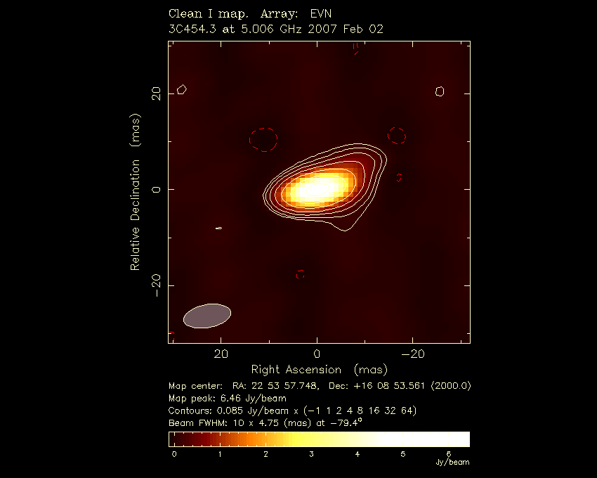
First 512 Mbps 5-station fringes

Testing to Shanghai is being scheduled now that the undersea cable has been repaired. As this report is written, dates/timing for the test are being arranged.
Deliverables
D # | Activity | Activity Specific Deliverable Number | Deliverable description | Current Status  (x of 4 )
D5 | SA1 | SA1.1 | Central data link control | 3
D11 | SA1 | SA1.2 | Job preparation utilities | 0
D12 | SA1 | SA1.3 | Fast/adaptive scheduling tools | 0
D27 | SA1 | SA1.4 | eMERLIN VSI interfaces design | 0
D28 | SA1 | SA1.5 | Selective data processor controls | 1
D35 | SA1 | SA1.5 | Network Protocol decision | 0
D36 | SA1 | SA1.7 | Monitored information handling modules | 0
D40 | SA1 | SA1.8 | Monitoring processes | 0

Deiverable number D28 and D29 are both listed as SA1.5 in the original Description of Work.
Section 3.2- SA2- Telescope Network Connections
A great deal of the work for SA2 has matured over the past few weeks. A large volume of information has become clear and is useful to present in full. The text is the feasibility study for SA2 with one section for each of the participants.
1. CNIG-IGN

The CNIG-IGN telescope is located in the town of Yebes, 75 km NE of Madrid (Spain). Several options have been investigated to deliver the data of the new 40-meter radiotelescope, under commissioning, to the GÉANT national node at RedIRIS.

Out of the study of feasibility it has been concluded that the best options are the serviced commercial lines. At least two companies offer solutions (fiber optics placed in high voltage electricity transport infrastructures by REE/Albura, now Deutsche Telecom; and by Telefónica de España, the largest telecommunications company in Spain). The Call for Tender is being finalized and will be issued shortly for construction in mid 2007.

Recently, RedIRIS has moved the GÉANT node infrastructure to the city of Alcobendas, north of Madrid and distant 94 km to Yebes (via Madrid). Negotiations with RedIRIS are finished, being already possible to install the needed equipment at their premises.
2. MPIfR
The venture to build an optical fiber to connect the Radiotelescope Effelsberg to the institute in Bonn and further to the next core node of the German NREN (DFN) at Birlinghoven, close to Bonn, was already initiated before the official start of the EXPReS project. The feasibility and the financial dimension of the "Effelsberg fiber" had also been verified before. During the first 12 months of EXPReS detailed project planning and negotiations about the rights to cross land were conducted, which lead to the final decision of the exact path for the fiber. As a result the "Haushaltsunterlage Bau" (HU-BAU) document was prepared and submitted to the Max-Planck Gesellschaft in autumn 2006. All required steps for allocating the money had been accomplished by the end of January 2007. The tender document is being prepared during February 2007. The first part - the fiber between the telescope and the institute in Bonn – has been put out to tender, and closing date is March 13 2007. Present best estimate for start of operation of the fiber between Effelsberg and the MPI is October 19, 2007.

A LOFAR station at Effelsberg is being installed, which will need a 10 Gbps line to Groningen with a 10 Gbit line (traffic at ~3 Gbit). EXPReS eVLBI traffic will be sent through the same line, as one fiber can be used to get from Groningen to JIVE/Dwingeloo.
3. Equipment of the last-mile infrastructure for participant INAF (telescope in Medicina)
The connection of the Medicina Radiotelescope to the GARR/GEANT network via longh path (120 KM) was available at the end of January 2006.

The first tests of the "last mile" connection (Bologna-Medicina) gave a sustained speed of 980 Mbit/sec. The repeater used to host this temporary connection via long path does not support the Jumbo Frames.

In February and March 2006, in cooperation with Garr’s and Jive’s network specialists, we made speed tests to tune the routers on the Bologna-Amsterdam path. Working with memory to memory tests we obtained a sporadic speed of 750Mbit/sec. but when transferring real data we had a significant loss in speed performance, in the range of 300-400 Mbit/sec, that we suppose is due to the lack of the jumbo frames.

The first e-vlbi observation test for Medicina took place on March 2006. In this observation run we had a lot of stops when sending data to Jive. The tests of the following days show a big inconsistence between the Operating System and the network board of the MK-V device. In the e-vlbi observational run in May 2006, Medicina produced the first flows of data useful for correlation. The sustainable speed for Medicina seemed to be 256 Mbit/s but this first observation was made at 128 Mbit/sec.

In June Medicina started working at 256Mbit/sec; the speed tests gave a value of 480Mbit/sec for the sustained exchange of data.

This limit, that precludes the use of the Antenna at 512Mbit/sec in the e-VLBI mode, seems to be imposed by the CPU overload of the MK-V devices, overload generated by the great number of network packets required in a transmission that must use low size frames.

While we are waiting for a shorter fibre path (40 Km) from the local government, we are working to upgrade the MK-V with a new generation Mother Board in order to overcome the CPU problems and to have a speed of 512 Mbit/s, the same of the other antennas of the European e-VLBI. Moreover we are working at a fibre bypass in the fields around antenna and to set up new communication devices that can be used on the new path at 10Gbit/s. It will be contributed by the local government. See:
http://www.ira.inaf.it/foto/2005-Fibra/index.html .
4. CAS (Shanghai, Urumqi, Miyun, Yunnan) (connection to GEANT NREN node)
The CAS radiotelescopes have been connect by fiber links to their nearby cities, and data transfer is already possible at a cost. At this moment, the fiber link is rented for data rates of 34 Mbps.

Alternatives to bring the data to Europe are being investigated. CSTNet plans to connect from Shanghai to Beijing and then to JIVE via Hong Kong and Amsterdam. A meeting on this issue was held on January 26 2007. The other choice is to connect via ORIENT, which is not operational yet. See:
http://www.oan.es/expres/china.pdf

The submarine cable was broken due to an earthquake in December 2006, and has been already repaired. Alternative data transmission using a fiber optics network through Siberia is not being pursued at this time, as the telescopes are connected with CSTNET while the Siberia network has a agreement with Chinese Education Network and only runs at 155 Mbps.

CSTNET plans to have a test experiment with the network from Beijing-Shanghai-Hong Kong-Amsterdam (2.5Gbps).
5. VIRAC
The construction of the last mile dark optical fiber from Irbene to Ventspils International Radioastronomy Center (about 30km) is finished. Equipment to light the fiber to 1 Gbps is being purchased.

Participation of VIRAC in e-VLBI observations depends on other issues, such as radiotelescope calibration and receiver availability. Tests are in progress.
6. HRAO
The 26-m radiotelescope at Hartebeesthoek Radio Astronomy Observatory (HartRAO) consists of a 3 km dark fiber circuit from the telescope to the proposed SANReN (South African Research Network) which will provide gigabit connectivity within SA. This will be installed in the next months. At this moment, connectivity is limited to 300 kbps.

The total (shared) international bandwidth for the whole Tertiary Education network to which HRAO attaches is currently 180.5 Mbps of which some 40 - 75Mbps is utilized depending on the time of day.

The real bottleneck is a reasonable cost and bandwidth connection from the SANReN to GÉANT. This will probably be implemented by a new cable from SA to Europe via the Atlantic. Negotiations for this cable are underway, and a 2-3 year time-scale is envisaged.

However, if rumors of international NREN consortia landing beachheads in South Africa sometime soon are true - this picture could change dramatically. [Project Manager: See Appendix on HartRAO]
7. NAIC (Arecibo)
There have been no substantial changes since last month's report.

Arecibo 305-m radiotelescope has participated in EVN e-VLBI observations at 32 Mbps (very occasionally at 64 Mbps). However, even 32 Mbps has not been recently sustainable.

The present plan is to connect via the Miami NAP (NAP Of The Americas) and the Abilene Internet2 backbone pathway to GÉANT. The Miami NAP is operated by AMPATH/CIARA (Florida International University). The trans-Caribbean circuit is leased from Centennial Puerto Rico, jointly with the University of Puerto Rico.

Parties involved in the "last mile to JIVE" from Arecibo include Cornell University, the University of Puerto Rico, Florida International University, possibly UCAID (Internet2/Abilene), and GÉANT. As such there will be administrative costs at several levels, some of which will be absorbed into the operating costs of the respective institutions.

A connectivity upgrade is expected by March 2007. In theory, a maximum of 155 Mbps should be possible at present. However in practice, it is difficult to sustain 32 Mbps, even at night.

Subject to vendor confirmation and availability of funding, the aim is to achieve sustained 1 Gbps rates over 2-3 hours per month. The circuit together with switching equipment will be leased from the telecom provider(s).
8. TIGO
There have been no substantial changes since last month's report.

Three different parts of the connection are to be considered:

a) TIGO-UdeC/DTI, already connected at 1 Gbps.
b) UdeC/DTI-REUNA, 155Mbps, limited by switch and rented service.
c) REUNA-world/GEANT, 90Mbps, limited by rented service.

The University of Concepción (UdeC) is connected by the national academic network (REd Universitaria Nacional = REUNA). This connection offers 155Mbps capacity of which around 100Mbps are used during business hours (6:00-23:00). In the moment this line does allow for data transmissions above 50Mbps only at weekends or during a few morning hours. This problem is subject to change presumably during the second half of this year 2006 to allow for the proposal to EXPReS: 24 times 24h with 64Mbps for e-VLBI. Please note, that UdeC rents only a fraction of the total bandwidth of 155Mbps and that for the test purposes of EXPReS the limit will be adapted to the needs.

REUNA is connected with 90Mbps to GEANT. Currently about 25Mpbs are used; indicating that about 64Mbps will be available for EXPReS upon special request. If necessary the bandwidth can be increased.

[Note: Hayo Hase has indicated via email that the connection between Chile and Europe has received continued funding through March 2008.]
9. Feasibility study of the last-mile connection to AARNET for participant CSIRO
The "last-mile" connections of the ATNF antennas (Parkes, Mopra, ATCA) to the AARNet began in late 2005 and were completed by March 2006. Legal agreements were completed by June 2006 and services were provided from July 2006. The AARNet backbone operates at multiple 10 Gbps wavelengths and each ATNF antenna has 2 x 1 Gbps services. The first 1 Gbps from the antennas to ATNF headquarters in Sydney started operation in July 2006. The second 1 Gbps service will operate between the observatories. AARNet has provisioned this service but connection awaits routing changes in the CSIRO network and it is likely to be completed in 2007.

The international connectivity to JIVE is to be handled with AARNET, also part of the EXPReS team.
10. Equipment of the last-mile infrastructure for participant MRO
There have been no substantial changes since last month's report.

A 5-year lease contract of the dark fiber with a local telecom company "Elisa" was signed on 02.11.2006 and the fiber was delivered on 16.02.2006 (before the official start of EXPReS). For lighting up the fiber, MRO bought (after a competitive bidding) a 10Gbps switch (Extreme Networks X450-24t with ZR optics), which is included into the equipment assets database of the university and it has a depreciation time of 4 years; longer than the EXPReS contract.

Salary costs associated with the 10G connection and supplementary equipment are being estimated.

Medicina tests
Separate from updates to the feasibility studies, are a few completed deliverables for the activity. D29 e-VLBI Tests observations Medicina is complete. Szomoru’s email of 2006 Aug 22 announces that testing with Medicina began (with several earlier instances of test runs). Through the course of the e-VLBI runs, Medicina has participated and contributed with results being announced through the standard channels.

Deliverables
D # | Activity | Activity Specific Deliverable Number | Deliverable description | Current Status  (x of 4 )
D13 | SA2 | SA2.01 | Feasibility study of the last-mile connection to the nearest NREN node for participant CNIG-IGN | 4
D14 | SA2 | SA2.02 | Feasibility study of the last-mile connection to the nearest NREN node for participant MPIfR | 4
D15 | SA2 | SA2.03 | Equipment of the last-mile infrastructure for participant INAF (telescope in Medicina) | 4
D16 | SA2 | SA2.04 | Feasibility study of the last-mile connections to the nearest GEANT NREN node for participant CAS (Shanghai, Urumqi, Miyun, Yunnan ) | 4
D17 | SA2 | SA2.05 | Feasibility study of the last-mile connection to the nearest NREN node for participant VIRAC | 4
D18 | SA2 | SA2.06 | Feasibility study of the last-mile connection to the nearest NREN node for participant HRAO | 4
D19 | SA2 | SA2.07 | Feasibility study of the last-mile connection to the nearest NREN node for participant NAIC (Arecibo) | 4
D20 | SA2 | SA2.08 | Feasibility study of the last-mile connection to the nearest NREN node for participant TIGO | 4
D21 | SA2 | SA2.09 | Feasibility study of the last-mile connection to AARNET for participant CSIRO | 4
D29 | SA2 | SA2.10 | e-VLBI test observations, Medicina | 3
D37 | SA2 | SA2.11 | Equipment of the last-mile infrastructure for participant MRO | 0
D38 | SA2 | SA2.12 | Construction and equipment of the last-mile infrastructure for participant CNIG-IGN | 0
D39 | SA2 | SA2.13 | Construction and equipment of the last-mile infrastructure for participant MPIfR | 0
Section 4.1- JRA1- FABRIC
Earlier in the month, a slightly updated version of the “eVLBI - GRID interface document” was submitted and loaded into the wiki. The deliverable was sent in by PSNC and addressed minor changes.

Joddrell Bank reports considerable progress on several items since Jonathan Hargraves joined. Hargraves is contributing to WP 1.2.1, 1.2.2 and 1.2.3 developing software elements for the iBOBs. Each of the iBOBs are running with Xilinx FPGAs. The FPGA SDK (formally, the Xilinx Embeded Systems Development Kit) will allow for additional development with the iBOB (e.g., ethernet interfaces libraries).

Work on the software correlator, WP 2.2, continues to mature and stabilize. This week marked another step for the team as the system obtained its first astronomy fringes. This is an essential early step for the software correlator and a mark that can be happily announced. Test N06C2 was reprocessed using the Software FX Correlator (SFXC) instead of the EVN hardware correlator. For each baseline (combination of two radio-telescopes) 256 lags are output and the averaging time was 0.2 seconds.

The next graph shows fringes for all 6 base lines (Medicina, Noto, Torun, and Westebork) right in the center of the lag domain. The fact that the fringes are centered on the central lag shows the delay model and clock offsets are being applied correctly by SFXC.

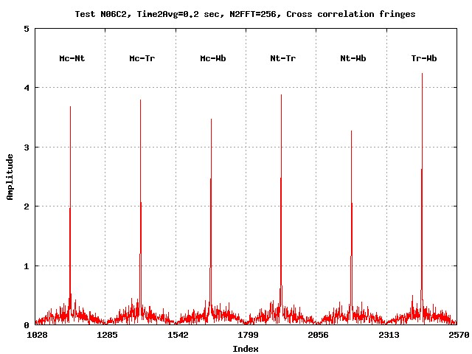
Fringes for all 6 baselines processed by SFXC.

Deliverables
D # | Activity | Activity Specific Deliverable Number | Deliverable description | Current Status  (x of 4 )
D2 | JRA1 | J1.1 | Data acquisition requirements document | 4
D3 | JRA1 | J1.2 | Protocols strategic document | 4
D8 | JRA1 | J1.3 | Visualization software | 0
D9 | JRA1 | J1.4 | Correlator design specification | 3
D22 | JRA1 | J1.5 | Overall design document | 0
D23 | JRA1 | J1.6 | e-VLBI-Grid design document | 4
D24 | JRA1 | J1.7 | e-VLBI fringes PC-EVN | 4
D25 | JRA1 | J1.8 | LOFAR connection strategic document | 4
D26 | JRA1 | J1.9 | Data acquisition design document | 3
D30 | JRA1 | J1.10 | eVLBI-Grid interface document | 4

Section 5.0- Appendices
The following sections contain the text of emails or links to documents referenced in the report. Shorter documents and emails are quoted in their entirety below. Longer documents are provided as linked documents. If you would like documents in a different format, please contact us and we will attempt to assist you.
Appendix - EXPReS Contact Points
For convenience, a list of the activities and the associated contact points are listed here for reference.

ID | Description | Contact | email
PC | Interim Project Coordinator | Huib Jan van Langevelde | langevelde // jive nl
NA1 | Management of I3 | T. Charles Yun | tcyun // jive nl
NA2 | EVN-NREN Forum | John Chevers | john.chevers // dante org uk
NA3 | e-VLBI Science Forum | John Conway | jconway // oso chalmers se
NA4 | Public outreach | Kristine Yun | kyun // jive nl
SA1 | Production Services | Arpad Szomoru | szomoru // jive nl
SA2 | Network provisioning | Francisco Colomer | f.colomer // oan es
JRA1 | FABRIC | Huib Jan van Langevelde | langevelde // jive nl
Appendix - Deliverables
The deliverables are being tracked on the wiki at:
<http://www.jive.nl/dokuwiki/doku.php/expres:management:deliverables2>
The wiki contains additional information to that listed below, including some comments on drafts that are nearing full completion and some additional meta-data used to track deliverables. The snapshot below is here for reference.

The status of the deliverable on an “x” to 4 scale:
x = Ongoing effort
0 = No work started
1 = Some work started
2 = Most work completed
3 = Deliverable in draft form
4 = Deliverable completed and presented to Project Manager

D # | Activity | Activity Specific Deliverable Number | Deliverable description | Planned Delivery Month | Actual Delivery Month | Current Status  (x of 4 )
D1 | NA4 | NA4.01 | Creation of Public EXPReS web-site | 2 | 2 | 4
D2 | JRA1 | J1.1 | Data acquisition requirements document | 2 | 3 | 4
D3 | JRA1 | J1.2 | Protocols strategic document | 2 | 2 | 4
D4 | NA2 | NA2.01 | EVN-NREN meeting No. 1 (under auspices of EXPReS) | 3 | 6 | 4
D5 | SA1 | SA1.1 | Central data link control | 3 |  | 3
D6 | NA3 | NA3.1 | First meeting of eVSAG under auspices of EXPReS | 4 | 9 | 4
D7 | NA4 | NA4.02 | Creation of EXPReS web-based management tools | 4 | 4 | 4
D8 | JRA1 | J1.3 | Visualization software | 4 |  | 0
D9 | JRA1 | J1.4 | Correlator design specification | 5 |  | 3
D10 | NA4 | NA4.03 | Generation of PR material (phase 1) | 6 | 1 | X
D11 | SA1 | SA1.2 | Job preparation utilities | 6 |  | 0
D12 | SA1 | SA1.3 | Fast/adaptive scheduling tools | 6 |  | 0
D13 | SA2 | SA2.01 | Feasibility study of the last-mile connection to the nearest NREN node for participant CNIG-IGN | 6 | 9 | 4
D14 | SA2 | SA2.02 | Feasibility study of the last-mile connection to the nearest NREN node for participant MPIfR | 6 | 9 | 4
D15 | SA2 | SA2.03 | Equipment of the last-mile infrastructure for participant INAF (telescope in Medicina) | 6 | 9 | 4
D16 | SA2 | SA2.04 | Feasibility study of the last-mile connections to the nearest GEANT NREN node for participant CAS (Shanghai, Urumqi, Miyun, Yunnan ) | 6 | 9 | 3
D17 | SA2 | SA2.05 | Feasibility study of the last-mile connection to the nearest NREN node for participant VIRAC | 6 | 9 | 4
D18 | SA2 | SA2.06 | Feasibility study of the last-mile connection to the nearest NREN node for participant HRAO | 6 | 9 | 3
D19 | SA2 | SA2.07 | Feasibility study of the last-mile connection to the nearest NREN node for participant NAIC (Arecibo) | 6 | 9 | 3
D20 | SA2 | SA2.08 | Feasibility study of the last-mile connection to the nearest NREN node for participant TIGO | 6 | 9 | 3
D21 | SA2 | SA2.09 | Feasibility study of the last-mile connection to AARNET for participant CSIRO | 6 | 9 | 3
D22 | JRA1 | J1.5 | Overall design document | 6 |  | 0
D23 | JRA1 | J1.6 | e-VLBI-Grid design document | 6 | 9 | 4
D24 | JRA1 | J1.7 | e-VLBI fringes PC-EVN | 7 | 7 | 4
D25 | JRA1 | J1.8 | LOFAR connection strategic document | 7 | 11 | 4
D26 | JRA1 | J1.9 | Data acquisition design document | 8 | 11 | 4
D27 | SA1 | SA1.4 | eMERLIN VSI interfaces design | 9 |  | 0
D28 | SA1 | SA1.5 | Selective data processor controls | 9 |  | 1
D29 | SA2 | SA2.10 | e-VLBI test observations, Medicina | 10 |  | 0
D30 | JRA1 | J1.10 | eVLBI-Grid interface document | 10 |  | 1
D30 | JRA1 | J1.10 | eVLBI-Grid interface document | 10 | 10 | 4
D31 | NA2 | n/a | NA2 annual report No. 2 (as part of EXPReS Ann. Rep No. 2) | 24
D32 | NA1 | NA1.01 | Annual report (incl. Financial information) to EC | 12 | 12 | 3
D33 | NA2 | NA2.02 | NA2 annual report No. 1 (as part of EXPReS Ann. Rep No. 1) | 12 | 12 | 3
D34 | NA4 | NA4.04 | e-VLBI Demonstration and attendance at Network events. | 12 | 12 | x
D35 | SA1 | SA1.5 | Network protocol decision | 12
D36 | SA1 | SA1.7 | Monitored information handling modules | 12
D37 | SA2 | SA2.011 | Equipment of the last-mile infrastructure for participant MRO | 12
D38 | SA2 | SA2.12 | Construction and equipment of the last-mile infrastructure for participant CNIG-IGN | 12
D39 | SA2 | SA2.13 | Construction and equipment of the last-mile infrastructure for participant MPIfR | 12
D40 | SA1 | SA1.8 | Monitoring processes | 12
Appendix - HartRAO Connectivity
The following text is an excerpt from an email Jonathan Quick sent regarding connectivity to HartRAO.

I've now been in contact with TENET and there is no "upcoming" connectivity that is in any way pending. Their beachead facility in Cape Town would be able to transmit 128Mbps currently on our behalf if we were able to connect that far. However a few comments are in order:

o Working with the standard costing models, expanding our
backbone connection by 128Mbps and hiring the required
~2.4Mbps incoming international bandwith to sustain the
ACKs would cost HartRAO approximately R1m (ie. ~ 120kEuro)
per month. TENET expects that it should be possible to
get some discount on this, but we would rapidly exhaust
our entire annual budget to sustain dataline charges at
anything close to this level.

In the past days, Quick followed up with the following news:

You asked me to keep you posted, and I am glad to report that in a phone
call, Johan Eksteen from the Meraka Insistute CSIR ( who I believe have
been tasked by Government to set up a SA national research network ) told
me that a contract for the "last mile" for HartRAO has just been signed
and we should expect installation by end of this month !!! He also
undertook to discuss further with TENET about the possibility of using
a point-to-point link to connect up with their beachhead facility and
access their outgoing bandwidth for 128Mbps testing as soon as possible
thereafter.

Quick hopes that network testing can begin in the April to May timeframe. We will provide updates as we learn more.
Appendix - Mark5 Upgrade at JIVE
Paul Boven sent the following announcement to the EVN mailing list describing the Mark5 Upgrade.

Subject: EVNtech: Mark5 upgrade at JIVE
Date: Thu, 01 Feb 2007 11:10:33 +0100
From: Paul Boven <boven@jive.nl>
To: evntech@jb.man.ac.uk

Hi everyone,

JIVE has just ordered an upgrade for all 16 Mark5 servers at the correlator center. This will offer us better performance especially for e-VLBI sessions. We recommend that all stations in the EVN perform similar upgrades to their Mark5's, in particular the stations who are or soon will be involved in e-VLBI.

In detail, these are the upgrades we will be carrying out:

New motherboards, Intel Brandon SE7520BD2SATAD2 - these are the same dual-Xeon 800MHz FSB boards that Conduant uses in the new Mark5Bs. In the past months we have tested one of these boards with good results.

Dual 3.2GHz 2MB 800MHz FSB Xeon CPU's

2GB of memory (2x 1GB PC3200 400MHz DDR2 ECC Reg CL3 dimm, e.g. Kingston Valueram KVR400D2D8R3/1G)

Antec TruePower 2.0 TPII-550EPS (part number TP2550EPS12V) - this power supply does not have the problems that were noted with some of the other Antec PSU's that were shipped with Mark5s. It has enough extra 12V and 5V connectors to power the diskpacks. Unfortunately, this model is end of life and might be hard to obtain.

New 250GB SATA 7200rpm disk for local storage (OS etc.)

Replacement boards need the right form-factor to allow correct positioning of the StreamStor and I/O cards. Some alternatives are the boards purchased by MPIfR (SuperMicro Xeon board X6DHE-XG2), which has been tested at Haystack, and the boards installed by Paul Burgess in the Jb and Cm Mark5s (Asus NCCH-DL Dual Xeon).

Regards,

Paul Boven.

Appendix - Network Upgrade at JIVE
Paul Boven sent the following announcement to the EVN mailing list outlining plans and activities for the JIVE network upgrade. The upgrade is in support of EXPReS activities and will be another important step forward for the project.

Subject: EVNtech: Heads up: network upgrade at JIVE
Date: Tue, 13 Feb 2007 14:45:12 +0100
From: Paul Boven <boven@jive.nl>
To: evntech@jb.man.ac.uk

Hi everyone,

JIVE has just ordered an upgrade for all 16 Mark5 servers at the correlator center. This will offer us better performance especially for e-VLBI sessions. We recommend that all stations in the EVN perform similar upgrades to their Mark5's, in particular the stations who are or soon will be involved in e-VLBI.

In detail, these are the upgrades we will be carrying out:

New motherboards, Intel Brandon SE7520BD2SATAD2 - these are the same dual-Xeon 800MHz FSB boards that Conduant uses in the new Mark5Bs. In the past months we have tested one of these boards with good results.

Dual 3.2GHz 2MB 800MHz FSB Xeon CPU's

2GB of memory (2x 1GB PC3200 400MHz DDR2 ECC Reg CL3 dimm, e.g. Kingston Valueram KVR400D2D8R3/1G)

Antec TruePower 2.0 TPII-550EPS (part number TP2550EPS12V) - this power supply does not have the problems that were noted with some of the other Antec PSU's that were shipped with Mark5s. It has enough extra 12V and 5V connectors to power the diskpacks. Unfortunately, this model is end of life and might be hard to obtain.

New 250GB SATA 7200rpm disk for local storage (OS etc.)

Replacement boards need the right form-factor to allow correct positioning of the StreamStor and I/O cards. Some alternatives are the boards purchased by MPIfR (SuperMicro Xeon board X6DHE-XG2), which has been tested at Haystack, and the boards installed by Paul Burgess in the Jb and Cm Mark5s (Asus NCCH-DL Dual Xeon).

Regards,

Paul Boven.
Appendix - e-VLBI Announcements and Distribution
Following up an a topic from the previous update, a short email conversation was initiated with John Conway (leader of NA3- e-VLBI Science Forum) regarding the distribution of the e-VLBI calls. Currently, the announcement is sent to:
 | List Name | List Address
 | Global VLBI exploder | vlbi@nrao.edu
 | MERLIN exploder | merlin-announce@jb.man.ac.uk
 | EVN technical exploder | evntech@jb.man.ac.uk

Infrequently, e-VLBI and VLBI announcements are sent directly to other mailing lists, e.g. to specialists in different frequencies. The more normal scenario is for the announcement to be forwarded informally to other lists by way of personal contacts. The EVN Program Committee has formally considered expanding the lists through which the announcement is distributed on more than one occasion, but chosen against doing so.
Appendix - e-VLBI Call For Proposals
John Conway published the e-VLBI call for proposals for the March session. The following is the text of the announcement.

CALL FOR EXPERIMENTAL EVN e-VLBI SCIENCE PROPOSALS

Proposals for science use of the EVN's developing e-VLBI
real-time VLBI capability are invited for the following 24 hr period

Run start Run end Proposal Deadline

Tues 27 Mar 13 UTC Wed 28 Mar 13 UTC Tues 13th Mar, 23:59:59 UTC

Using antennas Wb14 (tied array), Tr, On85, Mc, Jb2, Cm

Available observing bands are either 6cm or 18cm (but not both).
Only continuum proposals are presently supported. Proposals can be made
for any length of time within the above slot up to 24 hours in length.

The observations will be run at the highest possible bit rate allowed
by internet traffic. Based on recent experience it is expected that
256 Mbit/s will be achieved.

Note all proposals *must* be checked by Bob Campbell
(campbell@jive.nl) *prior* to submission in order to ensure that all
necessary technical information for scheduling is included (see
details below). Proposers should therefore contact Bob, in good time
before the proposal deadline, so that he can then check the technical
aspects of the proposal in the NorthStar database

-------------------------------------------------------------------------

PROPOSAL DETAILS

To accommodate observations requiring rapid reaction and results, e-VLBI
proposals can be made before the deadline given above. Envisioned uses
for e-VLBI runs are 1) Targets of Opportunity, 2) Preliminary fringe test
or other observations where rapid turnaround is required to plan future
proposals or observations. Any submitted e-VLBI proposals which can be
better executed in regular session observations are very unlikely to be
scheduled for these e-VLBI runs. In all cases proposed projects should
take account of the limited numbers of telescopes and bandwidth
available, carefully justifying that the science goals can be reached.

Proposals are eligible for scheduling only for the above advertised run.
Proprietary rights on the data are the standard ones of one year after
data distribution. PIs are strongly encouraged to visit JIVE during or
immediately after the observations to help rapidly reduce their data.
Proposals submitted for the above e-VLBI deadline will be reviewed by
the EVN PC within one week. Scheduling of these proposals will be
carried out by JIVE staff using information supplied in the proposal.
Proposals must therefore contain all the necessary information needed
for scheduling, including the exact target and calibrator positions etc.
**** All proposers MUST contact Bob Campbell (campbell@jive.nl) *****
in good time PRIOR to submitting their proposal to ensure that all
technical aspects are fully described in the proposal on the Northstar
database.

Before submitting a proposal, proposers should also consult the web
pages at http://www.evlbi.org/evlbi/per_session_status.html where
updated information about the status of each run can be found. Proposals
must use the Northstar online submission tool (see details below).

--------------------------------------------------------------------

HOW TO SUBMIT

The on-line proposal submission tool Northstar replaces the old
Latex-email way of submission for all proposals which involve the
EVN, including proposals for eVLBI runs.

To use Northstar, people should register at http://proposal.jive.nl
(only for the first proposal submission), complete technical information
on-line (equivalent to that previously in the coversheet), and upload
a scientific justification in pdf or ps format. Standard page limitations
apply and will be enforced. The deadline for submission is
23:59:59 UTC on 13th Mar 2007.

Because of the need for rapid distribution and review of eVLBI proposals,
submission via Northstar is the **only** means of submission allowed for
eVLBI proposals for this and future eVLBI deadlines. If advice
is needed about submitting via Northstar please contact Cormac Reynolds
(reynolds@jive.nl) or other JIVE staff.

--------------------------------------------------------------------

FORWARD LOOK

Two more 24hr long eVLBI runs have been organised for the first half of
2007 with dates and proposal deadlines given below.

Run Deadline

22/23 May 8th May

25/26 Jun. 11th June

Detailed calls for proposals will be issued before
each of the above deadlines. The schedule of eVLBI observations
for the second half of 2007 (July -December) is presently being organised,
but a number of 24hr runs are likely to be scheduled. It is anticipated
that several more stations will become available for eVLBI
toward the end of 2007.

-----------------------------------------------------------------------

ACKNOWLEDGEMENT

The continuing development of e-VLBI within the EVN is made possible
via the EXPReS project funded by the EC FP6 IST Integrated infrastructure
initiative contract #026642 - with a goal to achieve 1 Gbit/s e-VLBI real
time data transfer.

--------------------------------------------------------------------
Appendix - ASTRON / JIVE Picture of the Day
The ASTRON JIVE Daily Image website <http://www.astron.nl/dailyimage/> is part of the ongoing effort for both organizations informally to share tidbits of information with the public at large. The website displays a picture accompanied by a small amount of descriptive text. As the name suggests, a new image is updated daily based on submissions from the local community.

On 14 Feb 2007, Kristine Yun’s submission highlighted the telescopes participating in the EXPReS project. (Note: this image was shared in a previous report.) The direct URI for the page is:
http://www.astron.nl/dailyimage/index.html?main.php?date=20070214

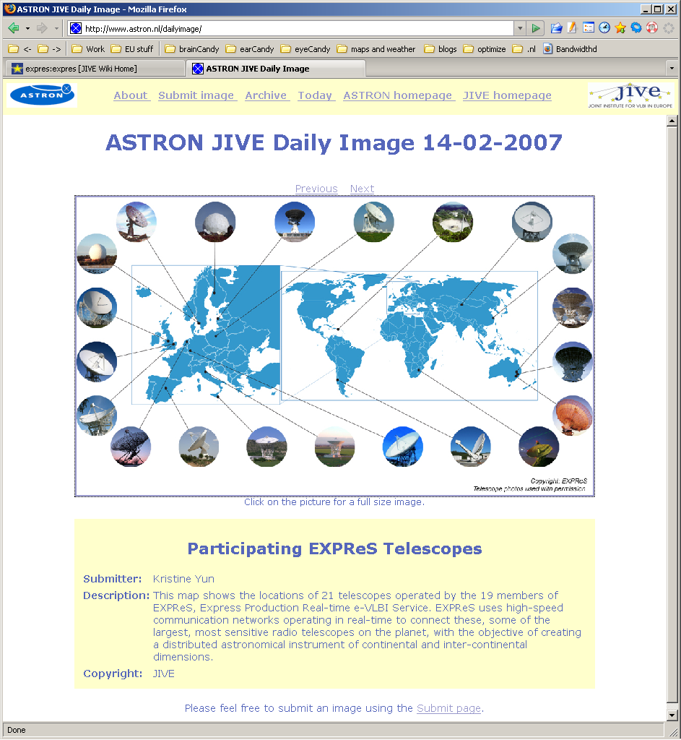

Appendix - Submarine cable status
On 2007 Feb 19, Zhang Xiuzhong provided an update on the status of the undersea cable break for our Chinese partners. He wrote:
I heard from the Director of CSTNET Li Jun. He told me that the undersea [fiber optic links] have been repaired. We have have the test experiment. For the experiment. Director will like to have a test between CSTNET to JIVE. If it work, we will try to connect our telescope to JIVE.
EXPReS is eagerly awaiting the opportunity to use this link for e-VLBI. We will provide updates as we receive them.

