
Express Production Real-time e-VLBI Service
EXPReS is funded by the European Commission (DG-INFSO),
Sixth Framework Programme, Contract #026642

e-MERLIN VSI Interfaces Design

SA1 Deliverable D27

Title: | e-MERLIN VSI Interfaces Design
Sub-title: | SA1 Deliverable D27
Date: | 2009 06 06
Version: | 1.0
Filename:
Author: | Ralph Spencer, The University of Manchester (UniMan)
Co-Authors | Paul Burgess (Uniman), Jonathan Hargreaves (UniMan), Anthony Rushton (UniMan)
 | Richard Hughes-Jones (UniMan and Dante)
Summary: | This report outlines the design of the hardware needed for connection of e-MERLIN telescopes to the Internet and thence to JIVE for e-VLBI, using both the existing analogue MERLIN systems and the high bandwidth digital system that is still under development. The digital interfaces to the e-MERLIN correlator are similar and use the same hardware for both the SA1 (e-MERLIN Out) and JRA activities (e-MERLIN In) in EXPReS. Multiple MERLIN telescope connectivity to JIVE has been achieved. The report also summarises the current status of the interface equipment and tests at the time of writing.
Delivery Slip
 | Name | Partner | Date | Signature
From
Approved by

Document Log
Version | Date | Summary of Changes | Authors
0.1 |  | Initial draft

Project Information
Project Acronym | EXPReS
Project Full Title | Express Production Real-Time e-VLBI Service
Proposal/Contract number | DG-INFSO #026642

Table of Contents
1 Introduction 3
1.1 The MERLIN Array 3
1.2 Transformation to e-MERLIN 4
2 Connection to the Internet and e-VLBI 5
2.1 Connection of the e-MERLIN correlator to JIVE 6
3 FPGA Functionality 9
3.1 Broad Band E-VLBI, Data at 4 Gbps from Onsala 10
3.2 iNetTest 14
3.2.1 FPGA “gateware” 15
3.2.2 Software for the embedded PowerPC CPU 15
3.2.3 Control Software 16
4 Current Status 19
5 Summary 19
6 Acknowledgements 19
7 References 19

Introduction
This project is for e-MERLIN enhancements enabling MERLIN telescopes to be added to the e-VLBI array, allowing connection of 4 telescopes at data rates up to 1 Gbps per telescope. This can be achieved by use of the existing analogue links from the remote telescopes in the MERLIN array, or via the new digital links being installed for e-MERLIN. Both approaches have been used. We first describe the MERLIN array, then its evolution to e-MERLIN and how it can be interfaced for e-VLBI.

The MERLIN Array

The MERLIN array consists of five remote radio telescopes at distances of up to 240 km from Jodrell Bank and two local telescopes on the Jodrell site. Each telescope is fitted with low noise radio receivers and can operate at frequencies of 1.4, 1.6, 5.0 and 22 GHz. Currently, the remote telescopes are connected by analogue AM modulated microwave links back to Jodrell Bank and each microwave link operates with a bandwidth of 28 MHz. At Jodrell Bank the frequency bands used on the microwave links are frequency converted to become compatible with the existing VLBI backend system and the MERLIN correlator. Figure 1 shows the layout of the telescopes in the UK and the microwave links. Figure 2 is a block diagram of the frequency conversion system needed for multiple telescope connection in VLBI (see below).
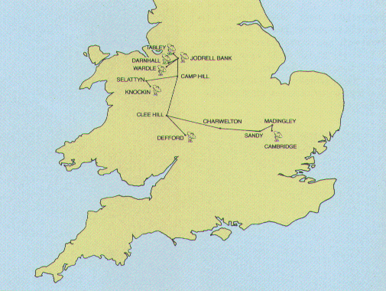

Figure 1 The MERLIN telescopes and the microwave links and repeaters.

The local telescopes (Lovell 76-m or the Mk2 25-m) are connected directly to the VLBI backend, and the receiver systems allow bandwidths in excess of 256 MHz, so that date rates of 1024 Mbps or higher can be achieved. The remote telescopes have bandwidths limited by the analogue links to 28 MHz and so have maximum data rates of 128 Mbps with 2 bit sampling.
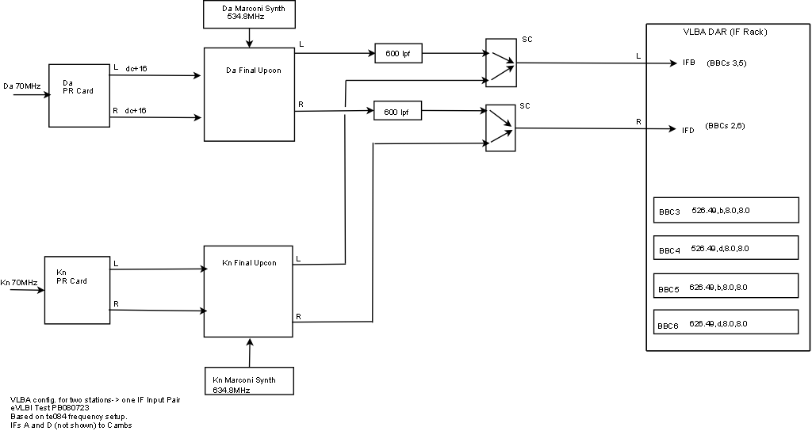

Figure 2 Diagram of the up-converter system bringing 2 remote telescopes (Da for the telescope at Darnhall, and Kn for Knockin) to the VLBA data acquisition rack at Jodrell Bank. This system can be used for 2 (as shown) or 3 remote telescopes.

Transformation to e-MERLIN

The restricted bandwidth of the microwave links in turn restricts the sensitivity of MERLIN (sensitivity is proportional to 1/ √B where B is the bandwidth). Some years ago it was realized that the use of optical fibres would allow us to use much greater bandwidths; the infra red properties of standard communication fibres now allowing bandwidths of THz. Our experience with the 120 Gbps links used for ALMA and EVLA Error: Reference source not found showed us that a collection of data links based on 10 Gbps technology would be suitable for e-MERLIN. The total astronomy data rate for e-MERLIN is 24 Gbps, which with formatting and framing results in a total of 30 Gbps per telescope (This is less than at ALMA and the EVLA due to the congested radio spectrum in the UK). Leased dark fibre, plus 100 km of new dig has allowed the telescopes to be connected back to Jodrell Bank. Figure 3 shows the layout of the fibre links. This is the most comprehensive private fibre network available to academic researchers in the UK. These links, together with new lower noise receivers, and resurfacing of the Lovell telescope, result in a factor of ~30 improvement in signal to noise ratio for the
e-MERLIN instrument [2]. A new correlator, using a sub-set of the EVLA correlator, has been designed by the Penticton radio astronomy group NRC-DRAO in Canada. This new correlator uses the WIDAR approach and can accommodate 30 Gbps and higher data rates. The correlator consists of a number of station boards, which de-format the 3 x 10 Gbps optical data on the three fibres from each e-MERLIN telescope, before passing the data on to the baseline boards where correlation takes place.

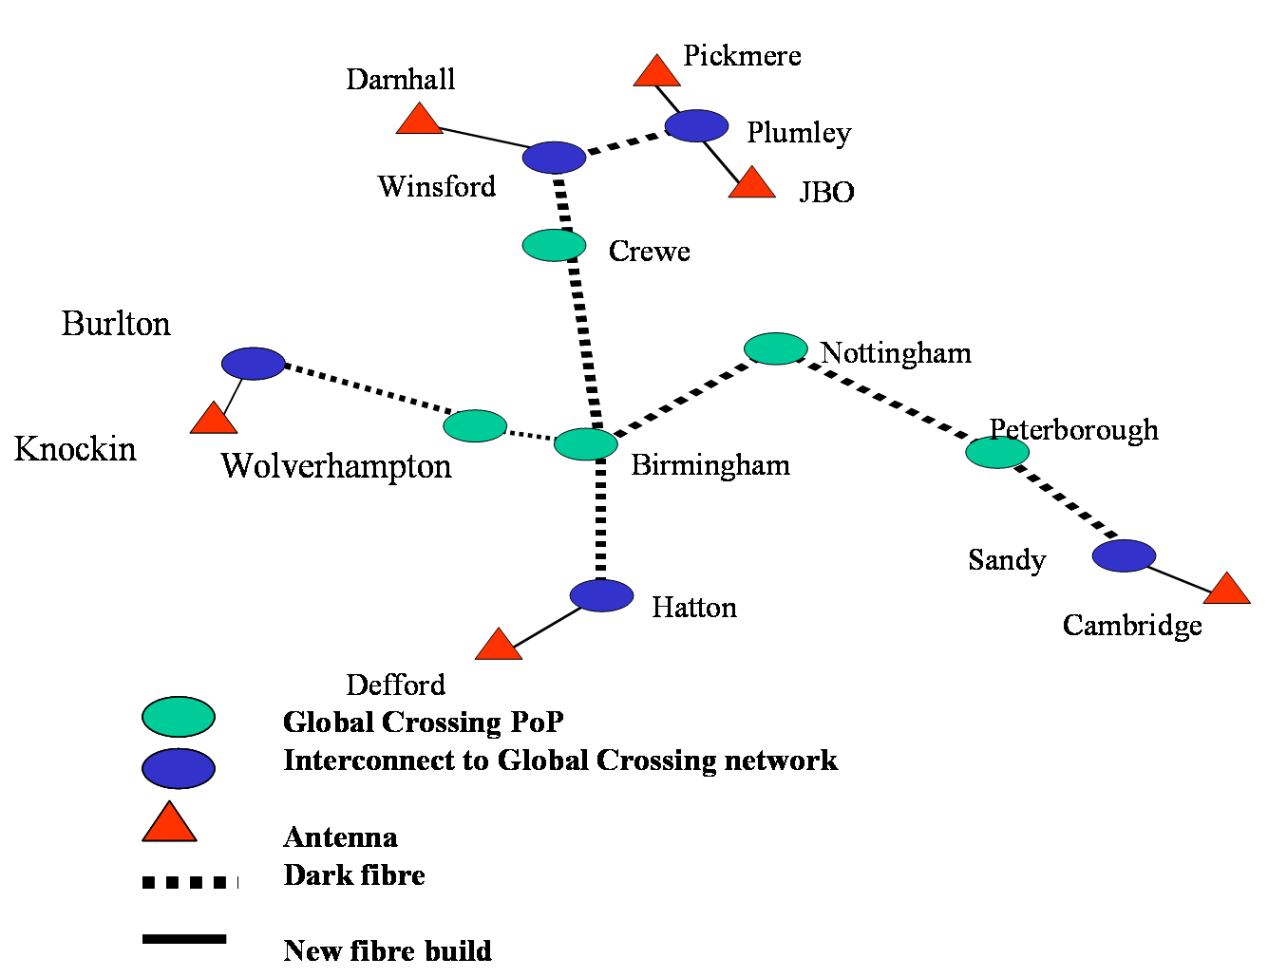
Figure 3 e-MERLIN fibre footprint.

Connection to the Internet and e-VLBI

Our work in the ESLEA project Error: Reference source not found has shown that connections between telescopes and the correlator at data rates approaching 1 Gbps were possible using the academic networks in Europe. The aims of EXPReS were to build on this and extend performance to higher data rates. Currently the local NREN, JANET [4] allows 1 Gbps lightpaths to be set up at no charge. Jodrell Bank currently has 2, which connect via e-MERLIN fibres to Plumley and then to TeleCity, Renolds House, Manchester where the POP for Janet is sited. Our tests (to be reported in D 45, D52 and D85) used these fibres and were able to transfer 4 telescopes, including a local telescope running at 1024 Gbps with 3 remote telescopes at 128 Mbps each. The protocol used to move the data over the academic network needs to be able to cross standard network switches and routers which make up the multi-domain paths. UDP/IP was selected following the studies and tests reported in reports D3[5] and D150 Error: Reference source not found.

Note that the protocol used by the e-MERLIN (and EVLA) on the optical fibre connecting telescopes is framed in a proprietary manner and very different to standard IP, and hence the need for format and protocol conversion for e-MERLIN data.

Figure 4 shows the outline of how telescope data can be connected using the IP capabilities of the Mk5 recording system to connect through to JIVE.

Initial tests at 1024 Mbps with local telescopes used the technique of selective packet dropping, resulting in line rates of ~950 Mbps, so we were able to use a single 1 Gbps light-path connection to JIVE. However work on bonded links enabled us to achieve a true 1024 Mbps for the local telescope, and 3 x 128 Mbps for remote telescopes, on 2 x 1 Gbps lightpaths to JIVE. It is expected that as the e-MERLIN system comes on stream over the next year the analogue links will be superseded, so the all digital link system being developed for e-MERLIN will be essential for VLBI operations for remote telescopes.

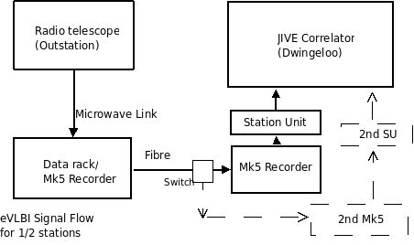
Figure 4 Outline of connection of a radio telescope data sent via the microwave links to the JIVE correlator.

Connection of the e-MERLIN correlator to JIVE

Our initial designs of 5 years ago were based on based on the use of digital to analogue conversion, making use of the digital links in e-MERLIN and the existing VLBI backend equipment, supplemented by a digital back end. However, the design of the hardware for this part of the project has changed considerably from our initial considerations, as explained below. The e-MERLIN data are in the form of a proprietary protocol as stated above on 3 x 10 Gbps optical channels from each telescope, resulting in a total data rate of 210 Gbps into the e-MERLIN correlator at Jodrell Bank. These data rates are incompatible with the typical 512 Mbps data streams required by VLBI and therefore format changing and data loss (via fewer digitization bits and less bandwidth) is required to fit into e-VLBI requirements. The optimum way to achieve the necessary interfacing is by the use of the two ancillary input/output chips on the e-MERLIN WIDAR correlator station boards, in order to send data from e-MERLIN telescopes to the outside world. These FPGAs are known as the “VSI Chips” but are in fact not restricted to VSI-H standards i.e. they can operate at higher data rates. The same chip can be used to bring data into the correlator, and the work required is very similar. For that reason the engineering time spent on SA1 and the JRA (see below) was necessarily split 50/50.

During 2006 it became clear that the optimum way to proceed was to make use of the Internet break-out board (iBOB) [7] designed by the University of Berkeley CASPER group (Prof. Dan Werthimer). This board has in-built serial I/O capability for driving 10 GE and hence the Internet, and can easily interface to the correlator VSI chips. Use of this board saves considerable hardware design effort. The remaining work is to configure the FPGA on the iBOB to allow for data output using VSI-E at rates up to 1 Gbps, including packetization etc. Work is also required on the VSI chips. The geometric delay and nx10 KHz offset, necessary for the WIDAR correlator approach, must be removed from the data, and bit dropping and channelization altered in order to fit the eVLBI data rate requirements. A block diagram of the system show in Figure 5 indicates how the network connections to the academic internet, and to Mk5B recorders will interface to the correlator. The diagram shows how the data will be moved for both e-MERLIN_IN, where a data stream comes from the Onsala Telescope into the e-MERLIN correlator and for e-MERLIN_OUT where up to four streams of data from the e-MERLIN telescopes are sent to the JIVE e-VLBI correlator.

Some aspects of the design were completed and published as documents on the EXPReS wiki[8] by B. Anderson, which partially fulfilled the requirements of this deliverable D27 e-MERLIN VSI Interface design. The prototype station board VSI chip has been tested by the Canadians and a report is available [9]. Prototype iBOBs were produced and tested for a variety of functions by Dan Werthimer's team at the University of Berkeley[10].

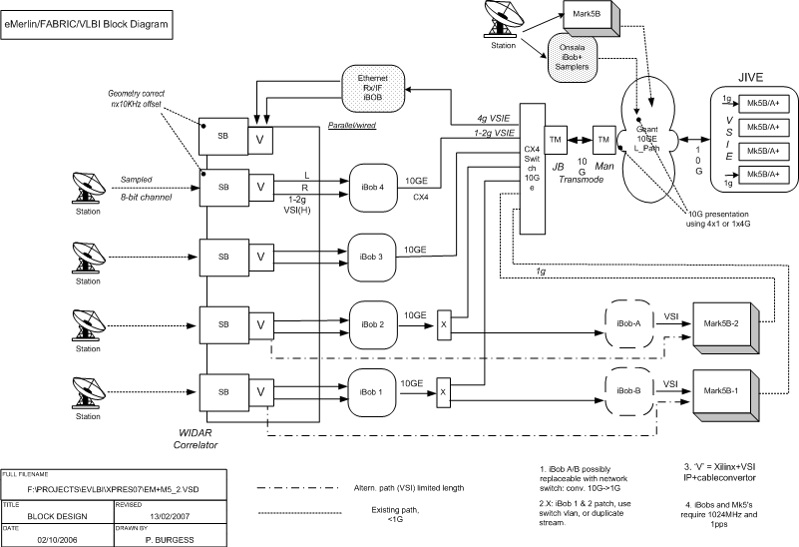
Figure 5 Block Diagram of the Interface to the e-MERLN for both e-MERLIN_OUT (SA) and e-MERLIN_IN (JRA).

The station board of the WIDAR correlator has high functionality, and can easily cope with the filtering and channelization requirements for VLBI. Figure 6 show a block diagram (courtesy NAIC) of the station board. Each MERLIN telescope sends data through a single station board, and the VSI chip can interface via an iBOB to a 10 GE connection for connection to the academic network.

In November 2008 it was decided to use Meritec cables to connect the iBOBs to the station boards. As well as maintaining compatibility with existing cabling, this solution is more flexible than using an MDR-80 ribbon cable as originally planned: inputs and outputs from different station boards can be mixed on one iBOB ZDOK connector. This will potentially allow one iBOB to export data from two station boards, reducing the number of iBOBs required. The interconnection is shown in Figure 7.

Figure 6 Block Diagram of a Station Board (from NRC-DRAO)

Figure 7 The interconnections between one Station Board and one iBOB
2mm Hard Metric to ZDOK PCB
Station Board Backplane
iBOB
2mm Hard Metric to ZDOK PCB
ZDOK0
ZDOK1
VSI 0 Out
40 pairs
VSI 1 Out
40 pairs
1 wafer Meritec cable: Clock, Sync, Valid, Spare
4 wafer Meritec cable: Data 0-15
Spare wafers allow, for example, two station boards to connect to one iBOB
CX4 10GE port 0
4 wafer Meritec cable: Data 0-15
SB to iBOB interconnections for eMERLIN export
1 wafer Meritec cable: Clock, Sync, Valid, Spare

FPGA Functionality

The e-MERLIN data needs to be channelized into the correct bands, have a 10 KHz offset removed and the delay model removed (the station board introduces delays into the interferometer signals to give equal delay paths for all telescopes before correlation, this task is done in the JIVE correlator so need to be removed). In addition the iBOB needs to packetize the data and drive 10 GE. The VSI chip tasks are:

Select one or more 128 MHz, 4 bit resolution or 64 MHz 8bit bands from the filter bank as input
Remove the fine part of the eMERLIN delay (62.5 ps – 16 ns)
Remove the N x 10 kHz offset
Extract sixteen bands of up to 8 MHz
Possibly support eight bands of 16 MHz
1Gbps = 2 polarizations x 2 bits x 16 Mbps x 16 bands

The iBOB tasks are:
Remove the coarse delay in 16 ns steps
Format the data into 10000 byte Mk5B frames
Form into packets.
Place 10 GE output

The tasks for the iBOB are illustrated in the block diagram in Figure 8, while Figure 9 shows the outline design for the filtering action required in the VSI chip.

ZDOK0
10GB PORT

.

1 Gb/s out
REMOVE DELAY MODEL (COURSE)
Use 72 bit wide bt 512k deep SRAM to remove eMERLIN delay model with 16 nanosecond resolution
FORMAT

Generate 10000 byte MkVb frames

Power PC

iBOB control and monitoring via registers on the OBP bus
10/100 ethernet
iBoB
ZDOK1
VSI Chip 0

Process left
polarisation data

VSI Chip 1

Process right polarisation data

Station Board
DATA 32 bit
DATA 32 bit
CLOCK
VALID
PDATA
CLOCK
VALID
PACKETISE
Divide each MkVb frame into two 5008 byte packets (include header)

Add Mk5C header to each packet

Figure 8 iBOB Block Diagram 1: JBO to JIVE Transmitter

Figure 9 Filtering architecture on the VSI chip

Broad Band E-VLBI, Data at 4 Gbps from Onsala
The FABRIC JRA calls for board band e-VLBI tests between Onsala and the e-MERLIN telescopes, using the new WIDAR correlator. As shown in Figure 5, the same hardware as for the SA1 activity is used, except now the data flow is into the correlator rather than out. The personalities of the IBOB and VSI chip are of course different in this configuration.

Figure 10 shows the high level block diagram of the functionality required for the eMerlinIN On2jbo_tx design for the iBoB which transmits data from the Onsala telescope to the WIDAR correlator at Jodrell Bank. Figure 11 shows the corresponding Simulink design. The functionality required for the design of the receiver, the functionality of eMerlinIN On2jbo_rx, situated at the correlator, is shown in Figure 12 and the Simulink design in Figure 13.

Figure 10 Functional block diagram of eMerlinIN_tx, On2jbo_tx the iBOB transmitter .
Figure 11 Top level Simulink design of eMerlinIN On2jbo_tx for the 4Gbps transmitting iBOB at Onsala
CX4
9ms at 4
Gbps
2 x
MDR80
‘VSI’
cables
Figure 12 Functional block diagram of eMerlinIN design On2jbo_rx, the iBOB receiver.
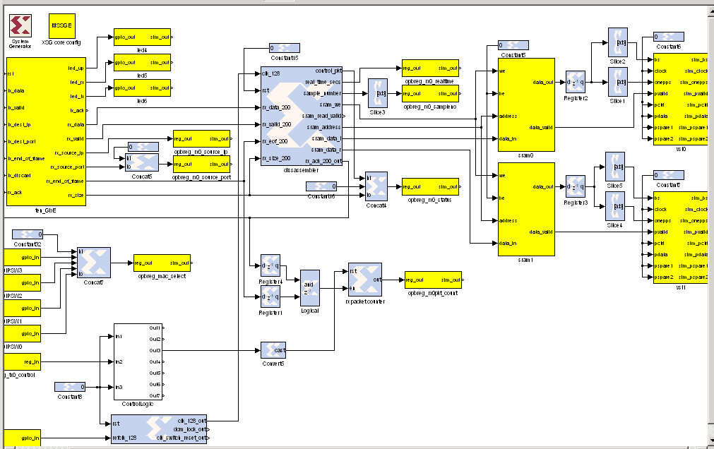
Figure 13 Top level Simulink design of eMerlinIN On2jbo_rx for the 4Gbps receiving iBOB at Jodrell Bank.

iNetTest

As a first step in creating the firmware designs for the units that move the VLBI data at 4 Gigabit/s from the telescope at Onsala to the correlator at Jodrell Bank, a design called iNetTest was produced to allow the iBoB hardware to perform as a two port 10 Gigabit Ethernet network test device. The two 10 Gigabit Ethernet ports are independent and full duplex, thus 4 independent test flows are available. As well as providing a network test device, the aims were to explore the capabilities and performance of the iBoB hardware and libraries [7], produce and test the firmware building blocks required for VLBI data moving, and create a flexible software architecture to allow control and monitoring of the iBoB systems.

Earlier e-VLBI work Error: Reference source not found, confirmed by the studies in ESLEA[11]and EXPReSError: Reference source not found, indicate that it is best to use the UDP/IP network protocol for moving real-time VLBI data. Also UDP/IP has been shown to be most useful in characterising the performance of end hosts and network components[14]. Thus the iNetTest hardware was designed to transmit streams of UDP/IP packets at regular, carefully controlled intervals and the throughput and packet arrival times were measured at the iNetTest receiver. Figure 14 shows the network view of the stream of the UDP packets.

The application transport header consisted of a 64 bit packet sequence number with bit 63 set to indicate that this packet was a test packet and not VLBI data. There was no application data header. This follows the current discussion of the VLBI community to define a common application transport header and a common VLBI Data Interchange Format (VDIF) as proposed by the VDIF Task Force[16].
n bytes
Number of packets
Time
•••
Transmit
Spacing
Figure 14 The network view of the spaced UDP frames that are transmitted from the source iNetTest to the destination iNetTest.

The packet length, spacing and number of packets to send is specified to the transmitting iNetTest unit via the software, but the data transmission is performed in hardware and is thus deterministic. Besides counting the received packets, the receiving iNetTest unit also checks that the 64 bit packet sequence number monotonically increases to check for lost packets. For each incoming packet stream the FPGA histograms the difference between the successive packet arrival times. The hardware can also log the transmission and arrival times of a snapshot of 2048 packets on each channel along with header data identifying the packet. This allows investigation of the one-way network transit delay of the packets.

The iNetTest design was divided into three areas: the FPGA “gateware”, the software for the embedded PPC CPU, and the control software external to the iBoB.

FPGA “gateware”
Figure 15 shows the simulink design of the iNetTest design. Each 10 Gigabit Ethernet port has its own set of control and status registers (CSRs) that allow setting of the IP address of the iNetTest port, the UDP port to be used for the FPGA hardware, and the parameters required for sending packets the destination IP address, the packet length, the inter packet spacing, and the number of packets. Other CSRs allow control of the packet flows and monitoring of the data packets received.
The histograms and packet time log are created from buffer cores and are accessible from the PowerPC when suitable bits are asserted in the control register, otherwise they are under the control of the FPGA.

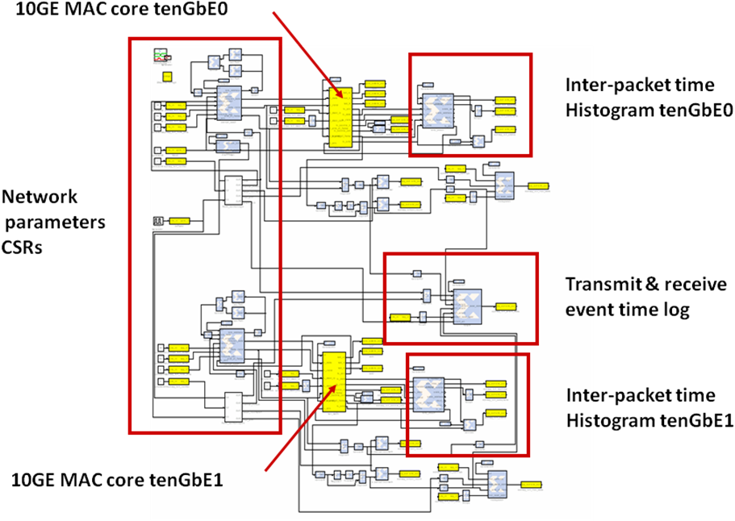
Figure 15. The Simulink Design of the iNetTest Unit

Ethernet packets that arrive on the10 Gigabit links that do not have the UDP port number of the hardware fabric are sent to the PowerPC CPU. The PowerPC CPU can also create packets to be sent on the 10 Gigabit Ethernet ports, but these have lower priority than the hardware generated packets. When the hardware assembles a packet for a given IP address it uses an ARP table in hardware to determine the correct MAC address and then clocks the packet via the PHY core into the RocketIO for transmission on the CX4 link. If the destination IP address is not on the local network, then the hardware selects the designated router MAC address.

As mentioned above in the discussions of the eMerlinIN and eMerlinOUT designs, the 10 Gigabit Ethernet ports are implemented using the PHY, MAC and RocketIO cores from the Berkeley libraries [7] along with various buffers, FIFOs and access to the PPC via the OPB bus.

Software for the embedded PowerPC CPU
The software that runs in the embedded PowerPC provides read and write access, where appropriate, to four types of components:
One word transfers to or from registers defined in the FPGA.
Bulk transfers to or from memory blocks defined in the FPGA “gateware”.
Access to the VHDL network modules.
Control of software actions in the PowerPC CPU e.g. initiating an ICMP echo request (ping) or generating an ARP request sequence.

The embedded PowerPC permits control of the above operations via a simple command line interface (CLI) available on the serial port or remotely using UDP/IP packets over the iBoB’s 10/100 Ethernet port. UDP/IP is used as there is insufficient memory available to allow use of a TCP stack.

The embedded PowerPC is also responsible for initialising all the Ethernet ports with their addresses and initiating a set of ARP requests to create the ARP hardware table. It is assumed that a class C IP network exists on each Ethernet port, but an IP packet for a non-local address will be sent to a specified gateway address.

Control Software
The architecture of the control software is shown in Figure 16. The design separates the human interface from the core code that interacts with the software in the embedded PPC in the FPGA. As indicated in Figure ss1three styles of human interface were provided;
A simple “terminal” style menu system.
A CLI allowing the iNetTest to be controlled from a perl script for making series of measurements.
A Graphical User Interface

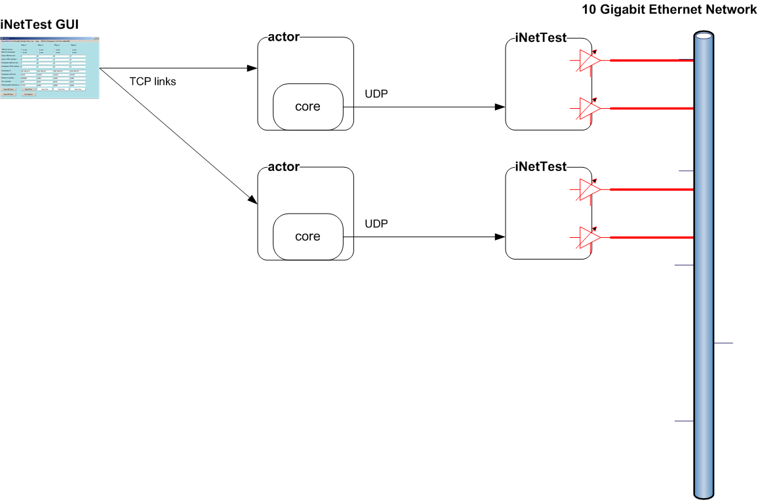
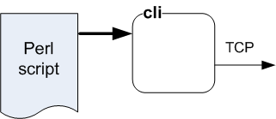
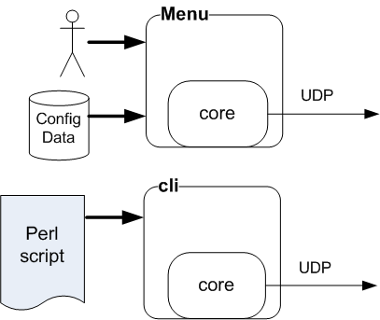
Figure 16 The architecture of the control software

The core code shares knowledge of the iNetTest resources or cores with the software in the PowerPC, and they use symbolic references to denote the cores due to the way the Xilinx tools allocate physical addresses. The PowerPC maps the symbolic reference onto the current address for that core. Access to a resource is performed by sending a UDP packet containing the request and waiting for the response packet. If no packet is received within a certain time, the core software re-sends the request.

The core software is also aware of the sequence of commands that are required to perform a certain action with a given FPGA resource, and translates the request from the human interface into the required sequence of requests. For example to start a data flow, several CSR accesses are required to clear counters, initialise histograms, set the parameters of the flow and then start the UDP/IP flow.

The “terminal” style menu and the CLI are stand alone programs which are usually run on a host local to the iNetTest unit.
The graphical user interface is designed to be used at a distance from the iNetTest units. It uses a TCP/IP link to connect to an actor on a host local to the iNetTest unit. It is written in C# and uses a series of Tab windows to provide control of: setting the network locations of the actors and the iNetTest units, requesting and displaying the 10 GE network parameters, showing the transmitter and receiver statistics, managing ARP on the iNetTest units, sending pings, control of the UDP flows, setting and displaying histograms,
Figure 17 provides an impression of these displays and Figure 18 shows the window that allows control of the UDP flows.
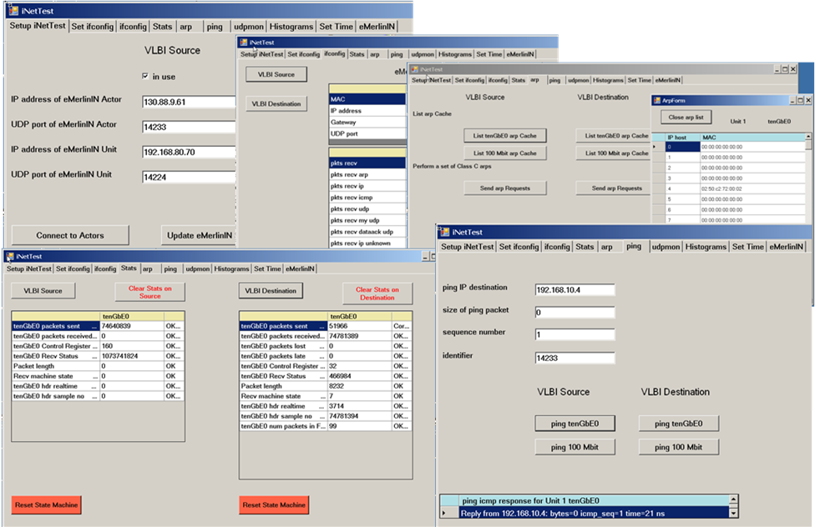
Figure 17 The Tab windows clockwise from the top for: defining the actors, showing the interface parameters, managing ARP, sending a ping and displaying statistics.

As well as providing the infrastructure required for iNetTest, this approach of abstracting the firmware and partitioning the software allowed simple extensions to provide control software for the iBoBs programmed for eMerlinIN, On2jbo_tx at Onsala and On2jbo_rx at Jodrell Bank. No major re-designs nor major sections of extra code were required. Figure 19 shows the control window for eMerlinIN.

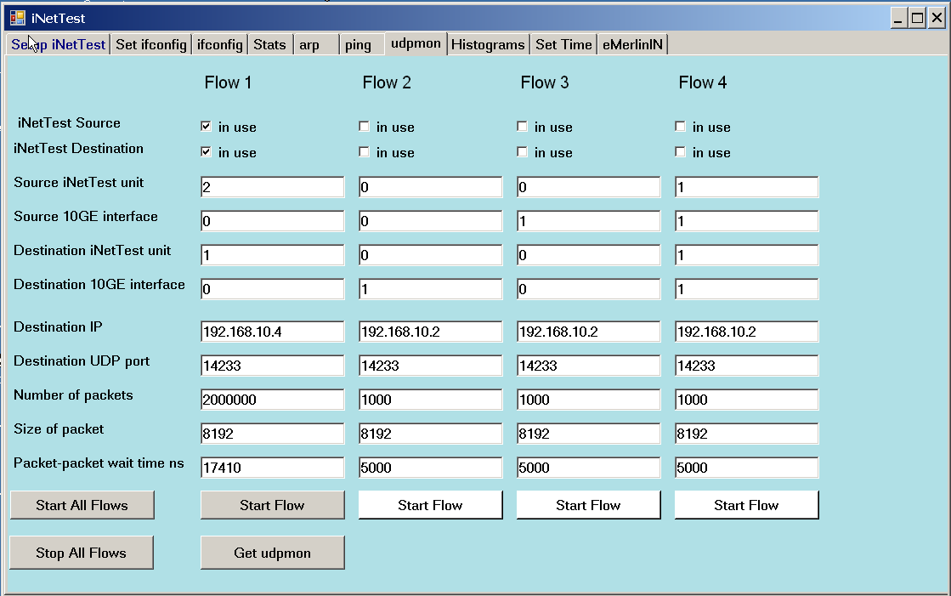

Figure 18 View of the window that allows control of the UDP flows.

Figure 19 View of the window that allows control of the eMerlinIN iBoB designs.

Current Status
High data rate e-VLBI using multiple MERLIN telescopes is now routine with a number of experiments already performed in e-VLBI sessions. Progression to 1024 Mbps or higher data rates for multiple MERLIN telescopes depends on the development and de-bugging of the correlator being built at JBO.

A station board for the e-MERLIN correlator arrived at the end of 2008. A further 2 boards arrived in April 2009, together with one correlator board. At the time of writing (June 2009) the code and hardware for the iNetTest application has been written and tested and is complete. The iNetTest IBOBs have been used extensively in 4 Gbps network tests between Onsala and Jodrell Bank. The iNetTest unis have also been used in field testing and evaluating commersion Ethernet testers from Xena[17]. Code for the 4 Gbps iBOB transmitter, eMerlinIN On2jbo_tx, is complete and tested, and code for the iBOB and VSI chip for the receiver, eMerlinIN On2jbo_rx, is also complete apart from minor modifications. Tests using sine wave signals injected locally at JBO and sine wave signals injected at Onsala and transmitted over the 4 Gigabit link to Jodrell have been successfully received in the Station board. Further tests are being performed.
Code for the eMERLIN –out operation has been implemented and partially tested. The development of e-MERLIN relies on the correlator being able to process incoming data from e-MERLIN telescopes. This aspect is still under development, though fringes were obtained between 2 local telescopes in May 2009, see the report for EXPReS deliverables D45, D52 and D85.

Summary

Hardware and outline firmware designs for the implementation of multiple MERLIN telescope operation in e-VLBI are complete. Two alternative approaches have been taken, one using existing analogue links, achieving 1024 Mbps across the network for the local telescope and 128 Mbps for up to 3 remote telescopes. This system is now in routine operation, partially satisfies the EXPReS deliverable and is producing good scientific results. The second approach utilizes the very high data rate capabilities of the new digital fibre links being installed for e-MERLIN. The design of the interface is complete, with further refinements on the firmware being undertaken in order to optimize performance. Full performance of the digital e-MERLN system with tests at 1024 Mbps or higher as not yet been achieved, largely due to delays in delivery of the correlator in circumstances beyond our control.

Acknowledgements
Throughout the development of EXPReS we have had encouragement, close co-operation and valuable technical discussions with network personnel from the campuses, the Metropolitan Area Networks, the National Research Networks JANET, SUNET and NORDUnet, DANTE and Internet2. We would like to thank all who have been involved, and this support has been vital in making the project an operational success.

References
- Durand, S., and McCool,, R. “Operational Requirements of the EVLA Optical Systems LO and IF” 2004, Proc. SPIE 5496, 344-355.
- eMerlin Home page http://www.e-merlin.ac.uk

R.E. Spencer, P. Burgess, S. Casey, R. Hughes-Jones, S. Kershaw, A. Rushton, M. Strong, A. Szomoru and C. Greenwood, “The contribution of ESLEA to the development of e-VLBI” in “Lighting the Blue Touchpaper for UK e-Science - Closing Conference of ESLEA Project “, PoS, March 2007 (http://pos.sissa.it/cgi-bin/reader/conf.cgi?confid=41#session-5 )

- JANET home page http://janet.net
- EXPReS Protocol Strategic Report D3 – interim report.
- EXPReS Protocol performance report D150
- IBOB web page http://casper.berkeley.edu/wiki/index.php?title=IBOB, viewed Nov 2008
- Anderson, B., Export/Import of VLBI Data from/to eMerlin, April 2006, (http://www.jive.nl/dokuwiki/doku.php/fabric:wp1 )
- http://www.drao-ofr.hia-iha.nrc-cnrc.gc.ca/science/widar/private/Station_Board.html . Then select Station Board VSI Test FPGA.
- Testing Prototype iBOBs http://seti.berkeley.edu/casper/
- Richard Hughes-Jones, Steve Parsley , Ralph Spencer, "High Data Rate Transmission in High Resolution Radio Astronomy - vlbiGRID", FGCS Special Issue: IGRID2002 Vol 19 (2003) No 6, August 03

ESLEA work on e-VLBI: A. Rushton, P. Burgess, R. Hughes-Jones, S. Kershaw, R.E. Spencer and M. Strong, “Trans-Atlantic UDP and TCP network tests” and S. Kershaw and R. Hughes-Jones, “TCPDelay: Constant bit-rate data transfer over TCP”, in “Lighting the Blue Touchpaper for UK e-Science - Closing Conference of ESLEA Project “, PoS, March 2007 (http://pos.sissa.it/cgi-bin/reader/conf.cgi?confid=41#session-5 )

- EXPReS Protocols report D150
- R. Hughes-Jones, P. Clarke, S. Dallison, “Performance of 1 and 10 Gigabit Ethernet Cards with Server Quality Motherboards,” Future Generation Computer Systems Special issue, 2004
- UDPmon: a Tool for Investigating Network Performance, http://www.hep.man.ac.uk/~rich/net
- “VLBI Data Interchange Format (VDIF) Specification”, as proposed by the VDIF Task Force.
- Xena Home Page http://www.xenanetworks.com/

