
Express Production Real-time e-VLBI Service
EXPReS is funded by the European Commission (DG-INFSO),
Sixth Framework Programme, Contract #026642

Monthly Report- Feb 2008
Title: | Monthly Report
Sub-title: | - Feb 2008
Date: | 2008 Mar 07
Filename:
Author: | T. Charles Yun, Project Manager, JIVE
Co-Authors | EXPReS Management Team
Summary: | EXPReS monthly update

Delivery Slip
 | Name | Partner | Date | Signature
From | T. Charles Yun | JIVE

Document Log
Version | Date | Summary of Changes | Authors
1.0 | 2008 Mar 07 | Final | tcy
0.9 | 2008 Feb 25 | draft | tcy
0.1 | 2008 Feb 20 | Initial draft | T. Charles Yun

Project Information
Project Acronym | EXPReS
Project Full Title | Express Production Real-Time e-VLBI Service
Proposal/Contract number | DG-INFSO #026642
Table of Contents
1. Introduction
2. Network Activity Updates
* NA1- Management
* NA2- EVN-NREN
* NA3- e-VLBI Science Forum
* NA4- Public Outreach, Dissemination and Communications
3. Specific Service Activity Updates
* SA1- Production e-VLBI Service
* SA2- Telescope Network Connections
4. Joint Research Activity Updates
* JRA1- FABRIC
5. Appendeces
Section 1.0- Introduction
The project year completed at the end of February and each of our project partners is now in process to prepare for the annual review. The project as a whole is beginning the transition to the introspective mode that is necessary for the annual report. Many of the section leaders have already provided draft sections of their text and the other partners are all aware that the efforts are underway. Once the project year’s data is processed, the financial data will begin to come in as well.
Section 2.1- NA1 - Management
Administrivia
The presentations and minutes from the Progress and Board meeting have been posted on the project wiki.
Several of our partners have had changes in their internal management structures. INAF sent a note indicating that Prof. Tommaso Maccacaro is their new president, taking over responsibilities from Piero Benvenutti. INAF has been told that they will need to provide a letter indicating that the change has occurred and also modify the corresponding A4 documents. We have asked to have copies of these documents sent to us as they are available.
Additionally, we learned that Robert Brown of Cornell will be stepping down from his position once a successor has been identified. This means that Cornell will also go through the same process as INAF. Once the official change happens, we will follow up with additional instruction to Cornell and information via this report.
MIT Haystack Status
The work at MIT Haystack has taken longer than expected. However, the end result has been useful for the long term operations of e-VLBI. During the most recent telecon, Haystack delivered the major remaining items of the project. The JIVE team will receive the code and should be testing/examining the final result as this report is being prepared. Additionally, Haystack committed to providing a summary document outlining their efforts. This document is to be delivered in mid-March.
Standards and e-VLBI: follow up to Concertation
The request to gather information about standards usage and development drew questions from almost all of our partners. Specifically, how deeply one should delve into the “usage” part of the question. Should we be concerned with reporting standards compliant usage of protocols such as TCP? Similarly, should we report on tests with TCP variants if we are not developing the code stack itself? In a related vein, there are standards of practice that exist inside of the VLBI community that might be considered a standard if anyone else were interested, but we are quite sure that no one else is interested... Clarification on the scope would be useful.
The following was a late, but good overall view of the efforts in the community:
In general, the community is not actively involved in setting standards; the community mostly follows the few VLBI-specific standards that are out there and are actually being used. There has not yet been a need to change any of the in-use standards. There is some desire in the global VLBI community to change the VEX standard (which standardizes the description of a VLBI experiment), but this would be a major commitment and long term effort, as well as being very specific to the VLBI community.
For the implementation of the software we're using the following standards: ISO/IEC 14882:1998 (C++), MPI, TCP.
The data formats that we use in the project are based on the following standards: MeasurementSet 2.0, FITS (in particular FITS-IDI) incorporating the WCS coordinate standard, VEX and JSON.
Update on the Period Review
The project office received communications from the Commission changing the date of the period review. We received an electronic copy of the letter changing the date to Friday 30 May 2008. The new date has been communicated to the participants.
Looking back at the previous review, the Project Manager suspect that the documents presented at the review should cover the regular monthly reports for both April and May. Unless notified, the project will assume that separate monthly reports for these dates are not needed. The June report will probably be focused on follow up actions to the review and will be submitted as such.
Section 2.2- NA2 - EVN-NREN
DANTE and JIVE have been in communication regarding a presentation for "GÉANT2 - A Global Leader" high-level political event being held on 3-4 March 2008 in Bled, Slovenia. Huib Jan van Langevelde will present “Radio-astronomy: A telescope larger than Europe” during the meeting. The EXPReS display will also be shipped to the meeting.
EXPReS thanks the effort of our friends at the Commission in making EXPReS’s participation at the event possible.
Section 2.1- NA3 - e-VLBI Science Forum
No update for this month
Section 2.1- NA4 - Public Outreach
A new 2.5 x 2 meter display (as part of D49) debuted at the progress and Board meetings in Utrecht at the end of January. We've received permission from event organizers and have started planning for the display to be at the following meetings:
* 3-4 March 2008 - GÉANT2 - a Global Leader, Bled, Slovenia
* 9-11 April 2008 - NORDUnet 2008, Espoo (Helsinki), Finland
* 19-22 May 2008 - TERENA Networking Conference 2008, Bruges, Belgium
* 16-17 June 2008 - 7th International e-VLBI Workshop, Shanghai Astronomical Observatory, Shanghai, China
Also part of D49, polo shirts and t-shirts bearing the EXPReS logo and URL have been distributed to EXPReS partner institutes.
Ongoing activities:
* Updates to the EXPReS web site with e-VLBI test results, papers and upcoming meetings
* Updates to network diagram and others for use in presentations and annual report
* Support for project partners' outreach efforts (e.g. Andrzej Marcki's article in monthly journal of Polish Astronomical Society and Tony Rushton's e-VLBI poster for industry/PR meeting at Rutherford Appleton laboratory)
Magazine mention
PMI, the Project Management Institute, is the international organization at the core of professional project management training, execution and research. EXPReS was contacted by their monthly magazine staff regarding a spotlight article. The overall article is short, but it was featured on the first page of the magazine. The magazine has a circulation of over 255,000 issues, so the article should quickly share some basic information to an extremely wide audience about the project.

 | 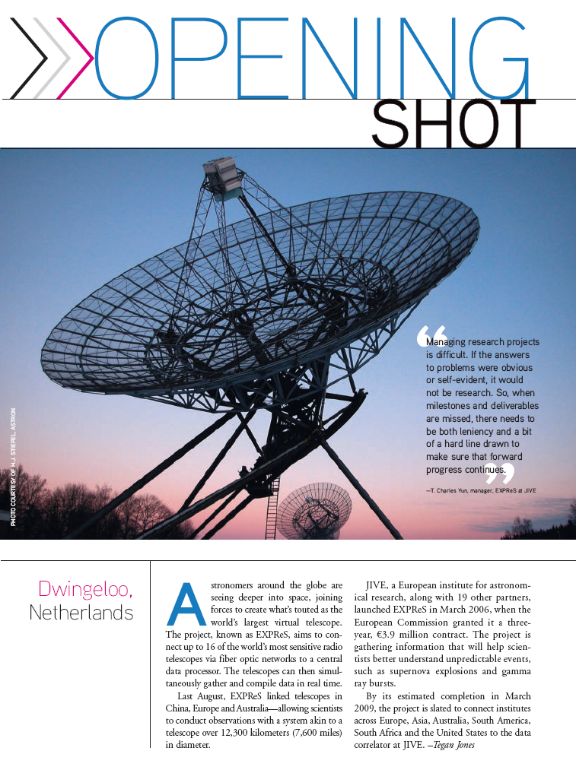
EXPReS is highlighted in PM Network Magazine, the official magazine of PMI (the Project Management Institute), cover on left, page 1 on right.

Section 3.1- SA1- Production e-VLBI Correlation
Additional Monitoring Tools
A new tool is being refined to chart and visualize the status of lightpaths connecting telescopes to JIVE. Briefly, the system collects SNMP calls from the existing router whenever the lighpath goes down. This data is generated only upon an event and as such, the visualization is a bit boring. However, the information is useful and several different revisions of the output have already been tested. Sample output from the system is provided below.
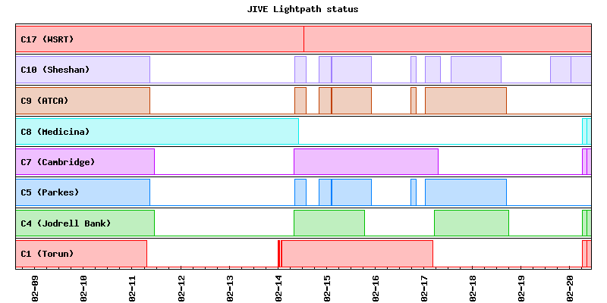
Visualization of JIVE Lightpath status
Channel Bonding
In order to support 1024 Mbps data rates, it is necessary to either use larger than 1000 Mbps (1.0 Gbps) connections or combine connections via a technique called channel bonding. Bonding has been tested locally to good results and the initial data is positive. The following graphs show that 1024 Mbps is possible using the channel bonding technique. Note, that to support 1024 Mbps, more than just 24 Mbps additional headroom is needed. The initial gigabit channel effectively supports ~990 Mbps and there is an additional bit of overhead for the headers. However, the total amount is still in the 40-50 Mbps range.
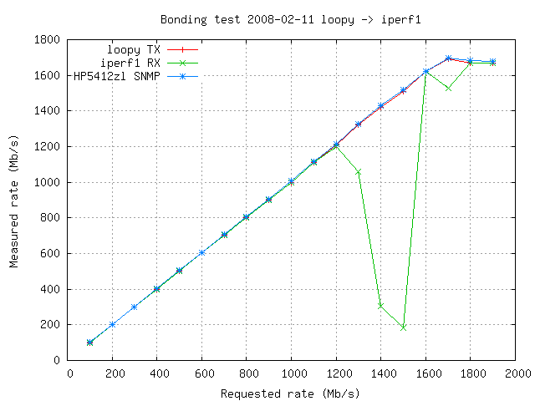
Throughput rates as measured by sender, receiver and middlebox (router)

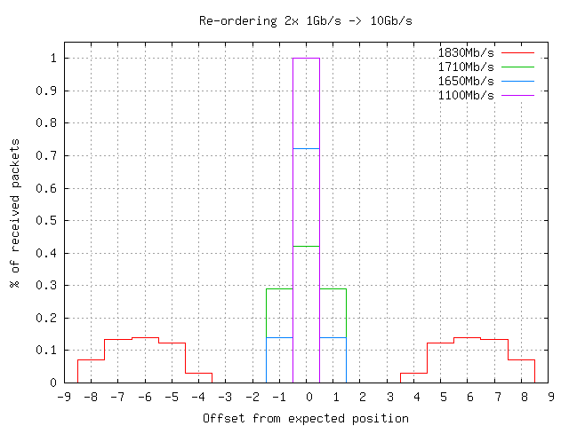
Packet reordering for various connectivity speeds

Arecibo Participates in e-VLBI
After a long absence, Arecibo has re-joined e-VLBI operations. On Tuesday 5 February, JIVE used its locally produced Mark5A control code (with UDP data transfer, inter-packet spacing tunability and drop (non-header) data packets at the sending side) to support the exchange. 64 Mbps produced fringes right away, 128 Mbps was only reached for very short periods, no doubt because of competing traffic. However by dropping 1 in 5 packets at Ar, steady green leds and good fringes were obtained, at an effective transfer rate of ~100 Mbps. After this success, we observed 3C395 with 6 stations at ~1 Gbps for several correlator-hours. The image below is from the observation.
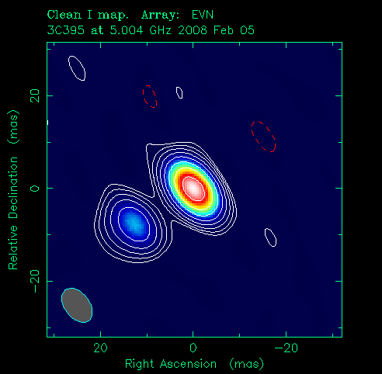
3C395 plot from the observation in which Arecibo participated
At this time, connectivity to Arecibo is still limited by a shared 155 Mbps connection to mainland USA. However, this situation is expected to improve very soon with promises that increased connectivity are coming. Bob Brown indicated at the Board Meeting that all the financial paperwork had been signed, so actual bits should be passing over the lines soon.
Section 3.2- SA2- Telescope Network Connections
There have been no significant developments in the connectivity status of telescopes in the past month.
Section 4.1- JRA1- FABRIC
Updates from the Board and Progress Meeting
The correlator code has been extensively profiled while running with some bottlenecks identified. Right now, the most important ones are decoding the input data (separating out the channels) and the fractional bit-shift correction (which uses two FFTs). The decoding of the input data effectively limits the input data rate to less than 200Mb/s. Work has started on optimization of the decoding process.
The new correlator output format has been implemented and is being tested. The software for converting the correlator output format into MeasurementSet format has been adapted for the new format. The first tests show that this format can be translated into the standardized FITS format used by the scientists to analyse the data.
Now that most components for the distributed correlation are there, we have started discussions with PSNC on how to test the integration of these components.
Appendix - EXPReS Contact Points
For convenience, a list of the activities and the associated contact points are listed here for reference.

ID | Description | Contact | email
PC | Project Coordinator | Huib Jan van Langevelde | langevelde // jive nl
NA1 | Management of I3 | T. Charles Yun | tcyun // jive nl
NA2 | EVN-NREN Forum | John Chevers | john.chevers // dante org uk
NA3 | e-VLBI Science Forum | John Conway | jconway // oso chalmers se
NA4 | Public outreach | Kristine Yun | kyun // jive nl
SA1 | Production Services | Arpad Szomoru | szomoru // jive nl
SA2 | Network provisioning | Francisco Colomer | f.colomer // oan es
JRA1 | FABRIC | T. Charles Yun | tcyun // jive.nl

