
Express Production Real-time e-VLBI Service
EXPReS is funded by the European Commission (DG-INFSO),
Sixth Framework Programme, Contract #026642

Monthly Report- April, May, June 2008
Title: | Combined Monthly Report for 3 months
Sub-title: | - April, May, June 2008
Date: | 2008 Jun 5
Filename:
Author: | T. Charles Yun, Project Manager, JIVE
Co-Authors | EXPReS Management Team
Summary: | EXPReS monthly update

Delivery Slip
 | Name | Partner | Date | Signature
From | T. Charles Yun | JIVE

Document Log
Version | Date | Summary of Changes | Authors
1.0
0.9 | 2008 Jun 6 | Final draft | tcyun
0.1 | 2008 Jun 5 | Initial draft | T. Charles Yun

Project Information
Project Acronym | EXPReS
Project Full Title | Express Production Real-Time e-VLBI Service
Proposal/Contract number | DG-INFSO #026642
Table of Contents
1. Introduction
2. Network Activity Updates
* NA1- Management
* NA2- EVN-NREN
* NA3- e-VLBI Science Forum
* NA4- Public Outreach, Dissemination and Communications
3. Specific Service Activity Updates
* SA1- Production e-VLBI Service
* SA2- Telescope Network Connections
4. Joint Research Activity Updates
* JRA1- FABRIC
5. Appendeces
Section 1.0- Introduction
The EXPReS Management Team just returned from Brussels where they presented the Period 2 report. The entire project was focused on the review and we believe that the result was a solid report and convincing presentations. The Project Office will receive written comments from the Commission in the near future and the actions to comments will be reported in the monthly updates.
Section 2.1- NA1 - Management
Administrivia
Per conversation with our science officer, the project did not submit a monthly report for March or April 2008 with the period review held at the end of May. This report is a summary of activities from March including some soon to be completed actions.
Note that the summer meeting season and holidays are upon us. The Project Manager will be travel for various meetings in June, July and August so reports will potentially be late. However, the meetings will cover EXPReS activities and reports from the meetings will be included in these documents.
Period 2 Review
EXPReS presented the annual report and next 18 month plan in Brussels at the end of May. The period 2 review completed successfully with positive verbal remarks. Copies of all of the documents (the full report, deliverables, presentations given in Brussels) are available in the protected section of the wiki:
http://www.jive.nl/dokuwiki/doku.php/expres:management:mt:secondannualreviewstart
In addition, meeting notes are also available, linked near the agenda.
Section 2.2- NA2 - EVN-NREN
The NREN community participated in TNC 2008 in Brugge, Belgium. The in-person forum was an excellent way for all of the participants to meet and catch up on information.
The EVN-NREN members were also provided an opportunity to prepare for the upcoming e-VLBI workshop in Shanghai, China. The meeting will be another opportunity to discuss the status of the network in China and a chance to meet in person.
Section 2.1- NA3 - e-VLBI Science Forum
The eVSAG will hold their next meeting via teleconference. The coordinating email has been sent out along with a partial agenda. Key topics include preparations for the end of project science and technology meeting as well as preparations for the next round of high-speed tests between sites. The draft agenda for the meeting is attached below.
e-VLBI test Dates
Test dates for e-VLBI have been announced, along with the observing schedule for the rest of the year.
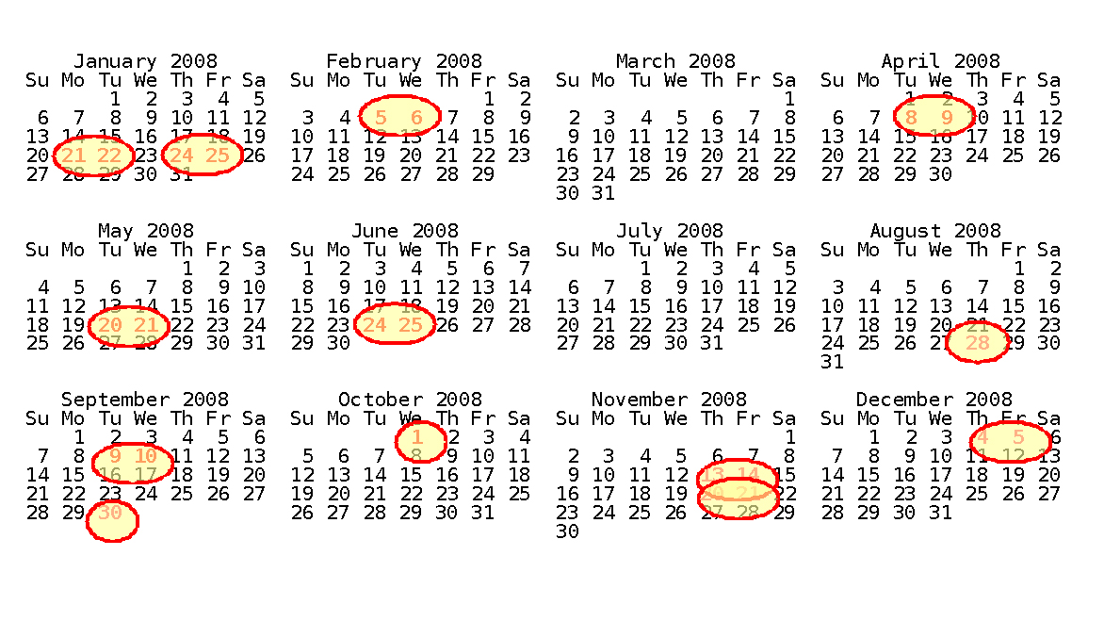
First Target of Opportunity Observation
In early April, Rossi X-ray Timing Explorer (RXTE) measurements indicated that X-ray binary Cygnus X-3 was undergoing a state change that was thought to indicate the start of flaring activity. Triggered by the RXTE data, we were able to conduct an e-VLBI observation using EVN telescopes on 9 April, just before Cyg X-3 became active. A week later the source indeed showed a violent outburst, which we observed with the e-EVN on 22 April, 24 April and 26 April. Astronomers quickly received their correlated data, and we expect scientific publication to result.
EXPReS Cited in publication
EXPReS was cited in another refereed journal paper (accepted for publication in Astronomy and Astrophysics). The paper is about "normal" VLBI observations of the highest redshift radio-detected quasar. This research made use of software tools (developed for EXPReS) to retrieve and process Westerbork synthesis array data recorded during VLBI runs.
The paper is on astro-ph as well:
arXiv:0805.0474
S. Frey, L.I. Gurvits, Z. Paragi, K.E. Gabanyi (2008)
High-resolution double morphology of the most distant known radio quasar at z=6.12
Section 2.1- NA4 - Public Outreach
TNC 2008
EXPReS coordinator Huib Jan van Langevelde was asked to provide the closing plenary talk for the TNC 2008 conference held in Brugge, Belgium on 23 May 2008. The presentation placed on spotlight on the achievements of EXPReS and e-VLBI and shows that radio astronomy is one of the most important users of advanced networks and network services.
Associated with the plenary was a demonstration in which several telescopes participated for the first time at higher speeds in e-VLBI. Additional information on the science is provide later in the report.
A press release discussing the observation was disseminated and has been picked up by many sources. To assist publishers, two press releases were created. One focuses on the science and astronomy of the demonstration, the other focuses on the networking technology. Copies of the releases are available via: <http://www.expres-eu.org/TERENA08_science.html> and < http://www.expres-eu.org/TERENA08_networking.html>.
Section 3.1- SA1- Production e-VLBI Correlation
Effelsberg Participates
Effelsberg has begun to participate in e-VLBI as of 1 April 2008. After troubleshooting some initial networking problems (the MTU between Effelsberg and JIVE turned out to be just a little smaller than the canonical 4470), the data arrived without problems and we got our first On-Ef an Tr-Ef fringes at 512 Mbit/s shortly after the antenna became available. Wb and Jb joined later, and fringes to those stations were seen too. Cm and Mc participated with formatted data only. We also ran at ~1 Gbit/s (with packet dropping) for a while, which didn't pose any problems for Effelsberg (and most of the other stations) either (see the attached fringe plot). At that point the total eVLBI network throughput was a record-breaking 6.71 Gbit/s (see plot).
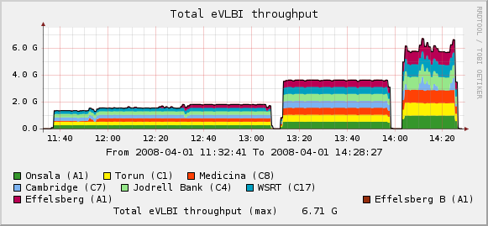 | 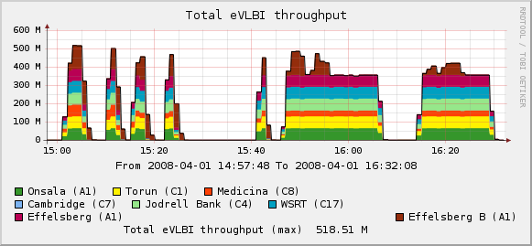
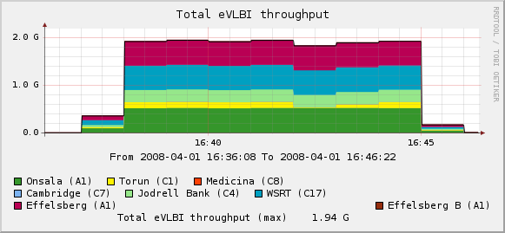 | 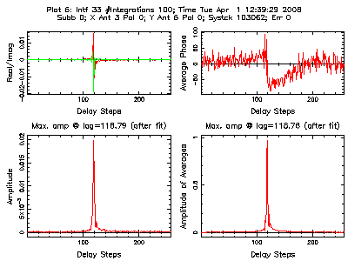
Network throughput diagrams and initial fringe plots from the first e-VLBI observation with Effelsberg.
Also tested was a new feature of the correlator control software. It is now possible to correlate stations running at different data rates, by reducing the number of subbands to 1/2, 1/4, etc. For this observation, Tr ran at 128 Mbps and Jb at 256 Mbps, with the rest of the array running at 512 Mbps . This worked perfectly, with the obvious lack of fringes in the dropped subbands. Using this feature will allow us to include stations like Arecibo or TIGO for which the available bandwidth is limited while running the rest of the array at the maximum data rate.
Deliverables
The software for Deliverable 92 “Software to create data product from distributed correlation” was uploaded to the wiki. The core of the code is now complete and marked “3.” The item will be marked fully complete once the final status of the correlator is known (near end of project).
Mark 5A and 5B tests
On 15 April, Effelsberg's Mark5A and Mark5B were connected to the same noise source. 128Mbps per Mark5 were sent to JIVE and played back on a Mark5A and Mark5A+ respectively. There were green LEDs at each station unit immediately and after syncing the Mark5B we instantaneously got a fringe between the Mark5A and Mark5B in the LCP signal as shown below.
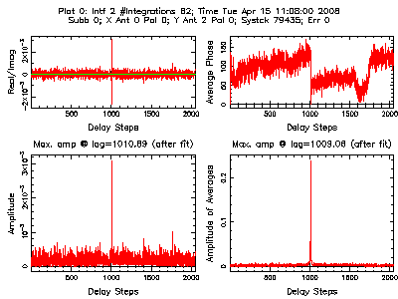
fringe0.gif showing fringes via Mark5A and Mark5B
The next step will be to observe an astronomical source with Mark5B equipment. This will happen once the schedule for the various participating bodies synchronize.
Channel Bonding
EXPReS’s desire to use channel bonding has been mentioned in the past. After some testing, it has been determined that the switch based method (802.3ad, LACP- Link Aggregation and Control Protocol) is not suitable and that a kernel level solution will be used instead. The main issue is the fact that router based systems assume that there are many different users with many different traffic flows. For e-VLBI, there is one flow to one destination, confounding the MAC/source-destination hash.
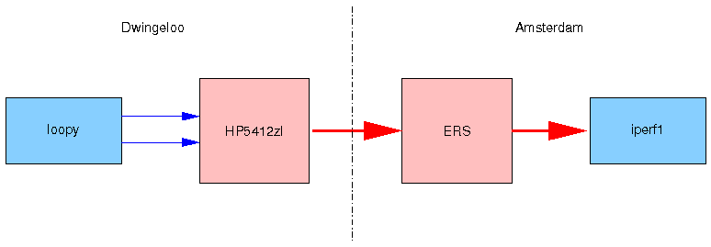
Kernel based solution to round-robin traffic across two paths.
The kernel based method has been tested at a variety of speeds assuring that the current network bandwidth necessary to support e-VLBI will function. Internally, test flows were generated and packet ordering was analyzed. The results below show that the round-robin method will be suitable.

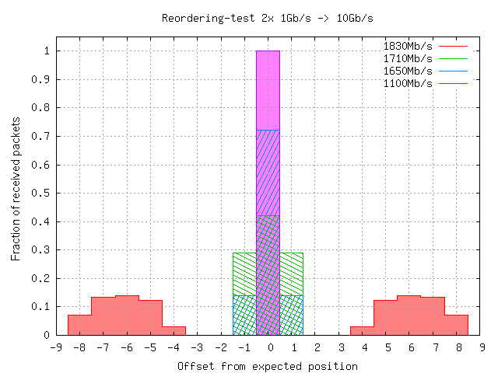
Diagram showing packet offset for flows recombined from two ports for various network speeds.

TERENA NETWORKING CONFERENCE 2008, Demonstration, TIGO-Arecibo Fringes
During the first full week of May, both TIGO and Arecibo participated in e-VLBI. The first fringes from their observations are shown below.
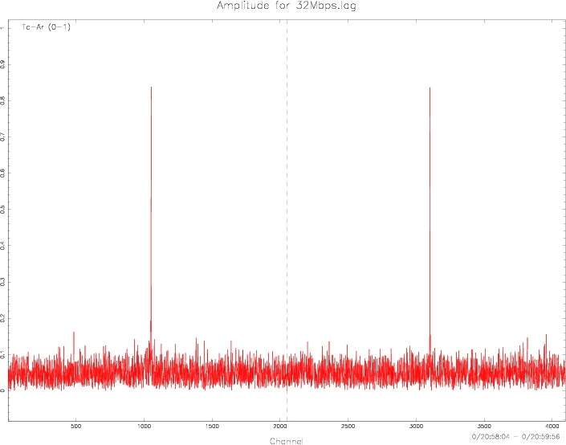 | 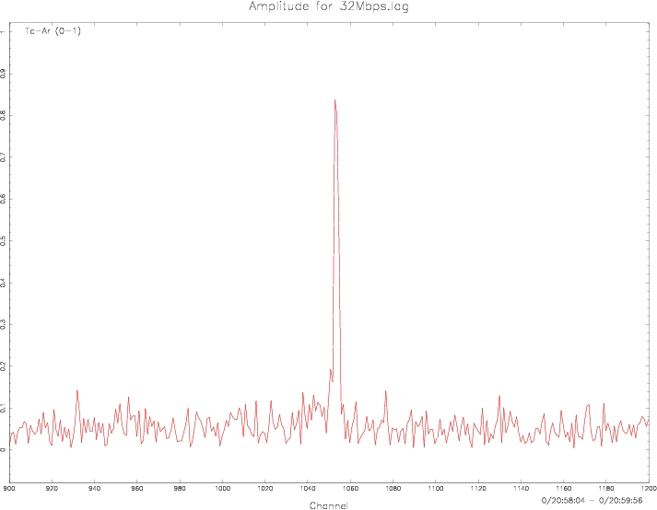
Fringe Plots from the TIGO-Arecibo demo
This work was in preparation for the TNC 2008 Demo where the observation was running at 256 Mbps for Arecibo and the European telescopes, TIGO and Hart joined at 64 Mbps -this mixed type of operation was notpossible earlier, the lowest connectivity always determinedthe maximum data rate we achieve.
I am sure that the results of this test will have important implications for the science runs later this year.
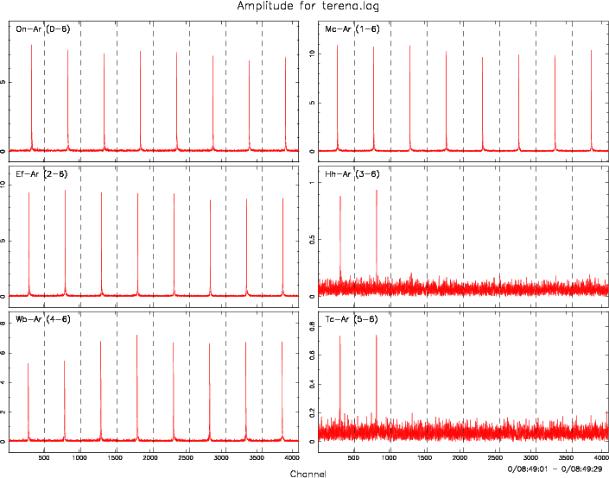
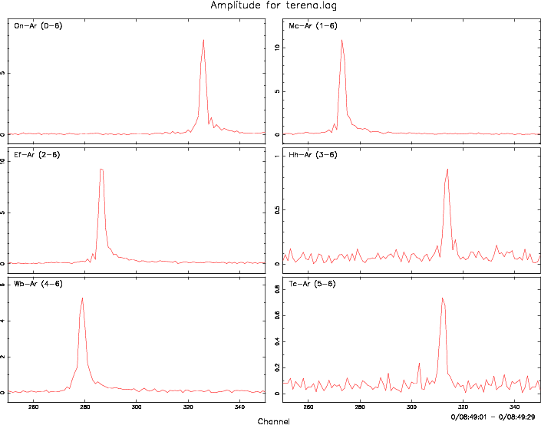
Fringe Plots from the TNC 2008 Demonstration
A press release highlighting the demo and the closing keynote was also released, and is described more fully in the NA4 section of this report.
Section 3.2- SA2- Telescope Network Connections
Effelsberg Connectivity Announcement
As noted above, Effelsberg has connectivity and is participating in e-VLBI. Richard Porcas announced the achievement via email to several lists (see below).
Subject: [vlbi] Effelsberg and EVN eVLBI
From: "Richard Porcas" <p222rwp@mpifr-bonn.mpg.de>
Date: Fri, April 18, 2008 15:26

Effelsberg 100m telescope available for EVN eVLBI runs

Following tests of the new optical fibre connection
between Effelsberg and Bonn, and successful "first fringes"
at the EVN correlator at JIVE with 6 other telescopes
(see http://www.mpifr-bonn.mpg.de/public/pr/pr-evlbi-en.html)
the MPIfR is pleased to announce that the Effelsberg 100m
telescope will be made available for future EVN eVLBI
sessions, starting with the run on 20 May 2008.

For further information on EVN eVLBI runs, consult:
http://www.evlbi.org/evlbi/evlbi.html

Richard Porcas
HartRAO Demo
EXPReS encountered a pleasant surprise when we discovered that Hartebeesthoek would have limited connectivity sooner than expected. The timing coincided with a visit to their facility by several EC officials. To showcase the connection, EXPReS partners worked to execute the first e-VLBI demo with HartRAO.
The new connection was via Johannesburg and London. It was provided on the 1 May, tested on the 2nd and used in an e-VLBI demo on the 5th. Although we were informed that the bandwidth limit would be 50 Mbps, the tests showed that 64 could be sustained, and even (for a very short time) 128 Mbps. Participating telescopes were Mc, Tr, On, Cm, Jb and Ar. For a very short time (few minutes) we actually did get a fringe between Hh and Ar (second appended photo).
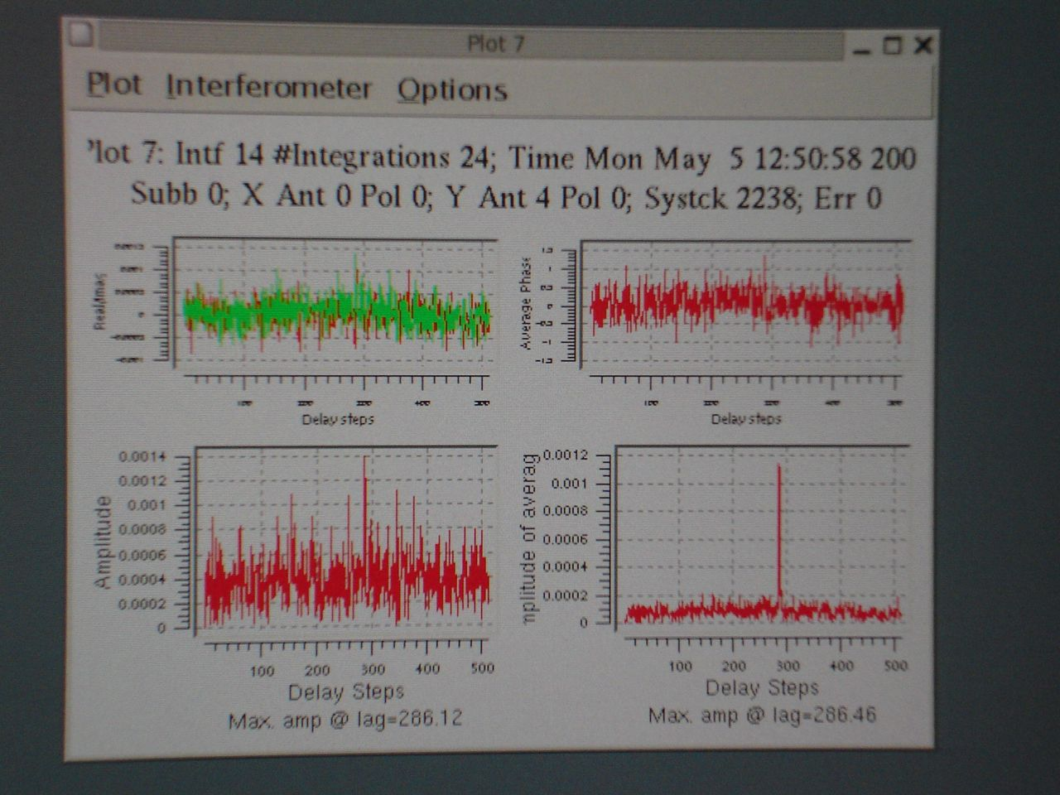
Fringe plot during the HartRAO demo
MERLIN/JIVE Connectivity
he links between JIVE and MERLINE were provisioned quite some time ago, but there were lingering problems on the link. The link was made operational through some short-term fixes in late April 2008, Jodrell Bank made the switch-over to the GEANT lightpaths. After additional testing, the root cause of the problem (a configuration mismatch) was discovered and resolved, and the lightpaths became fully operational on 2008-10-01.
Section 4.1- JRA1- FABRIC
4 Gbps Data Recorder
Metsähovi has shared a preliminary document describing a 4 Gbps data recording system that could support future, high-speed e-VLBI observations. The document indicates that sustained 4 Gbps write speeds have been recorded from 10 Gbps network connections using COTS equipment (both PATA and SATA drives).
Personnel
JVIE Continues to seek to fill the software engineering position vacated earlier in the year. Interviews with several candidates have been completed, but a suitable replacement has not yet been found.
Appendix - EXPReS Contact Points
For convenience, a list of the activities and the associated contact points are listed here for reference.

ID | Description | Contact | email
PC | Project Coordinator | Huib Jan van Langevelde | langevelde // jive nl
NA1 | Management of I3 | T. Charles Yun | tcyun // jive nl
NA2 | EVN-NREN Forum | John Chevers | john.chevers // dante org uk
NA3 | e-VLBI Science Forum | John Conway | jconway // oso chalmers se
NA4 | Public outreach | Kristine Yun | kyun // jive nl
SA1 | Production Services | Arpad Szomoru | szomoru // jive nl
SA2 | Network provisioning | Francisco Colomer | f.colomer // oan es
JRA1 | FABRIC | T. Charles Yun | tcyun // jive.nl
Appendix - Draft Agenda for eVSAG teleconference
On 3 June 2008, John Conway distributed an email organizing the next eVSAG meeting. The meeting will be via teleconference instead of face to face meeting (quoting John, “[a] face-to-face meeting is obviously best for communication but is very expensive in money, peoples time (most of 3 days which is 1.3% of mine and probably your annual work time) and also in the CO2 produced”). An early agenda was also distributed and is copied below.

1) Station reports (short written submission only)

2) Technical progress in NA1 - progress on near-1Gbps, eVLBI+record, cross
correlation of different bit rates, adding
global stations etc

3) Technical progress in JRA, 4Gbps tests, software correlation

4) Report from Shanghai eVLBI meeting + geodesy eVLBI

5) Planning for near end of project Science/Technical workshop in
June (?) 2009

6) PC report on eVLBI proposals submitted/scheduled in last year

7) eVLBI observing policy

a) Adding new frequency bands for eVLBI or just allow proposals
at any EVN band soon?
b) Triggered observations of generic class objects, clarification
of EVN policy
c) Interaction of triggered and ToO obs.
d) Modifiying sessions/policy to best exploit Arecibo high bit rate
observing?
e) Blue sky thinking, after running the present policy for 4 calls
keep with this or are there more radical changes that could/should
be implemented?
f) Start to incorporate eVLBI into regular sessions?
g) Possible eVLBI + software correlation science demos

Probably 2-3 hours minimum is needed to cover all the above,
I suspect that point 7 will be the most lively, the idea is that we
should raise ideas for observing policy that the EVN PC can then
decide on at its June 27th meeting.

John

Appendix - Call for EVN eVLBI proposals -deadline June 1st
On 15 May 2008, John Conway distributed the EVN e-VLBI call for proposals to the EVN mailing list. This message is then forwarded to many other groups. A copy of the note is available below. Note that the ToO process changes are included in the text of current calls.

CALL FOR EVN eVLBI SCIENCE PROPOSALS - DEADLINE 1st JUNE
------------------------------------------------

Proposals for EVN eVLBI observations are invited for submission. New
features include;

* The Effelsberg 100m telescope has been successfully tested for eVLBI
(http://www.expres-eu.org/Effelsberg.html) and will participate in
future scheduled EVN eVLBI observations.

* A transmitted data rate of 512Mbit/s is expected for the participating
European antennas. Lower bitrates for spectral line observations are
also supported.

* Proposals for any science goal, not just rapid response science can
be made. In addition a special class of 'triggered' proposal for the
pre-set eVLBI dates is supported. Finally eVLBI can be combined with
EVN session disk observations for denser time monitoring of variable
sources.

* eVLBI can also be used for EVN Target-of-Opportunity (ToO) observations
set-up at short notice on any date for high priority unanticipated events.
See the EVN ToO policy at http://www.evlbi.org/proposals/too.nov07.pdf

---------------------------------------------------------------------------
Upcoming scheduled eEVN runs are

Run start Run end

Tue 9th Sep 13:00 UTC Wed 10th Sep 13:00 UTC
Tue 30th Sep 13:00 UTC Wed 1st Oct 13:00 UTC
Thu 13th Nov 13:00 UTC Fri 14th Nov 13:00 UTC
Wed 19th Nov 13:00 UTC Thu 20th Nov 13:00 UTC
Thu 4th Dec 13:00 UTC Fri 5th Dec 13:00 UTC

In the first half of 2009 eVLBI runs are likely to be scheduled at
approximately the same rate between EVN disk sessions.

Participating eEVN antennas are Ef, Wb (tied array, except 5cm), Tr, On, Mh,
Mc, Jb2, Cm. In addition in some runs other stations (e.g. Ar and Sh)
may be added on a best effort basis when technically feasible.

Wavelength bands covered are 18/21cm, 6cm, 5cm and 1.3cm. Please see
http://www.evlbi.org/evlbi/e-vlbi_status.html for the availability of
different eVLBI stations per observing band.

Note that because of on-going engineering work participation of Jb2
and Cm cannot be guaranteed and/or they may be replaced by other
MERLIN telescopes.

---------------------------------------------------------------

TECHNICAL DETAILS

CONTINUUM OBSERVATIONS - will be run at the highest possible reliable
bit rate. Based on recent experience it is expected that at least 512 Mbit/s
will be achieved (however Cm is presently limited to 128 Mbit/s of useful
data by its microwave link). Continuum observations can be proposed for
only one of the available frequency bands in any given 24hr session.

SPECTRAL LINE OBSERVATIONS - can be carried out at data rates
between a minimum of 32 Mbit/s and a maximum of 512Mbit/s. For two-bit,
dual-polarisation observations, the lower limit implies at least
4 channels of 4 Msample/sec sampling (Nyquist channel bandwidth = 2MHz;
with oversampling possible down to spanned channel bandwidths of 0.5MHz).
Observations may be proposed for the 18cm/21cm, 5cm and 1cm bands.
Note that only standard and short observation proposal types (see below
for definitions) are allowed for spectral line observations. Triggered
spectral line proposals will not be accepted.

-------------------------------------------------------------------------

eVLBI OBSERVATION CLASSES

Proposals submitted to use eVLBI on the fixed dates defined above fall
into the three classes as defined below. Time within the first two
classes will only be allocated in response to proposals submitted for the
standard EVN proposal deadlines of 1st Feb, 1st June and 1st Oct. PI's
should make clear in the proposal text which class of observation is
being requested.

1) General eVLBI proposals

Any proposal requesting eVLBI observing time during one or several
eVLBI sessions, excluding triggered response science (see below).
General eVLBI proposals can be for any scientific purpose and do not need to
be justified based on the rapid data delivery of eVLBI. Proposals
for source monitoring may also request complementary observing time
during regular EVN sessions using disk recording. Note that the eVLBI
portion of monitoring proposals cannot be guaranteed in every requested
run as they may be overridden by higher rated, triggered eVLBI proposals
(see below). General eVLBI proposals can be either continuum or spectral
line. Scheduling will be done by JIVE staff using the technical
information included in the proposal; it is therefore vital that all
technical aspects are fully specified in the proposal.

2) Triggered eVLBI proposals

A proposal to be scheduled during an eVLBI run only if a specific
triggering criterion is met. Only continuum observations can be
proposed for within this class. Triggered proposals must include a
precise and justified triggering criterion. They must also give an
estimate of likely time intervals between trigger events, and a maximum
number of trigger events that will be observed. The maximum period for
which a triggered proposal will remain active is one year.

PIs of successful proposals in this class will be informed after
proposal review that their trigger requests will be accepted. Such
trigger requests should be sent by e-mail to the EVN PC Chair (Tiziana
Venturi (tventuri@ira.inaf.it)with copies to the EVN Scheduler
(Richard Porcas <porcas@mpifr-bonn.mpg.de> and JIVE/EXPReS
(Bob Campbell <campbell@jive.nl>, Zsolt Paragi <zparagi@jive.nl>).
These trigger requests must be received no later than 0800 UT
the day before the eVLBI run. The email should provide evidence that
the trigger criterion in the original proposal has been met and
give the exact GST range and source position requested. All requested
technical parameters must match those in the original proposal.
The PC Chair will evaluate the trigger request (and decide on
priorities if more than one conflicting trigger request is received) and
will inform the PI by 1700UT whether their experiment is to be observed.
The experiment will then be scheduled by JIVE staff in accordance with
the instructions given in the original proposal.

3) Short eVLBI observations

Short eVLBI observations may be requested in order to rapidly obtain
results in preparation for a later proposal. Examples include checking
calibrator or target source compactness. These projects are limited to less
than 2 hours in length. Such requests may be submitted up to three
weeks prior to the start of any eVLBI run directly to the EVN PC Chair.
There is no need to submit a full proposal via Northstar but the email
to the Chair must clearly indicate the purposes and observing details of
the proposed observation. A standard VLBI coversheet should also be sent
including information on proposed observing modes, stations/GST ranges and
precise positions for all targets and calibrators. The information sent
must be sufficient to allow central scheduling of the observations by JIVE
personnel.

2) Triggered eVLBI proposals

A proposal to be scheduled during an eVLBI run only if a specific
triggering criterion is met. Only continuum observations can be
proposed for within this class. Triggered proposals must include a
precise and justified triggering criterion. They must also give an
estimate of likely time intervals between trigger events, and a maximum
number of trigger events that will be observed. The maximum period for
which a triggered proposal will remain active is one year.

PIs of successful proposals in this class will be informed after
proposal review that their trigger requests will be accepted. Such
trigger requests should be sent by e-mail to the EVN PC Chair (Tiziana
Venturi (tventuri@ira.inaf.it)with copies to the EVN Scheduler
(Richard Porcas <porcas@mpifr-bonn.mpg.de> and JIVE/EXPReS
(Bob Campbell <campbell@jive.nl>, Zsolt Paragi <zparagi@jive.nl>).
These trigger requests must be received no later than 0800 UT
the day before the eVLBI run. The email should provide evidence that
the trigger criterion in the original proposal has been met and
give the exact GST range and source position requested. All requested
technical parameters must match those in the original proposal.
The PC Chair will evaluate the trigger request (and decide on
priorities if more than one conflicting trigger request is received) and
will inform the PI by 1700UT whether their experiment is to be observed.
The experiment will then be scheduled by JIVE staff in accordance with
the instructions given in the original proposal.

3) Short eVLBI observations

Short eVLBI observations may be requested in order to rapidly obtain
results in preparation for a later proposal. Examples include checking
calibrator or target source compactness. These projects are limited to less
than 2 hours in length. Such requests may be submitted up to three
weeks prior to the start of any eVLBI run directly to the EVN PC Chair.
There is no need to submit a full proposal via Northstar but the email
to the Chair must clearly indicate the purposes and observing details of
the proposed observation. A standard VLBI coversheet should also be sent
including information on proposed observing modes, stations/GST ranges and
precise positions for all targets and calibrators. The information sent
must be sufficient to allow central scheduling of the observations by JIVE
personnel.

-------------------------------------------------------------------------

PROPOSAL DETAILS

Proposals requesting observing time for the above runs should
be submitted by the 1st June 2008 deadline. Proposals can be made for
any length of time within the above advertised slots up to 24 hours in
length. Short time requests (defined above) of up to 2 hours in length
can be submitted directly to the PC Chair up to three weeks before
each run. Proprietary rights on all eVLBI data are the standard ones
of one year after data distribution (see archive policy at
www.evlbi.org/user_guide/archive_policy.html). All standard and
triggered proposals must use the Northstar online submission tool
(see details below).

Because detailed scheduling of eVLBI runs will be done by JIVE staff
all eVLBI proposals must include the observing frequency, the requested
GST range, the minimum bit rate and a minimum number and configuration
of telescopes required. It is essential that standard proposals also
include accurate target and calibrator positions. For triggered proposals
as much information as possible should be given about potential targets
and their calibrators, which will help in evaluating the technical
feasibility of the proposed observations.

The technical details of all proposals must be discussed with JIVE
staff prior to submission to ensure proper and efficient scheduling
(contact campbell@jive.nl).

-----------------------------------------------------------------

HOW TO SUBMIT

The on-line proposal submission tool Northstar replaces the old
Latex-email way of submission for proposals which involving the
EVN, including proposals for eVLBI runs (an exception to this
at present are ToO proposals which are submitted by email according
to the procedure described at http://www.evlbi.org/proposals/too.nov07.pdf).

To use Northstar proposers should register at http://proposal.jive.nl
(only for the first proposal submission), complete the technical information
on-line (equivalent to that previously in the cover-sheet) and upload
a scientific justification in pdf or ps format. Standard page limits apply
and will be enforced. If there are any problems with running Northstar
contact Antonis Polatidis at JIVE (polatidis@jive.nl). The deadline for
submission for standard and triggered proposals is 23:59:59 UTC on 1st
June 2008.

-----------------------------------------------------------------------

ACKNOWLEDGEMENT

The continuing development of eVLBI within the EVN is made possible
via the EXPReS project funded by the EC FP6 IST Integrated infrastructure
initiative contract #026642 - with a goal to achieve 1 Gbit/s eVLBI real
time data transfer and correlation.

--------------------------------------------------------------------

John Conway - Chairman EVN eVSAG (eVLBI Science Advisory Group)

