
Express Production Real-time e-VLBI Service
EXPReS is funded by the European Commission (DG-INFSO),
Sixth Framework Programme, Contract #026642

Monthly Report- Sep 2007
Title: | Monthly Report
Sub-title: | - Sep 2007
Date: | 2007 Nov 08
Filename:
Author: | T. Charles Yun, Project Manager, JIVE
Co-Authors | EXPReS Management Team
Summary: | EXPReS monthly update

Delivery Slip
 | Name | Partner | Date | Signature
From | T. Charles Yun | JIVE

Document Log
Version | Date | Summary of Changes | Authors
1.1 | 2007 Nov 08 | spelling corrections | tcy
1.0 | 2007 Oct 04 | final | tcy
0.8 | 2007 Sep 29 | Draft | tcy
0.1 | 2007 Sep 27 | Initial draft | T. Charles Yun

Project Information
Project Acronym | EXPReS
Project Full Title | Express Production Real-Time e-VLBI Service
Proposal/Contract number | DG-INFSO #026642
Table of Contents
1. Introduction
2. Network Activity Updates
* NA1- Management
* NA2- EVN-NREN
* NA3- e-VLBI Science Forum
* NA4- Public Outreach, Dissemination and Communications
3. Specific Service Activity Updates
* SA1- Production e-VLBI Service
* SA2- Telescope Network Connections
4. Joint Research Activity Updates
* JRA1- FABRIC
5. Appendices
Section 1.0- Introduction
The summer is officially over with an upswing in activity and travel. Most of the activities participated in various workshops and meetings over the past month. The e-VLBI workshop gathered most of the "e" specific researchers from around the world and EXPReS was well represented. Other fairly complex activities are hiding behind the simple descriptions of "investigating the problem." The monitoring and tracking tools that are now in place should help with the process.
Section 2.1- NA1 - Management
PPAM 2007
EXPReS was asked to present at PPAM 2007 <http://www.ppam.pl/> and the project manager was selected to make a workshop presentation. The presentation outlined the project goals and activities to date and linked the work with the other activities presented in the session. The workshop provided a good opportunity to exchange information with other projects that were working on computation-intensive projects as well as to compare some of EXPReS's networking requirements against other applications.
e-VLBI Workshop
There is an annual e-VLBI meeting that attracts astronomy and technical participants from the field called the International e-VLBI Workshop. The sixth annual meeting was held in Bonn between the 17th and 18th of this month. EXPReS was a significant participant both in presentations and as well in the organization of the event. Arpad Szomoru (SA1) and Tasso Tzioumis (vice-chair of the EXPReS Board) were on the Programme Committee. EXPReS also provided some support for organization and dissemination activities. Additional information about the workshop is available via <http://www.mpifr.de/old_mpifr/div/vlbi/6th_evlbi/index.html>.
The 6th International e-VLBI Workshop was an ideal opportunity to hold EXPReS related meetings. Both EVN-NREN (NA2) and FABRIC (JRA1 WP1) organized meetings to be held in association with the workshop. Both the EVN-NREN and the FABRIC meetings were well attended.
Each of the activity leaders received and responded to a request to update the deliverables list on the wiki. The list should reflect the most up to date information.
EARNEST Workshop
EXPReS was invited to participate in the EARNEST workshop and was represented by the project manager. Details of the workshop are available <http://www.terena.org/activities/earnest/>.
Videoconference Solicitation
The project manager distributed an informal note to each of the partner sites requesting feedback on videoconferencing preferences. Most sites responded, but a clear consensus on tools was not achieved. The two most popular options (three votes each) were open source AccessGrid <http://www.accessgrid.org/> and the commercial solution from WebEx <http://www.webex.com/>. We will pursue a test conference sometime "soon" with some of the more experienced sites. The primary hurdle is local- the video room at JIVE is currently being updated.
Section 2.2- NA2 - EVN-NREN
EVN-NREN gathered for a meeting after the e-VLBI Workshop in Bonn, Germany on Wed 19 Sep 2007. Minutes and presentations will be made available on the project wiki.
Section 2.1- NA3 - e-VLBI Science Forum
The eVSAG continues to discuss how changes to e-VLBI scheduling can be made with regard to target of opportunity observations. The discussions are active and should result in written comments that will be shared within the community.
Section 2.1- NA4 - Public Outreach
After the successful EU-CN-AU demo, a handful of small issues arose from the wording of the press release. Specifically, several networking partners asked to be included in the "Participating Network Organizations" section. A round of email was exchanged to make sure that all networking partners were properly identified and the online text has been updated. More slowly, a process is being identified to address two points. The first point is how a partner was skipped in the original release. The second point is more sensitive and deals with the concern that the press release's boilerplate (the text describing JIVE, EXPReS and listing the participants) is significantly longer the press release itself. We are speaking with other outreach professionals to see how they address the problem of projects with large numbers of participants who contribute at varying levels of time, resources and energy.
Due to additional information about the type of upcoming meetings, JIVE and Jodrell Bank are considering a shift from the initially planned booth display stand to a different type of meeting support object. Several factors have lead to this consideration. First, the types of meetings that EXPReS personnel attend generally do not involve display stands. Additionally, the personnel who do attend meetings are not enthusiastic about setting up the display. Lastly, it is unclear the number of upcoming meetings that could take advantage of the display. Kristine Yun and Alastair Gunn have begun an email exchange to determine alternatives. They will deliver alternatives and timetables for their release once ideas have been traded.
Section 3.1- SA1- Production e-VLBI Correlation
Network Monitoring and Graphing
JIVE has installed and made publicly available information regarding the status of the network connections that support e-VLBI. The graphs are available at <http://graphs.jive.nl/>. The monitoring has been in place for several months, but the availability of the data has not been widely shared. The URL is now public as we feel most of the minor bugs have been removed from the system. The information is proving useful to many of our partners as network connections are tested.
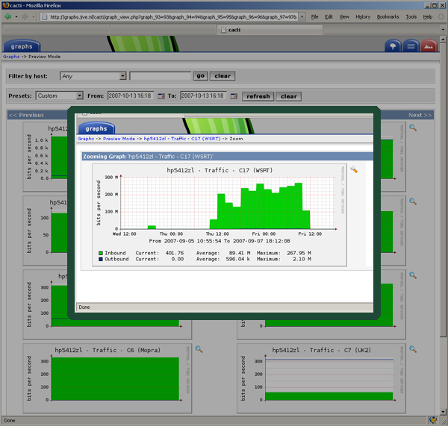
Sample output from network monitoring system from a randomly selected day
Lightpaths and test to Australia
EXPReS is preparing for a 3 x 1 Gbps lightpath test with Australia. A few issues have been identified with the link and are being investigated by members from all sides. The most interesting problem is a problem that causes network throughput to drop at periodic intervals. Progress is being made on this front, but the time difference between sites introduces a bit of delay. See the graph below for some additional information.
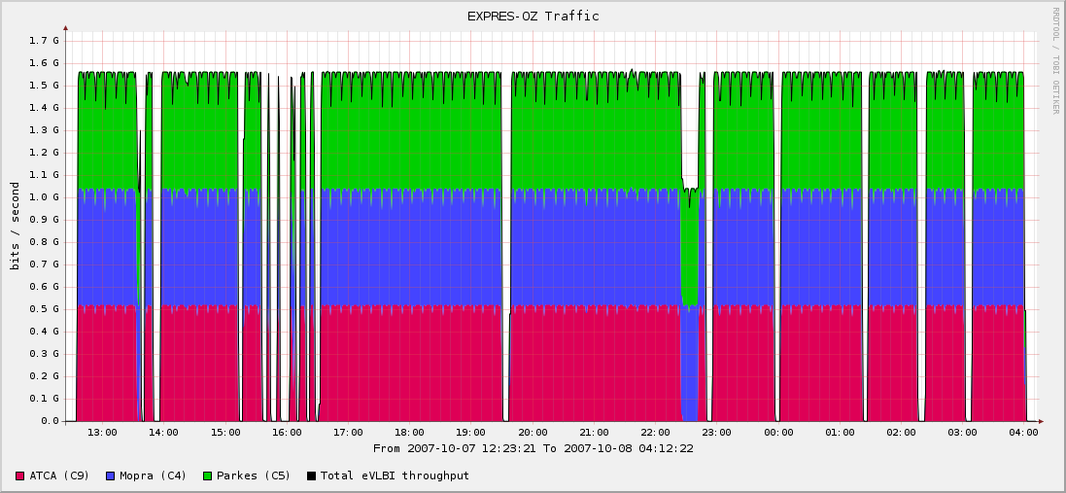
Network traffic between NL and AU indicating periodic throughput problems.

Section 3.2- SA2- Telescope Network Connections
Arecibo has shared that they are expecting improved connectivity. At this time, the upgrade plans are not yet finalized, but there are high hopes that by the end of the year, connectivity will be stabilized for the dish.
Section 4.1- JRA1- FABRIC
6th e-VLBI Workshop, Bonn, Germany
MPIfR, the Max-Planck-Institut für Radioastronomie, hosted the e-VLBI workshop and the follow on FABRIC business meeting. Details of the meeting are available via the URL <http://www.mpifr.de/old_mpifr/div/vlbi/6th_evlbi/index.html>. A software correlator status report generated a great deal of discussion, providing important feedback and useful commentary on the process.
Following the end of the official workshop, FABRIC WP1 held a follow on meeting. Presentations from this session are available on the project wiki via <http://www.jive.nl/dokuwiki/doku.php/expres:wp1_2007sep_mtg>.
Update from ASTRON
Within the EXPReS/ FABRIC project ASTRON performs a task which concerns a workload of 12 man-months. The biggest part of this FABRIC task is performed by the ASTRON employees. However, for the other part of the (remaining) work additional manpower is needed that must come from outside of ASTRON. Due to the nature of this remaining work, for which an experienced network engineer is needed and the fact that only a very limited amount of hours are available for performing the remaining work, the finding of a suitable hire is difficult. Therefore it is ASTRON's intent to use a subcontractor for performing the remaining work. For selecting the subcontractor three quotations from three companies were requested. The quotation with the lowest hour rate was selected for performing the ASTRON-FABRIC work.
The costs that are related to the use of the subcontractor are: at 85 euro per hour (excluding tax, including travel) the total subcontractor cost forecast is: 60keuro.
The last deliverable of ASTRON in the FABRIC project, which is scheduled in month 18, concerns the realization and test of a data link between the E-LOFAR station at Effelsberg (Germany) and the LOFAR central processor at Groningen (the Netherlands). To realize this link, a fiber needs to be deployed between Bonn (Germany) and Effelsberg. Obtaining the required licenses for the deployment of this link was delayed. This caused a delay in finishing the deliverable. Since the deployment of the mentioned fiber cable is not yet completed, the amount of delay is currently unclear. As soon as the fibers are in place and available for testing, the amount of delay will be reported.
Work Package 2- Distributed Correlation
WP2 has nearly completed the VEX to Control File software interface. This interface is still waiting on finalization of the data product; work on the data product is currently underway. That stated, the software continues to evolve and improve to keep up with the developments in other parts of the software, particularly the core Correlator software.
Appendix - EXPReS Contact Points
For convenience, a list of the activities and the associated contact points are listed here for reference.

ID | Description | Contact | email
PC | Project Coordinator | Huib Jan van Langevelde | langevelde // jive nl
NA1 | Management of I3 | T. Charles Yun | tcyun // jive nl
NA2 | EVN-NREN Forum | John Chevers | john.chevers // dante org uk
NA3 | e-VLBI Science Forum | John Conway | jconway // oso chalmers se
NA4 | Public outreach | Kristine Yun | kyun // jive nl
SA1 | Production Services | Arpad Szomoru | szomoru // jive nl
SA2 | Network provisioning | Francisco Colomer | f.colomer // oan es
JRA1 | FABRIC- WP1  FABRIC - WP2 | T. Charles Yun  Mark Kettenis | tcyun // jive.nl  kettenis // jive.nl

