
Express Production Real-time e-VLBI Service
EXPReS is funded by the European Commission (DG-INFSO),
Sixth Framework Programme, Contract #026642

Monthly Report- Nov/Dec 2007
Title: | Monthly Report
Sub-title: | - Nov/Dec 2007
Date: | 2007 Dec 17
Version: | DRAFT
Filename:
Author: | T. Charles Yun, Project Manager, JIVE
Co-Authors | EXPReS Management Team
Summary: | EXPReS monthly update

Delivery Slip
 | Name | Partner | Date | Signature
From | T. Charles Yun | JIVE

Document Log
Version | Date | Summary of Changes | Authors
0.8 | 2007 Dec 17 | Draft | tcy
0.1 | 2007 Dec 6 | Initial draft | T. Charles Yun

Project Information
Project Acronym | EXPReS
Project Full Title | Express Production Real-Time e-VLBI Service
Proposal/Contract number | DG-INFSO #026642
Table of Contents
1. Introduction
2. Network Activity Updates
* NA1- Management
* NA2- EVN-NREN
* NA3- e-VLBI Science Forum
* NA4- Public Outreach, Dissemination and Communications
3. Specific Service Activity Updates
* SA1- Production e-VLBI Service
* SA2- Telescope Network Connections
4. Joint Research Activity Updates
* JRA1- FABRIC
Section 1.0- Introduction
Due to the imminent holidays and associated travel, this report will cover the November and December period. Regular monthly reports will resume in January.

Section 2.1- NA1 - Management
EXPReS Progress and Board Meeting
Final plans for the EXPReS Progress and Board meetings have been distributed. The meetings will be held at the end of January in Utrecht, the Netherlands. Details are available on the project wiki at < http://www.jive.nl/dokuwiki/doku.php/expres:2008jan_board>.
e-Concertation Meeting
The Project Manager and three other EXPReS participants were present at the 4th e-Infrastructure Concertation held in Sophia-Anitpolis, France. One of the requests from the meeting was for projects to discuss and determine the ways in which they implement, use and propose standards. With this charge, the project manager returned to speak with several project members inside his home institute.

As pointed out during the meeting, the definition of a standard varies based on the type of work that is being carried out. Our network engineers all indicated that they were "standards compliant" becuase they transfered data over the internet using TCP and UDP. Compliance to the stadard definition of TCP and UDP is necessary for successful data excahnge. Some of the astronomers indicated that they worked on "standardizing" the way in which data was stored onto disk, but that this process was difficult due to proprietary hardware. In their mind, the data format was standardized, but the mechanism to put the data onto disk was via a non-standard, proprietary device.

During the discussions, the Project Manager also asked with what standards groups the project participants interacted. In general, there was little direct interaction with standards setting bodies. The initial examples given were ISO and IETF. However, through conversation, mentioning groups like OGF did bring a change in the conversation. While none of those contacted worked closely with OGF, many stated that it was a more likely body than others. [Note: Richard Hughes-Jones works very closely with OGF and the grid community at large. I spoke with him at the workshop, but do not include those discussions in the initial group that I cover here.]

The proejct manager will continue to pursue these converstations, but requests clarification from the Comission as to what direction the conversations should take and how much energy should be placed into the activity.
Ongoing discussions with MIT Haystack
As mentioned in the previous report, MIT Haystack has not delivered the software modifications as expected. Following on the face to face meeting at the end of October, regular teleconferences have been held. While frustrating, it is understood that the problems are truely difficult and tie into the highly complicated hardware/software combination that drives the communication into and out of the correlator.
Exerting exceptional pressure is probably not constructive. Instead, JIVE is working with MIT to isolate the most important elements of the work and to see if the existing pieces of code can be shared so that additional development and trouble shooting can be distributed across different teams. To that end, the current source three will be shared and reviewed. All parties hope for progress and good news on the next scheduled call in mid-January 2008.
Section 2.2- NA2 - EVN-NREN
The EVN-NREN leader participated in the e-Concertation meeting held in the south of France earlier in December. During this meeting, there were several opportunities to discuss efforts that may be similar and useful across projects.
e-VLBI Workshop
Shanghai Observatory will host the next e-VLBI Workshop. We expect that a large number of EXPReS partners will participate in the meeting. The Project Office is working closely with the organizing committee to provide basic assistance and support. The initial announcement has been distributed and the first call for talks should be distributed around the New Year. EVN-NREN is investigating if this meeting will be a good opportunity to hold another close discussion with international networking partners, particularly the Chinese partners who would hopefully come in larger numbers do to the proximity of the location.
Section 2.1- NA3 - e-VLBI Science Forum
The eVSAG chairman and EXPReS coordinator jointly presented to the EVN directors meeting in November in Madrid a proposed modification to the adopted policy for Targets of Opportunity (ToO) observations, making clear that these were not restricted in how often they could be activated; instead it was made clear that they will be organised solely of the basis of scientific quality. This proposal was adopted by the directors. Subsequent email discussions involving the eVSAG chair finalised the policy text on this point and a few other details. This change allows e-VLBI to be used in a more flexible way for ToOs than has been possible before.
eVSAG members have also in November and December been very active in providing input to a new poster to advertise the latest possibilities with e-VLBI, This poster highlights both the technical advances and the new proposals policies; covering both triggered and ToO observations (see above). The NA4 section of the report contains more information and a copy of the poster.
In December the eVSAG chair began discussions of the venue, exact date and formation of the Scientific organising committee for a conference on the astronomical use of e-VLBI scheduled for November 2008.
Section 2.1- NA4 - Public Outreach
EVN e-VLBI Observing Opportunities Poster
Thanks to EXPReS, the European VLBI Network is now ready to begin advertising e-VLBI observing opportunities as part of their 2008 Call for Proposals. To advertise this, EXPReS is publishing an A2-sized Call for Proposals poster to be distributed to all known university astronomy and astrophysics departments in Europe. An electronic version of the poster will also be emailed to the same and to known astronomy mailing lists. It is already available for download from the EXPReS wiki (http://www.jive.nl/dokuwiki/lib/exe/fetch.php/expres:outreach:evn_cfp2008.pdf?id=expres%3Aoutreach&cache=cache) and will also be available for download from the public EXPReS site.
Copy of ToO Poster.

Display Stand
A display stand is being designed with the help of Alastair Gunn at Jodrell Bank. This display will measure 2.5 x 2.2 meters and will be available for use at conferences, meetings and open days. The graphic is in final stages of design and should be ready for internal review before the end of the year.
Merchandise (Shirts)
High-quality polo shirts bearing the EXPReS logo and URL will be ready for distribution to partner institutes at the end of December or beginning of January. T-shirts with a more explanatory design (tag line and graphic) will be printed in January for distribution at the progress and board meetings.
Magazine Mention
An upcoming issue of PM Network magazine, published by the Project Management Institute, will highlight EXPReS as an example of a large, international project. PM Network magazine is distributed internationally and has a circulation of over 250,000. Information about the project, its successes and challenges, and images have been provided for inclusion. Exact publication date is not yet known, but is planned for early 2008.
Web Site Updates
Some updates have been made to the EXPReS web site to make changes to the left navigation more flexible and to accommodate online registration for 2008 board & progress meetings.
Press Release and Media Coverage
A press release from project partner GEANT2 led to an article in EC Research news: http://ec.europa.eu/research/headlines/news/article_07_11_26_en.html
Section 3.1- SA1- Production e-VLBI Correlation
During November and December two e-VLBI sessions were scheduled. A long term triggered proposal had been approved, but unfortunately the universe did not comply, no trigger appeared and thus no science runs were scheduled.
A light-weight version of the Mark5A code, locally developed specifically for UDP e-VLBI, was tested operationally at 512 Mbps and beyond. This version, which is very stable thanks to rigorous thread management, can drop packets at the sending side and pad the data stream with dummy packets at the receiving side, thereby maximizing the use of our 1 Gbps connections.
After establishing that this worked well with all European stations at 512 Mbps (and at 64 Mbps from Arecibo and TIGO), we tested 1 Gbps operations on the 11th of December. By dropping 1 in 10 packets we managed to run 5 stations for over an hour at close to 1 Gbps. Onsala did not participate, as the Onsala Mark5 hardware has not been upgraded yet; as a consequence it cannot reach much more than 600 Mbps (an upgrade is planned by the end of the year). Medicina struggled to keep synch and we had to drop slightly more packets, 1 in 7. This is probably caused by a local hardware issue.
This method of course causes a slight lowering of the signal-to-noise, but still greatly improves the results compared to regular 512 Mbps operations. As a next step, we will change the packet-dropping algorithm in such a way as to prevent headers from being dropped, which will improve the synchronization. A closed feed-back loop will also be implemented, which will determine the packet dropping rate based on the actual throughput.

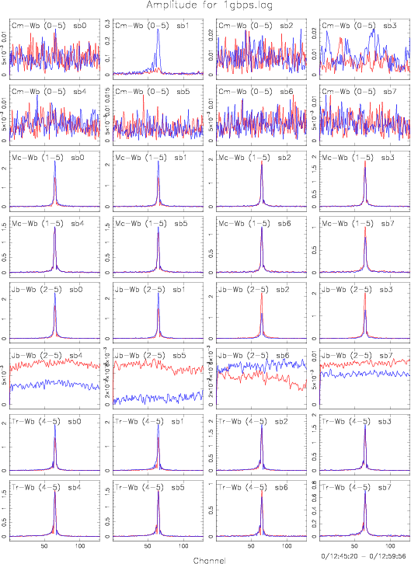
A large effort went into adapting the correlator control system in order to enable Mark5B playback. First fringes were obtained, but some problems remain, notably with the e-VLBI capability of Mark5B. In collaboration with Haystack engineers we are working on solving these problems and we expect to have a working solution by the end of 2007.
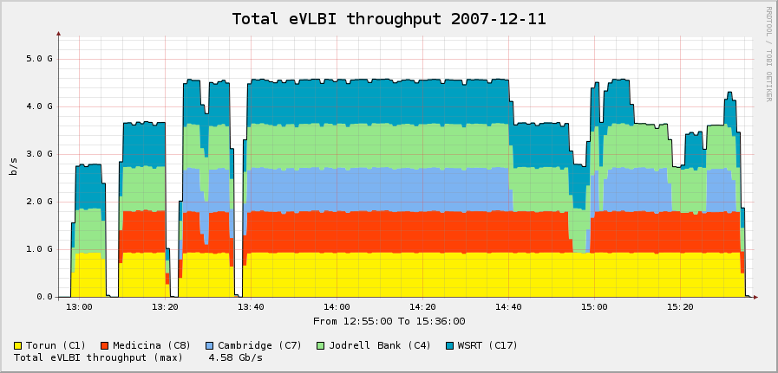
Work on adaptive observing, the ability to change observational parameters during observations, progressed well. All individual elements of software adaptations and new bits of software have been tested separately, an end-to-end test will be conducted in the next month.
Section 3.2- SA2- Telescope Network Connections
SA2 reports the first e-VLBI Fringes using the newly laid Effelsberg fibre for data transfer: observation on December 12th 06:51UT result at 13:40!
The data was transferred between Effelsberg and Bonn at about 500 Mbit/s. There was not enough time for more tuning. Line tests at up to 10 Gbit will be done tomorrow with special computers. Results will follow.
Participating stations were Wettzell and Medicina (was also a test for an INAF software correlator). Data from those two stations came in via the 1 Gbit line from Geant. The data rates for those transfers were lower. If you are interested you can get the numbers.
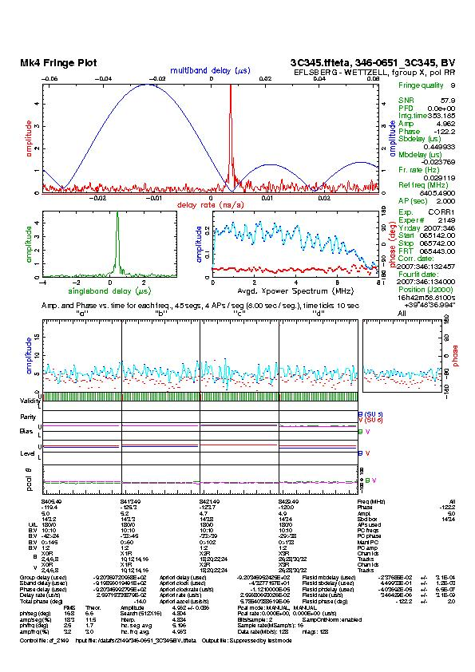
Initial results from the first Effelsberg tests.
By mid-January 2008, DFN will have moved its POP to Bonn university. MPIfR expects that the 10 Gbit line to Groningen will be ready. They hope to do some line testing for eVLBI before the Feb session with additional tests after the Feb session with JIVE. In March/April we will move the VLBI equipment to the Faraday room and hope for operational eVLBI sessions after the equiment is re-built.

Section 4.1- JRA1- FABRIC
The latest version of the software correlator has been used to process the FTP fringe tests for the Oct-Nov EVN session. This revealed a couple of problems in the code, which have subsequently been fixed.
A problem with applying the delay model has been fixed. The phase of the output of the software correlator now matches the output of the existing hardware correlator (with a better SNR). New experiments have been selected and correlated to do a more thorough scientific evaluation of the correlator output.
Further development has concentrated on making the code more scalable and on optimization of the code. The correlator output format has been changed to make it more self-contained, which will help the analysis of the results.
Prototypes for the web services for use with the workflow manager en VLBI grid broker have been tested. These tests revealed interoperability problems between the Python ZSI library used at JIVE for implementing services and the Axis2 library used at PSNC to implement the client. These issues are still under investigation.

