
Express Production Real-time e-VLBI Service
EXPReS is funded by the European Commission (DG-INFSO),
Sixth Framework Programme, Contract #026642

Monthly Report- July 2007
Title: | Monthly Report
Sub-title: | - July 2007
Date: | 2007 July 25
Version: | DRAFT
Filename:
Author: | T. Charles Yun, Project Manager, JIVE
Co-Authors | EXPReS Management Team
Summary: | EXPReS monthly update

Delivery Slip
 | Name | Partner | Date | Signature
From | T. Charles Yun | JIVE

Document Log
Version | Date | Summary of Changes | Authors
1.0 | 2007 Sep 1 | Final | tcy
0.8 | 2007 Aug 01 | Draft | tcy
0.1 | 2007 Jul 25 | Initial draft | T. Charles Yun

Project Information
Project Acronym | EXPReS
Project Full Title | Express Production Real-Time e-VLBI Service
Proposal/Contract number | DG-INFSO #026642
Table of Contents
1. Introduction
2. Network Activity Updates
* NA1- Management
* NA2- EVN-NREN
* NA3- e-VLBI Science Forum
* NA4- Public Outreach, Dissemination and Communications
3. Specific Service Activity Updates
* SA1- Production e-VLBI Service
* SA2- Telescope Network Connections
4. Joint Research Activity Updates
* JRA1- FABRIC
5. Appendeces
Section 1.0- Introduction
Many of the request for July updates included responses highlighting the summer holidays. In spite of many people being away, there is evidence of good progress from almost all fronts. Many of the reports build upon smaller and more gradual activities starting earlier in the year. Additional related activities should be completed next month, particularly with the APAN meeting (at the end of August) acting as a hard deadline.
Section 2.1- NA1 - Management
Since the start of the project, ASTRON has had an open (part-time) position as part of the EXPReS project. As of early 2007, ASTRON had not yet filled the position. Because of this, they have decided to execute the work through a contract agreement. The specific items to be executed are carrying out selected network investigations and to provide deployment support for the team activities in the FABRIC tasks. The arrangement assumes that these activities will be completed by the end of 2007 at a cost of 35,000 EUR maximum. The work started on 2007/02/01 by dr. Roel Gloudemans, who will report directly to the ASTRON project manager for FABRIC, dr. Peter Maat. ASTRON indicated that they were moving in this direction early 2007, but formal plans were not shared until recently.
JIVE just learned that the project support secretary, Diana van Dijk, will be leaving. The project office will determine quickly a replacement can be found. The process for advertising the position has been started and the hope is to fill the position as quickly as possible.
Section 2.2- NA2 - EVN-NREN
The EVN-NREN mailing list has been actively adding members from NREN's across the planet. The new members represent many of the NREN's involved in the networks that support EXPReS. There are currently over 40 participants, representing over 10 countries, and each continent.
The list is currently exchanging information on the next EVN-NREN agenda. A formal list of topics and speakers will be available closer to the meeting.
Section 2.1- NA3 - e-VLBI Science Forum
The eVSAG reports a relatively light month. The main objectives are to post meeting minutes and presentations from the recent eVSAG meeting.

Section 2.1- NA4 - Public Outreach
JIVE has combined existing internal data with the Google Maps API to produce an interactive, online correlation display system. The majority of the work is now complete enough to share results. The real time display shows stations from which the correlator is currently processing data. This display is of interest to EXPReS as it displays a straight line indicating the speed of the network connection between the site and the correlator.
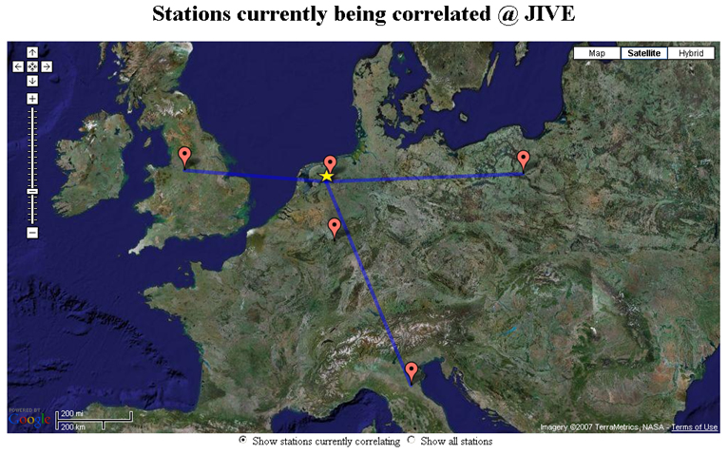
Figure: Correlation display, "Currently correlating" display

The second display is a list of all of the telescope sites that could send data to JIVE for correlation. This display includes both astronometric and geodetic telescopes, of which a subset has sent data to JIVE.
When the final URL is published, the code that was used to generate the map will be shared.

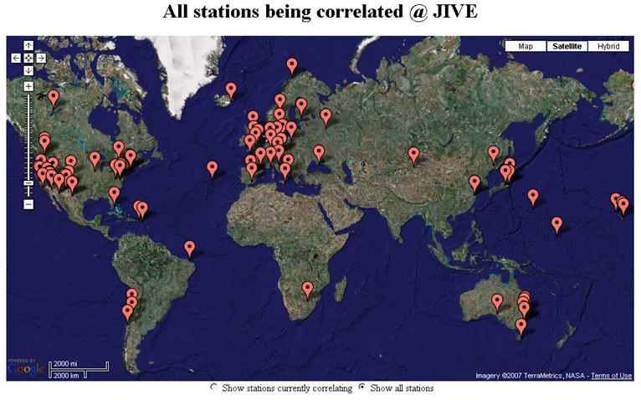
Figure: Correlation display, all telescope sites
Section 3.1- SA1- Production e-VLBI Correlation
After several weeks of code hacking in collaboration with software engineers at Manchester University a solution was produced which enabled us to transfer formatted telescope data from Medicina and Torun to JIVE at 512 Mbps, using UDP. b This will next be tested on the Shanghai-JIVE connection. Testing from Australia continued as well and resulted in the transfer of data from 3 Australian telescopes at 64 Mbps (via the normal production network, as there are no lightpaths in place yet). Some issues with the format conversion of the data remain to be sorted out, and we are currently waiting for AARNET to finish work on a lightpath with enough capacity to transfer up to 3x512 Mbps.
The lightpaths from the UK telescopes, previously directly from UKLight to Netherlight, were migrated to GEANT, but hardware intercompatibility issues made it impossible to use these. The cause of the problems has been identified and UKERNA is now working on solving the issue; in the mean time we continue using the old UKLight-Netherlight connections.
EXPReS is currently using the open-source 'Cacti' software to track and graph network usage. We have a dedicated machine that does an SNMP poll of the network switch every minute and adds the results to the appropriate graphs. This data is kept for several days and automatically reduced to lower resolution data, that's kept for up to a year.
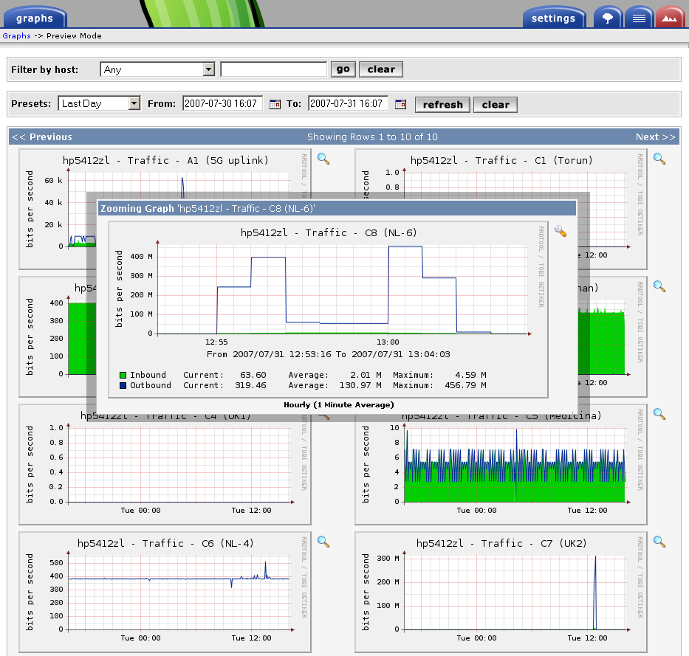
Figure: Cactii output displaying network utilization on one of the links into JIVE

This data forms the foundation for a larger network monitoring scheme that will allow e-VLBI operators to track the status of the network and respond to problems as they evolve. The next steps
On 26 June 2007, the European VLBI Network (EVN) carried out the first successful six station e-VLBI observations at 512 Mbps data rate. The image below shows J0000+4054, a compact symmetric object (CSO). CSOs are believed to be young radio sources from the observed small size and proper motions in their radio structure. A copy of the press release is available at <http://www.expres-eu.org/512Mbps_6tel.html> and is included as an appendix.
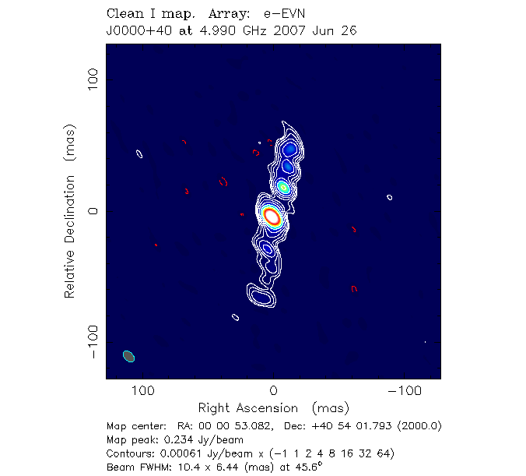
Figure: J0000+4054, a compact symmetric object (CSO

Section 3.2- SA2- Telescope Network Connections
Francisco Colomer, the leader of SA2, informed me earlier that he would be away for this month's report. A combined report will be provided once he returns from holiday.
Section 4.1- JRA1- FABRIC
Work Package 1- Scalable Connectivity
Testing of the TIEN2/Orient path has been scheduled for early August and results should be available soon. The decreased latency using this path promises to make transfers between China and JIVE more efficient/effective (due to BDP). The work will also help establish path characteristics for the upcoming APAN demo. The tests will use both the TCP and UDP transfer software developed inside of EXPReS. Other protocol variants may be investigated depending on availability of time.
Work Package 2- Distributed Correlation
An initial cluster-aware version of the software correlator core has been successfully tested on the DAS-3 cluster in the Netherlands. Development on this continues and is currently focused on processing the full bandwidth of VLBI experiments and getting it ready for a possible demo at SC07.
Discussions with Poznan about the interfaces between the software correlator core, workflow manager and VLBI grid engine are continuing, but actual code development is mostly on hold until the software engineer position has been filled again. Interviews for this position have been conducted and a few suitable candidates have been identified. We hope to complete the procedure in the first half of August.
Appendix - EXPReS Contact Points
For convenience, a list of the activities and the associated contact points are listed here for reference.

ID | Description | Contact | email
PC | Interim Project Coordinator | Huib Jan van Langevelde | langevelde // jive nl
NA1 | Management of I3 | T. Charles Yun | tcyun // jive nl
NA2 | EVN-NREN Forum | John Chevers | john.chevers // dante org uk
NA3 | e-VLBI Science Forum | John Conway | jconway // oso chalmers se
NA4 | Public outreach | Kristine Yun | kyun // jive nl
SA1 | Production Services | Arpad Szomoru | szomoru // jive nl
SA2 | Network provisioning | Francisco Colomer | f.colomer // oan es
JRA1 | FABRIC- WP1  FABRIC - WP2 | T. Charles Yun  Mark Kettenis | tcyun // jive.nl  kettenis // jive.nl
Appendix - Upcoming e-VLBI Observations
The next three dates for e-VLBI sessions have been announced online <http://www.evlbi.org/evlbi/per_session_status.html>. The dates are: 21 August, 6 September, and 9 October. The details for proposals have been (or will be) announced via email and are available online at <http://www.evlbi.org/evlbi/call_evlbi.html>.
Appendix - Press Release for First 6 Station, 512 Mbps Observation
The full press release is available online at <http://www.expres-eu.org/512Mbps_6tel.html> which includes the image of J0000+4054 that is included in this report.

News / Press Releases
First 512 Mbps e-EVN image from six stations
DWINGELOO, The Netherlands (6 July 2007) - On 26 June 2007, the European VLBI Network (EVN) carried out the first successful six European station e-VLBI (electronic very long baseline interferometry) observations at 512 Mbps data rate. The target was J0000+4054, classified as a compact symmetric object (CSO). CSOs are believed to be young radio sources from the observed small size and proper motions in their radio structure. The attached image of J0000+4054 shows this radio emission elongated roughly in North-South direction with a dynamic range exceeding 1000:1 and a noise level of 200 microJy/beam.
The observations were made using the Cambridge, Jodrell Bank (MkII), Medicina, Onsala, Torun and Westerbork (phased array) telescopes. The 3-hour observations were carried out in phase-referencing mode, changing between a bright calibrator and a fainter target source every few minutes. Due to microwave link limitations between Cambridge and Jodrell Bank, Cambridge effectively participated at 128 Mbps.
JIVE has been running e-VLBI operationally for over a year. The success with the 512 Mbps experiment proves the ability to support multiple baselines at high data rates in support of scientific observations. This capability makes e-VLBI competitive with disk based observations and brings us closer to a fully real time, network based, VLBI system. By early 2008 we expect that several new EVN stations come online or upgrade their connection, including the 100m Effelsberg, and the 300m Arecibo telescopes.
About the European VLBI Network (EVN)
The European VLBI Network (EVN, www.evlbi.org) is an interferometric array of radio telescopes spread throughout Europe and beyond, which conducts unique, high resolution, radio astronomical observations of cosmic radio sources. It is the most sensitive VLBI array in the world, thanks to the collection of extremely large telescopes that contribute to the network.

About EXPReS
Express Production Real-time e-VLBI Service (EXPReS, www.expres-eu.org) is a three-year project funded by the European Commission with the objective of creating a distributed, large-scale astronomical instrument of continental and intercontinental dimensions. This electronic Very Long Baseline Interferometer (e-VLBI) is achieved using high-speed communication networks operating in real-time and connecting together some of the largest and most sensitive radio telescopes on the planet. EXPReS is coordinated by JIVE, the Joint Institute for VLBI in Europe (www.jive.nl), which is hosted by ASTRON, the Netherlands Foundation for Research in Astronomy (www.astron.nl), in Dwingeloo.
About JIVE
The Joint Institute for VLBI in Europe (JIVE, www.jive.nl) was established as a scientific foundation in December 1993. JIVE's mandate is to support the operations of the European VLBI Network (EVN) in the widest sense. The major activity has been the development, construction and successful operation of the EVN Data Processor, a powerful supercomputer that combines the signals from radio telescopes located across the planet, creating one huge telescope of intercontinental dimensions. Using this technique of Very Long Baseline Interferometry (VLBI), astronomers can make detailed images of cosmic radio sources, providing astronomers with the clearest, highest resolution view of some of the most distant and energetic objects in the Universe.
# # #
Contact:
Arpad Szomoru, Head of Data Processor Research and Development
Express Production Real-time e-VLBI Service (EXPReS)
Joint Institute for VLBI in Europe
+31 521 596 500
szomoru@jive.nl
www.expres-eu.org

