
Express Production Real-time e-VLBI Service
EXPReS is funded by the European Commission (DG-INFSO),
Sixth Framework Programme, Contract #026642

Monthly Report- Aug 2007
Title: | Monthly Report
Sub-title: | - Aug 2007
Date: | 2007 Aug 25
Filename:
Author: | T. Charles Yun, Project Manager, JIVE
Co-Authors | EXPReS Management Team
Summary: | EXPReS monthly update

Delivery Slip
 | Name | Partner | Date | Signature
From | T. Charles Yun | JIVE

Document Log
Version | Date | Summary of Changes | Authors
1.0 | 2007 Sep 01 | Final | tcy
0.1 | 2007 Aug 28 | Initial draft | T. Charles Yun

Project Information
Project Acronym | EXPReS
Project Full Title | Express Production Real-Time e-VLBI Service
Proposal/Contract number | DG-INFSO #026642
Table of Contents
1. Introduction
2. Network Activity Updates
* NA1- Management
* NA2- EVN-NREN
* NA3- e-VLBI Science Forum
* NA4- Public Outreach, Dissemination and Communications
3. Specific Service Activity Updates
* SA1- Production e-VLBI Service
* SA2- Telescope Network Connections
4. Joint Research Activity Updates
* JRA1- FABRIC
5. Appendeces
Section 1.0- Introduction
The highlight of this month is the work the leads to the demo at the APAN meeting. This event, with related press coverage, is the culmination of many hours of work and effort by EXPReS members around the planet. We are pleased that the demonstration went well and that e-VLBI can be shown as an effective and useful tool.
Section 2.1- NA1 - Management
JIVE filled the position of Scientific Programmer earlier in the month with the arrival of Hüseyin Özdemir. Özdemir is a mechanical engineer by training, receiving his doctoral degree in computational fluid dynamics. Özdemir will work on the software correlator and the interfaces to the workflow manager and VLBI grid broker developed by PSNC.
As mentioned previously, the project secretary will be leaving. JIVE has moved forward with a plan to find a replacement. Additionally, we have secured some overlap time between the exiting and entering personnel for knowledge transfer once the new hire has started.
Section 2.2- NA2 - EVN-NREN
The major activity for NA2 is preparation for the EVN-NREN meeting in Bonn, Germany (in conjunction with the 6th International e-VLBI Workshop). Additional details of the meeting (agenda, participants) are available from the meeting website:
<http://www.mpifr.de/old_mpifr/div/vlbi/6th_evlbi/index.html>.
Section 2.1- NA3 - e-VLBI Science Forum
eVSAG has been active again leading discussions on the mailing list regarding the development and evolution of the rapid response capabilities of e-VLBI. This discussion, while in the background, is proving an important discussion ground to push the awareness and capabilities of e-VLBI into the mainstream conscious of the EVN and participating astronomers.
Minutes from the previous eVSAG meeting (Gothenburg, June 28th) were also posted to the wiki at the beginning of the month.
Section 2.1- NA4 - Public Outreach
The most visible activity over the past month is the distribution of the press release that follows the successful demonstration of e-VLBI in Xi'an, China. The text of the press release is included as an appendix. The image below was distributed with the press release to show the global distribution of participating locations. The lines connecting sites represent the logical network connections between the participating sites.
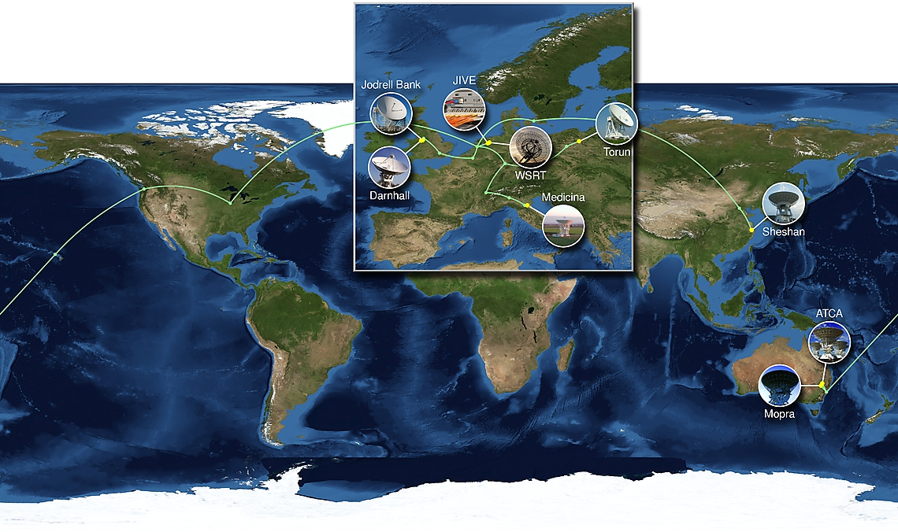
Figure: Visual display of participating sites for the Xi'an demo

As reported previously, EXPReS has developed an online tool that displays the status of the correlator, specifically, the stations from which the correlator is currently processing data. The official URL for the site is<http://www.expres-eu.org/maps/current/>. The source code is being made available (additional information available on the web page). Note that the data that drives the web page, specifically which sites are being correlated, is not available to the public nor are no plans to make the data available.
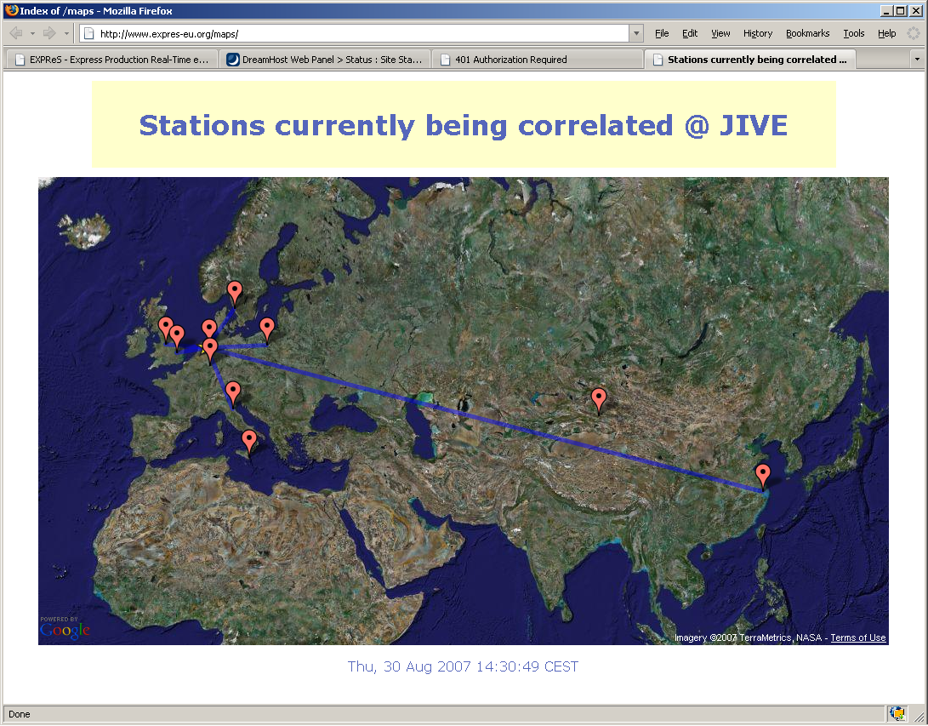
Figure: Visual display of sites being processed by the correlator at JIVE.

Section 3.1- SA1- Production e-VLBI Correlation
At the very beginning of the month, JIVE ran a variety of tests on the link between JIVE and China via the TIEN2/Orient link. A variety of tests were run, including TCP and UDP. The graphs below show some of the early results. The first shows the typical TCP "sawtooth" behavior as TCP encounters congestion. The second graph shows a more stable UDP flow at 512 Mbps.
On 8 August, JIVE ran formatter tests with China (via the CSTNET--CERNET--TIEN2--SURFnet link) and were able to sustain 512 Mbps for the test. Arpad Szomoru reported the results in an email on the same day (see appendix for copy of email).
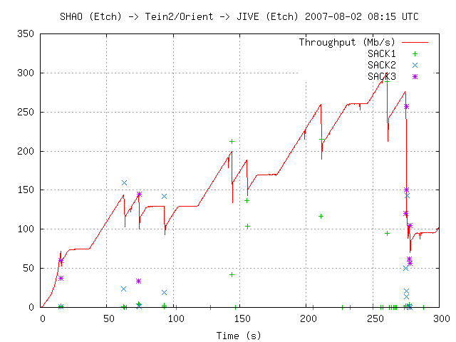
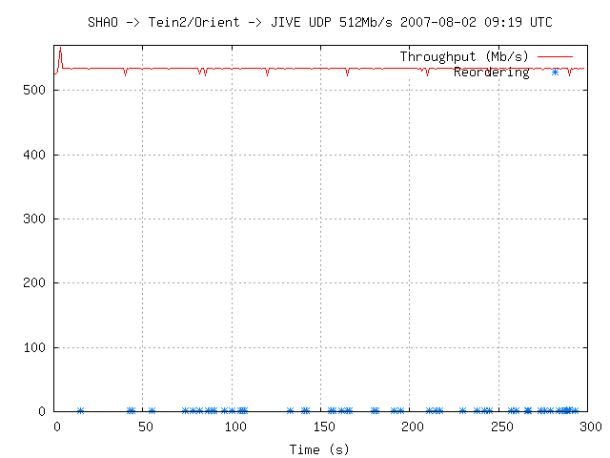
Figures: Two network traffic graphs from the first results of our tests from SHAO to JIVE, via the Tein2/Orient link.

This work formed the basis for the successful demo that was held at the 24th APAN Meeting in Xi'an, China. There are several highlights from the demo. First are the successful tests of the EU-CN, EU-AU and CN-AU baselines. Second is the longest e-VLBI baseline (Jodrell Bank to Mopra). Third, EXPReS and its EVN partners have shown that the vision of e-VLBI is a reality, sites from around the world can provision networks, transmit data, and provide correlated results in real time. A press release was issued to distribute the results to a wider audience (see appendix and posting at <http://www.expres-eu.org/ShAuEu_fringes.html>). The English language release was used as the basis for several translations as well.
The network map (shown below) graphs network utilization for all participating sites over the time span of the demonstration.

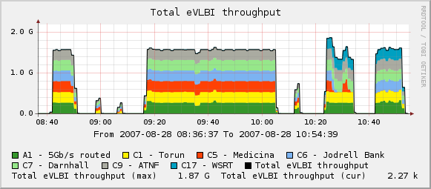
Figures: Network utilization during the Xi'an demonstration.

Section 3.2- SA2- Telescope Network Connections
Effeslberg
There has been a surge of activity in SA2 with several important accomplishments to announce. The first is progress at Effelsberg. Faron, the company responsible for installing the fiber connection, provided pictures of the installation progress. The project office was sent a note late in August indicating that the last conduit spool was delivered and they hoped to have in installed in the ground before September. The conduit would have fiber installed at approximately the same time.

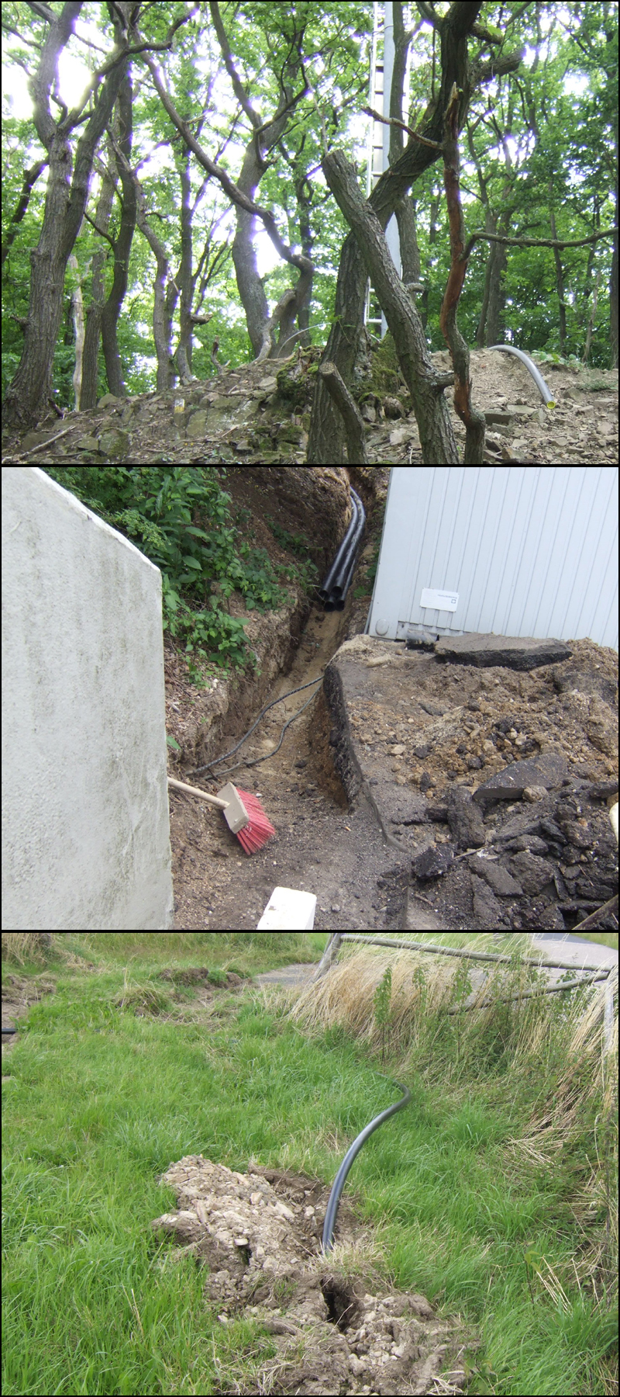
Figures: Pictures from the Effelsberg fiber installation provided by Faron, the company executing the work.

Arecibo
Arecibo also provided welcome news with an update. The University of Puerto Rico (UPR) and Arecibo are nearing a deal with their local telecoms provider. They will be provided additional bandwidth specifically for, and only during, e-VLBI sessions. To support this, they are upgrading the local loop to 1 Gbps and using MPLS to priority route through the UPR commodity connection.
The island of Puerto Rico is still bandwidth challenged; there are currently a limited number of connections that reach the island. In a few months, one of the telecom providers expects to tap into a larger fiber bundle in the area. They hope to offer a 10 Gbps lightpath but the pricing is considerably more than any previous estimations. Discussions on how to fund such a connection have yet to take place, but the possibility is quite exciting.
Finally, Arecibo pointed out they they are off the air due to regular maintenance and painting.
Manchester
Manchester reports that the 2 x 1 Gbps connections to Manchester and then through JANET to GEANT2 and JIVE continue to be used for testing and e-VLBI. One of the 1 Gbps lines out of Jodrell is also used for testing to Chicago, and eventually Haystack (to be reported by Anthony Rushton at the e-VLBI meeting in Bonn, Germany in mid-September).
Net North West are in the process of upgrading links to its remote sites to 10 Gbps. A tender is still in preparation (inspite of the initial timescale being quoted as May for contract signing). As an interim measure we are investigating the use of Transmode equipment in order to upgrade our link to 10 Gbps but this would have to funded by JBO.
Connection to Janet in Manchester is still under discussion. However we expect connection to be made shortly.
Hartebesthoek
From South Africa, we have received mixed news. On the upside, the HRAO reports that their 1 Gbps connection has been delivered and that it should go live sometime soon. Unfortunately, obtaining international connectivity remains a challenge. The scale of the challenge is such that the observatory does not feel its individual voice or actions will be able to initiate change. HRAO and EXPReS are working together to see if a combined statement can be helpful.
Onsala
Onsala reports that they have an installation date of early November for their 10 Gbps fiber connection. This will require new hardware at the observatory and Chalmers. The data will travel via Gothenburg over SUNET.
Talks continue regarding the NORDUNet link to the UK to support higher bandwidth e-VLBI testing. While still in early stages, all parties are optimistic that the path will be in place in time for a demo.
Section 4.1- JRA1- FABRIC
Work Package 1- Scalable Connectivity
Testing of the TIEN2/Orient path has been scheduled for early August and results should be available soon. The decreased latency using this path promises to make transfers between China and JIVE more efficient/effective (due to BDP). The work will also help establish path characteristics for the upcoming APAN demo. The tests will use both the TCP and UDP transfer software developed inside of EXPReS. Other protocol variants may be investigated depending on availability of time.
Preparations for the WP1 business meeting in Bonn are complete.
Work Package 2- Distributed Correlation
An initial cluster-aware version of the software correlator core has been successfully tested on the DAS-3 cluster in the Netherlands. Development on this continues and is currently focused on processing the full bandwidth of VLBI experiments and getting it ready for a possible demo at SC07.
Discussions with Poznan about the interfaces between the software correlator core, workflow manager and VLBI grid engine are continuing, but actual code development is mostly on hold until the software engineer position has been filled again. Interviews for this position have been conducted and a few suitable candidates have been identified. We hope to complete the procedure in the first half of August.
Poznan provided a short document outlining the current state of the Workflow Manager. Formally, the manager is dependent on a final version of the software correlator. Thus, the workflow description will remain in a semi-complete state until the process for integration with the final software correlator interface is complete.
Appendix - EXPReS Contact Points
For convenience, a list of the activities and the associated contact points are listed here for reference.

ID | Description | Contact | email
PC | Interim Project Coordinator | Huib Jan van Langevelde | langevelde // jive nl
NA1 | Management of I3 | T. Charles Yun | tcyun // jive nl
NA2 | EVN-NREN Forum | John Chevers | john.chevers // dante org uk
NA3 | e-VLBI Science Forum | John Conway | jconway // oso chalmers se
NA4 | Public outreach | Kristine Yun | kyun // jive nl
SA1 | Production Services | Arpad Szomoru | szomoru // jive nl
SA2 | Network provisioning | Francisco Colomer | f.colomer // oan es
JRA1 | FABRIC- WP1  FABRIC - WP2 | T. Charles Yun  Mark Kettenis | tcyun // jive.nl  kettenis // jive.nl
Appendix - Email announcement of successful formatter tests with China
-------- Original Message --------
Subject: Shanghai via Siberia
Date: Wed, 8 Aug 2007 17:11:14 +0200 (CEST)
From: Arpad Szomoru <szomoru@jive.nl>
To: jean-luc.dorel@ec.europa.eu
CC: Bernhard.Fabianek@cec.eu.int, Charles Yun <cyun@jive.nl>
References: <4614CD08.1040900@jive.nl> <4614F1EF.C6A3.0024.0@jive.nl>

Hi Jean-Luc, Bernhard. Here is the message I just sent out to evntech,
reporting on the progress wrt the Shanghai connection.
Regards, Arpad

Today we ran a formatter test between Shanghai telescope and JIVE, using a
modified Mark5A code with UDP. The data path followed the new
Siberian connection, via CSTNET - CERNET - TEIN2 - SURFNet. Data rates of
up to 512 Mbps were reached and sustained, but only 64, 128 and 256 gave
green leds on the Station Units, 512 Mbps stayed yellow (indicating valid
time stamps without synchronization).
We think we understand what causes this and intend to repeat the test
soon after some software modifications. If at all possible, Shanghai will
be included in the testing part of the next e-VLBI session, on the 21st of
August.

Appendix - Upcoming e-VLBI Observations
The next three dates for e-VLBI sessions have been announced online <http://www.evlbi.org/evlbi/per_session_status.html>. The dates are: 21 August, 6 September, and 9 October. The details for proposals have been (or will be) announced via email and are available online at <http://www.evlbi.org/evlbi/call_evlbi.html>.
Appendix - Press Release for First e-VLBI data from China-Australia, China-Europe and Australia-Europe baselines
EXPReS published the following the following press release after the successful demonstration of e-VLBI in conjunction with the 24th APAN Meeting. A copy is also available online at <http://www.expres-eu.org/ShAuEu_fringes.html>.
First e-VLBI data from China-Australia, China-Europe and Australia-Europe baselines

DWINGELOO, The Netherlands (28 August 2007) - Today, collaborators in the EXPReS project (Express Production Real-time e-VLBI Service) conducted the first successful real-time correlation of e-VLBI data from Chinese and Australian telescopes, from Chinese and European telescopes, and from Australian and European telescopes. The observation was demonstrated before advanced networking experts at the 24th APAN (Asia-Pacific Advanced Network) Meeting in Xi'An, China.

e-VLBI is a technique by which widely separated radio telescopes simultaneously observe the same region of sky, and data from each telescope are sampled and sent to a central processor via high-speed communication networks operating in real-time. This central data processor, a purpose-built supercomputer, decodes, aligns and correlates the data for every possible telescope combination and can generate images of cosmic radio sources with up to a hundred times better resolution than images from the best optical telescopes.

e-VLBI data were previously obtained using European, Australian and Chinese telescopes in separate tests as part of EXPReS, a three-year project coordinated by the Joint Institute for VLBI in Europe (JIVE) and funded by the European Commission. Today's tests, however, demonstrated the first real-time correlation results from Chinese-Australian and Chinese-European baselines. Data were also obtained from an Australian-European baseline for a short time as the target source set and rose in observing areas on opposite sides of the earth.

The observations were conducted by JIVE staff members in collaboration with their European VLBI Network (EVN) partners in Europe, China and Australia. Participating radio telescopes included the Mopra and Sheshan telescopes during the Chinese-Australian part of the experiment, and the Sheshan, Darnhall, Jodrell Bank, Medicina, Torun and Westerbork telescopes in the European-Chinese part.

Data were transferred to JIVE at a rate of 256 Mbps per telescope. Mopra was connected directly to JIVE through a dedicated 1-Gbps lightpath set up by the Australian, Canadian and Dutch national research and education networks (NRENs) AARNet, CANARIE and SURFnet, respectively. The Sheshan telescope was for the first time connected via the Chinese NRENs CSTNET and CERNET, the new high speed route across Siberia provided by the EC-sponsored ORIENT and TEIN2 networks, the pan-European GÉANT2 network and finally SURFNet. Most of the European telescopes have been connected for some time via dedicated lightpaths provided by the GÉANT2 partners.

"This is a fantastic achievement," said Huib van Langevelde, director of JIVE, present at the APAN meeting in China. "When we started doing e-VLBI we wondered whether we would ever be able to connect to these far-away telescopes, because there are not only various oceans to cross but also many different network providers."

Arpad Szomoru, head of R&D at JIVE, added, "We have recently developed and implemented various solutions that allow us to stream data over these enormous distances that overcome the problems with long round trip times over normal TCP/IP."

Additional tests with telescopes in Puerto Rico and Chile are planned for the near future. EXPReS aims to implement up to 16 simultaneous 1 Gbps-network connections between the central processor at JIVE and partner telescopes across Europe, Asia, Australia, South Africa, South America and the USA by 2009.

About JIVE
The Joint Institute for VLBI in Europe (JIVE) is a scientific foundation with a mandate to support the operations of the European VLBI Network (EVN). The major activity has been the development, construction and successful operation of the EVN Data Processor, a powerful supercomputer that combines the signals from radio telescopes located across the planet, creating a single virtual telescope of intercontinental dimensions. Using this technique of Very Long Baseline Interferometry (VLBI), astronomers can make detailed images of cosmic radio sources, providing astronomers with the clearest, highest resolution view of some of the most distant and energetic objects in the Universe.

About EXPReS
Express Production Real-time e-VLBI Service (EXPReS) is a three-year project funded by the European Commission with the objective of creating a distributed, large-scale astronomical instrument of continental and intercontinental dimensions. This electronic Very Long Baseline Interferometer (e-VLBI) is achieved using high-speed communication networks operating in real-time and connecting together some of the largest and most sensitive radio telescopes on the planet. EXPReS is coordinated by JIVE, the Joint Institute for VLBI in Europe, which is hosted by ASTRON, the Netherlands Foundation for Research in Astronomy, in Dwingeloo.

# # #

Contact:
Arpad Szomoru, Head of Data Processor Research and Development
Express Production Real-time e-VLBI Service (EXPReS)
Joint Institute for VLBI in Europe
mobile: +31 06 5050 2091 (UTC/GMT +8 hours)
szomoru@jive.nl
www.expres-eu.org

Kristine Yun, Public Outreach Officer
Express Production Real-time e-VLBI Service (EXPReS)
Joint Institute for VLBI in Europe
+31 521 596 500
kyun@jive.nl
www.expres-eu.org

For additional information:

* JIVE - www.jive.nl
* EXPReS - www.expres-eu.org
* APAN - www.apan.net

Participating astronomy institutes and telescopes:

* CSIRO Australia Telescope National Facility (Mopra telescope) - www.atnf.csiro.au
* Institute of Radioastronomy, National Institute for Astrophysics (Medicina telescope) - www.ira.cnr.it
* Jodrell Bank Observatory (Darnhall and MkII telescopes) - www.jb.man.ac.uk
* Netherlands Foundation for Research in Astronomy (Westerbork telescope) - www.astron.nl
* Shanghai Astronomical Observatory, Chinese Academy of Sciences - center.shao.ac.cn
* Torun Centre for Astronomy, Nicolaus Copernicus University (Torun telescope) - www.astro.uni.torun.pl

Participating network organizations:

* AARNet - www.aarnet.edu.au
* CANARIE - www.canarie.ca
* CERNET - www.edu.cn/english_1369
* CSTNET - www.cstnet.net.cn/english
* DANTE (ORIENT, TEIN2 and GÉANT2 networks) - www.dante.net
* SURFnet - www.surfnet.nl

