ROT 54/2,6 Radio telescope

The movement of subreflector of the radio telescope is realized with the East-West and North –South axis by the Cardan system of mounting in the Regel (Fig. 1,2)

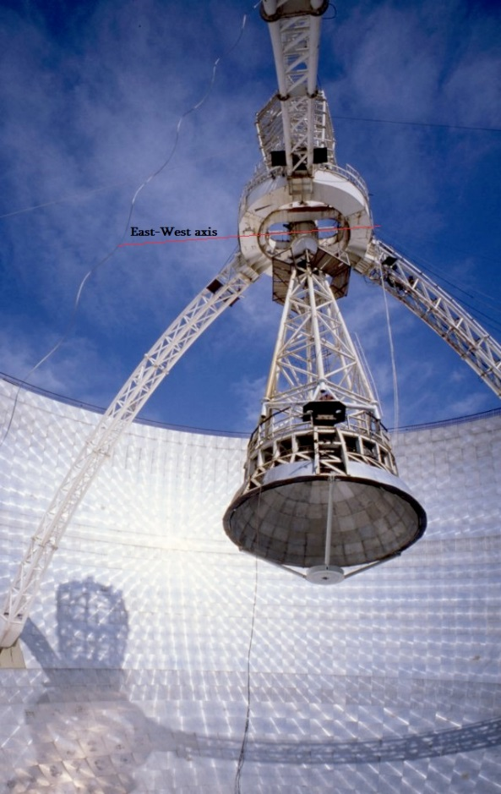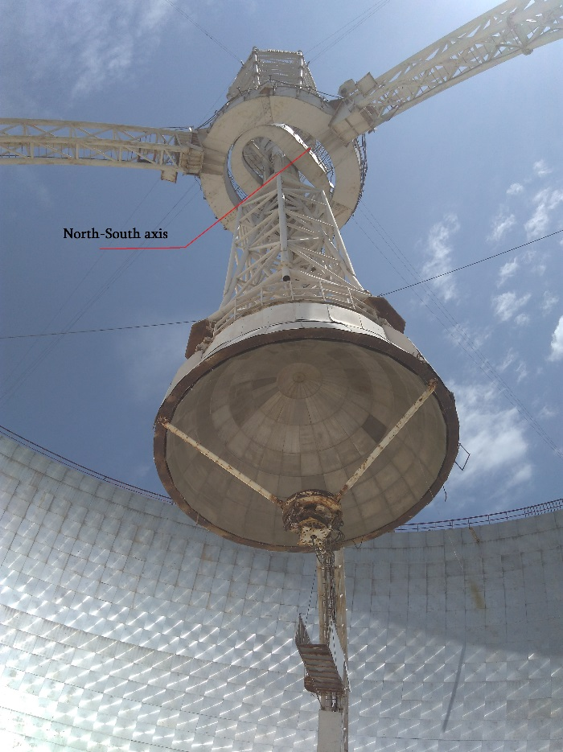
Fig.1 Fig.2

South edge of the North-South axis (in the normal condition) presented in the fig.3,4,5. North edge of that axis as well as the East edge of the axis East-West are normal also now.
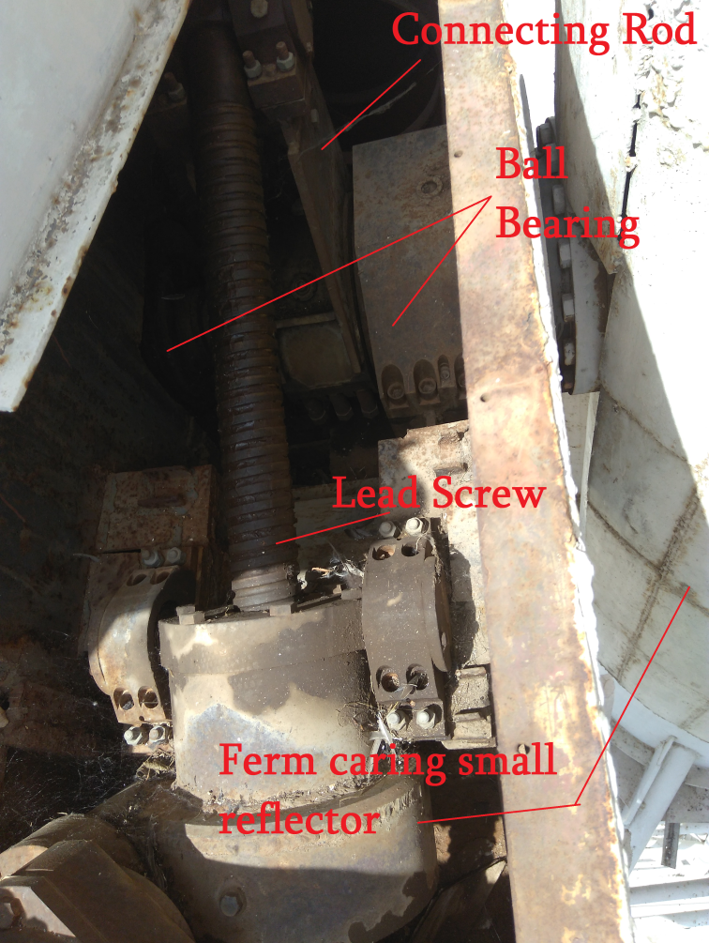
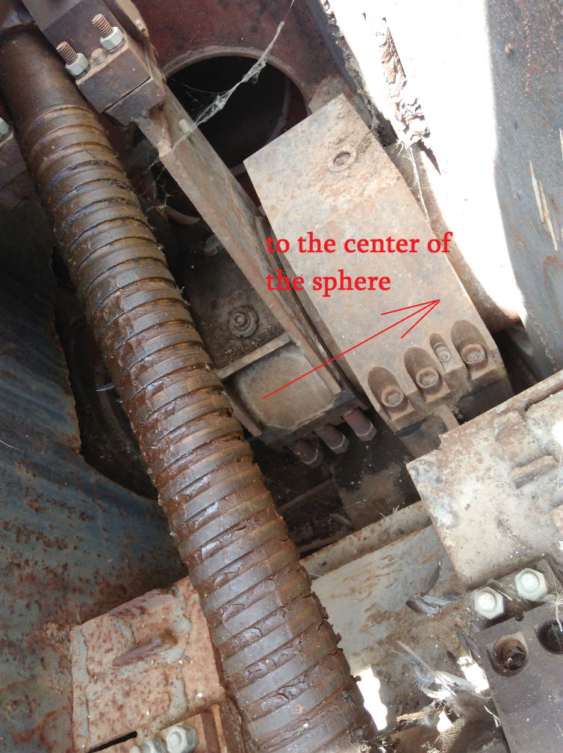
Fig. 3 Fig.4

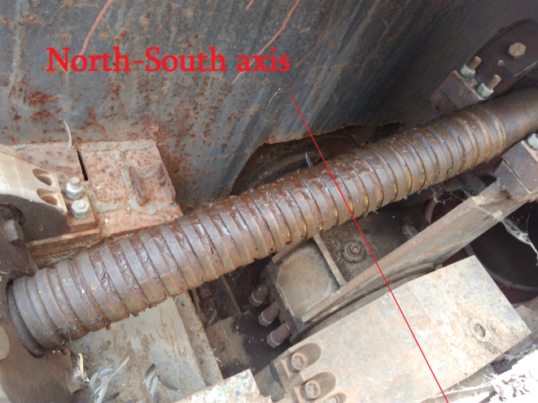
Fig.5

The Connecting Rod (bracket) of the Cardan system of the East-West axis is defected. (Fig. 6,7,8).
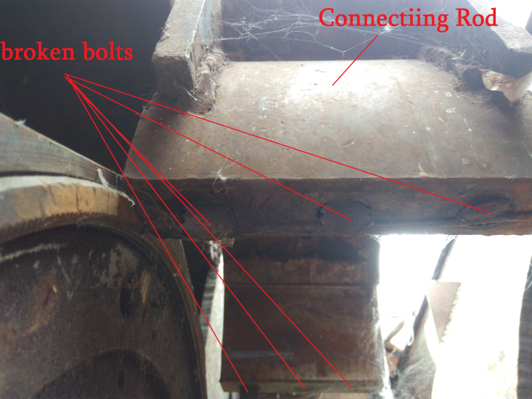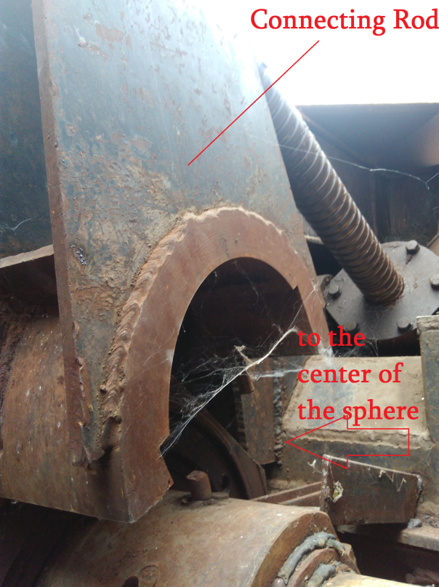
Fig. 6 Fig.7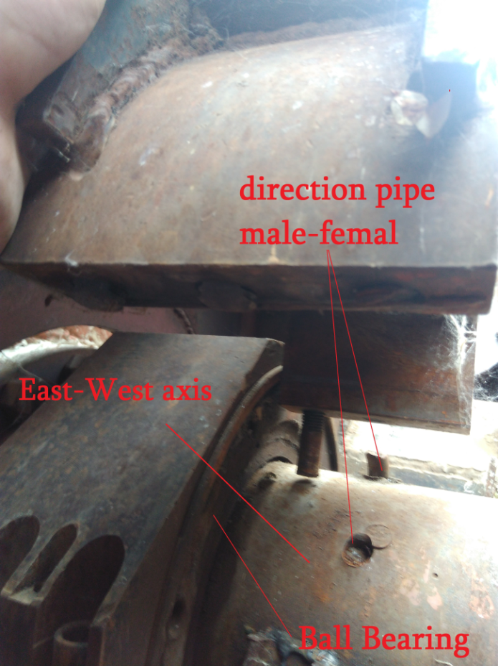
Fig.8
The Connecting Rod (brackett) clamping (like hug using male-female directed pipes) over the axis by six bolts (three on each side). The bolts are broken and stay inside the Connecting Rod (Fig. 6). The down –part of the brackett clamp is laying near (Fig. 9,10,11). It is nessesary to demolish the connecting rod and move to workshop for repearing the entries for new bolts.

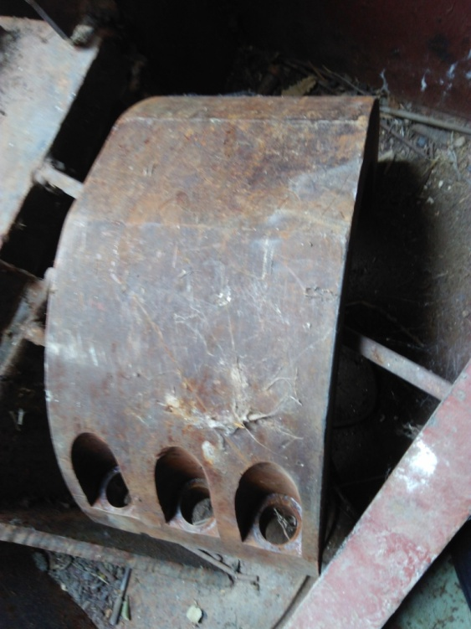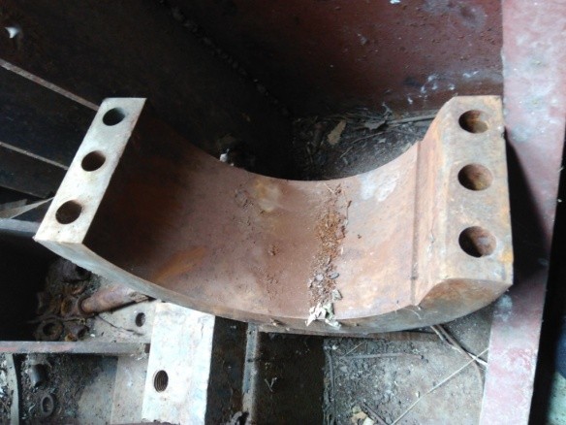
Fig. 9 Fig.10
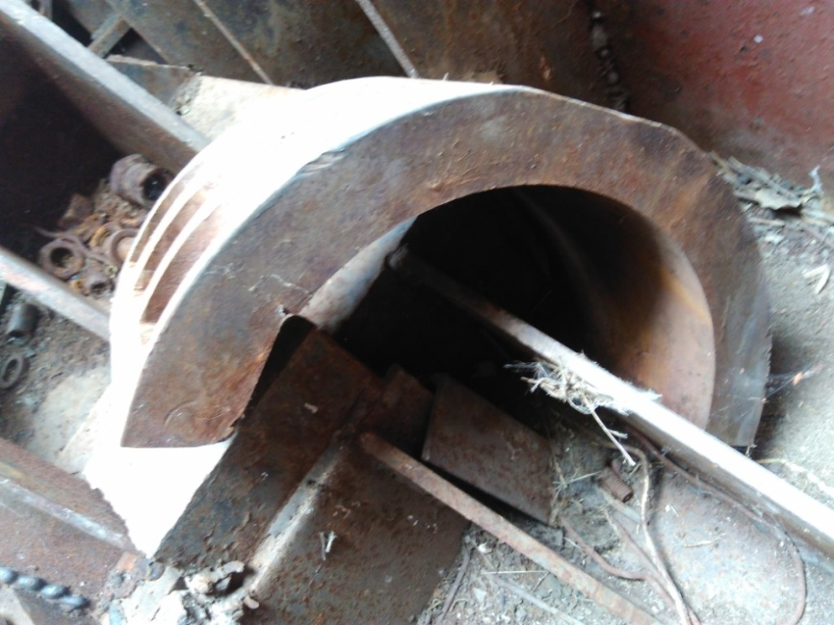
Fig.11

In this moment the East-West axis fixed with regel by welding using pieces of metal till the time when repearing work will start (fig.12).
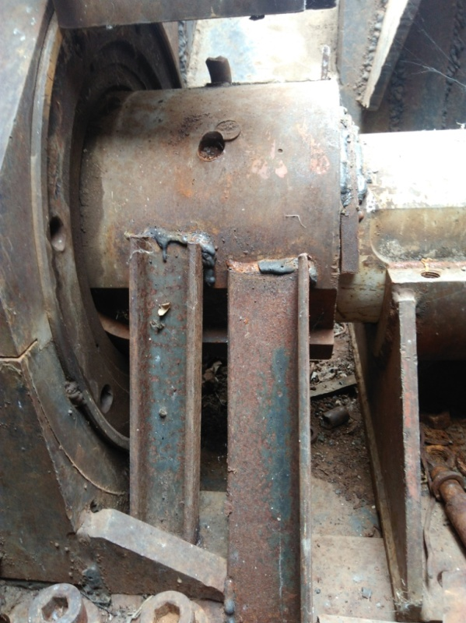
Fig.12

There are Ball Bearings in the edges of axis North-South and East-West for the limited horizontal movement of axis to the self-direction. (Fig. 13, 14).
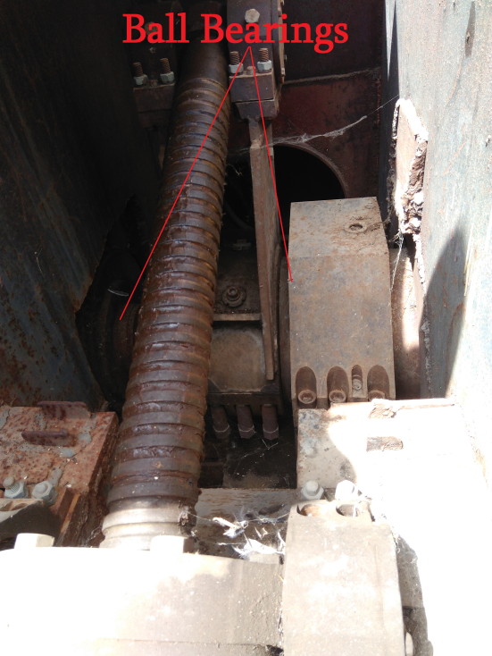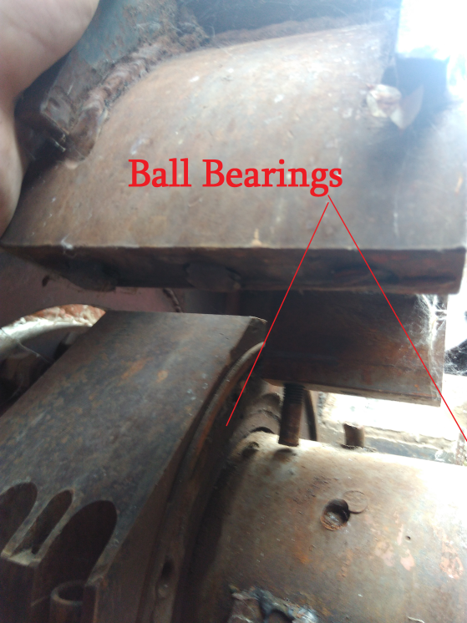
Fig. 13 Fig.14
The East – West axis is not damaged: it is only fixed by welding. It will function after repairing of the Connection Rod.
There are stop pins in the both edge sides of the Lead Screw for limited rotation of the axis (Fig. 15, 16).
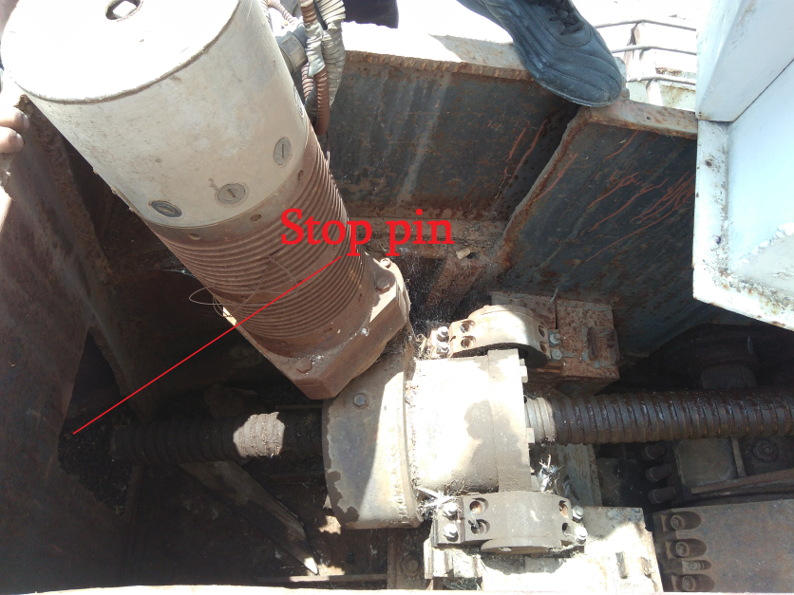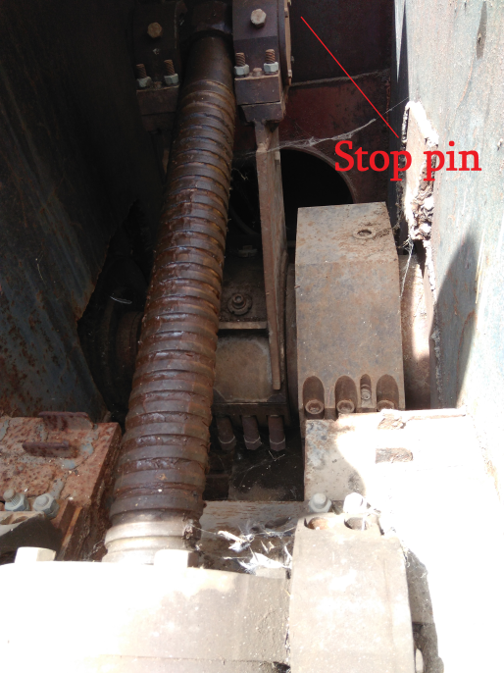
Fig.15 Fig. 16

